Downloading Quality Images Scaffold

- Using a web browser like Firefox, Internet Explorer or Safari, go to an image search engine such as www.Bing.com  Bing is a great search engine for images.  - If you roll over the word “Images,” you’ll see searches for wallpaper or black and white images. | 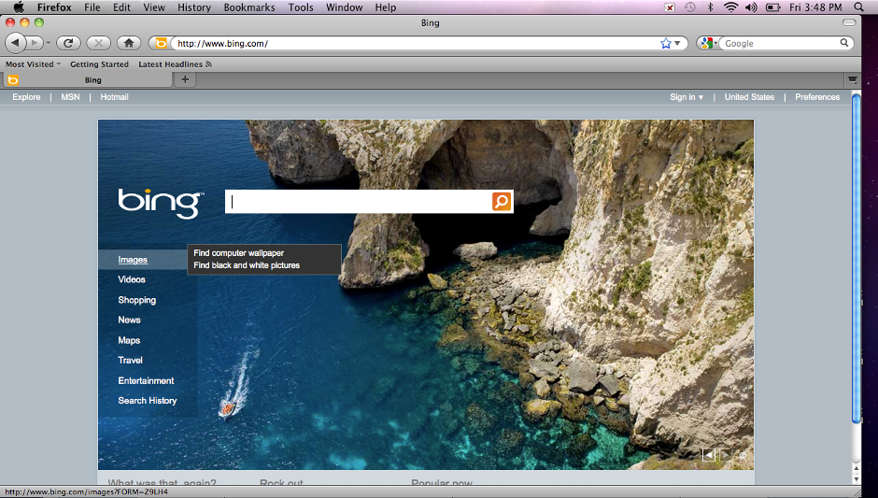
- Click the word “Images,” and a window opens that allows you to type your search topic.  - When you type in your search topic, additional suggestions appear.  I clicked on “whale shark.” | 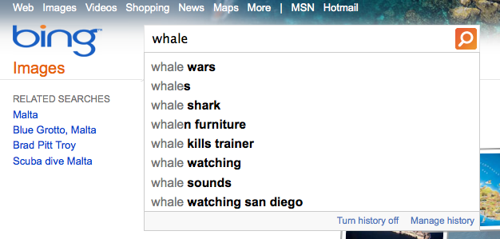
- The images of whale sharks that appeared are thumbnails of the actual image.  NEVER save a thumbnail to use in a project. Thumbnails are tiny files that will look pixilated when enlarged. | 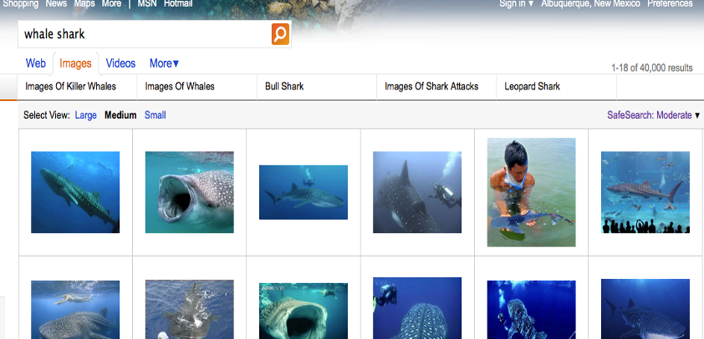
- Notice the left sidebar shows related topics, as well as choices for size, layout, color and style of an image.  These choices allow you to narrow your search and find the right shape and size photograph or illustration. | 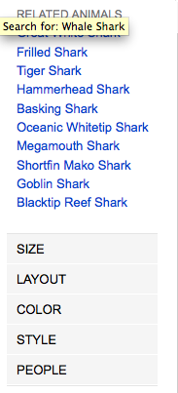
- Roll over one of the thumbnails and image information appears. Here you can see the original image is 650 x 436 pixels, a good size for projecting in PowerPoint, that the type of image file is a jpeg, as well as the URL where the image is located. | 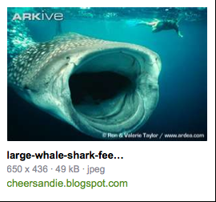
- If you click on the thumbnail, you’ll see a link to the full sized image, the name and size of the image, and the information you’ll need to use to cite your source. | 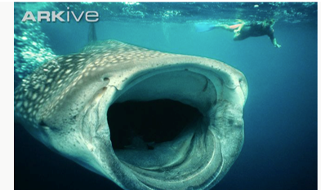  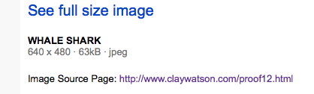
- Click the “See full size image” link, then either drag the image to your desktop, or right click and save the image to your desktop.  Note: While building a project, it’s better to save all images to a labeled folder, rather than copying and pasting images into your project. | 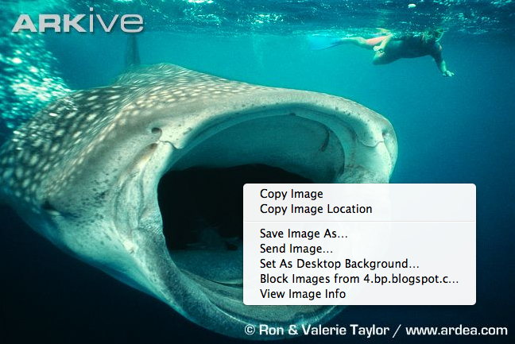
- It will save time if you create your Image Credits slide while you collect the images you’ll use. Open PowerPoint, choose the Title and Content slide layout format, and type Image Credits for the title.  Then type the name for the image before pasting in the URL where the image came from.  This saves time, as you don’t have to save the URL in a document, then add it later to the PowerPoint – you just put it into the PowerPoint right off the bat. | 