Using PowerPoint (2007) Slide Layouts

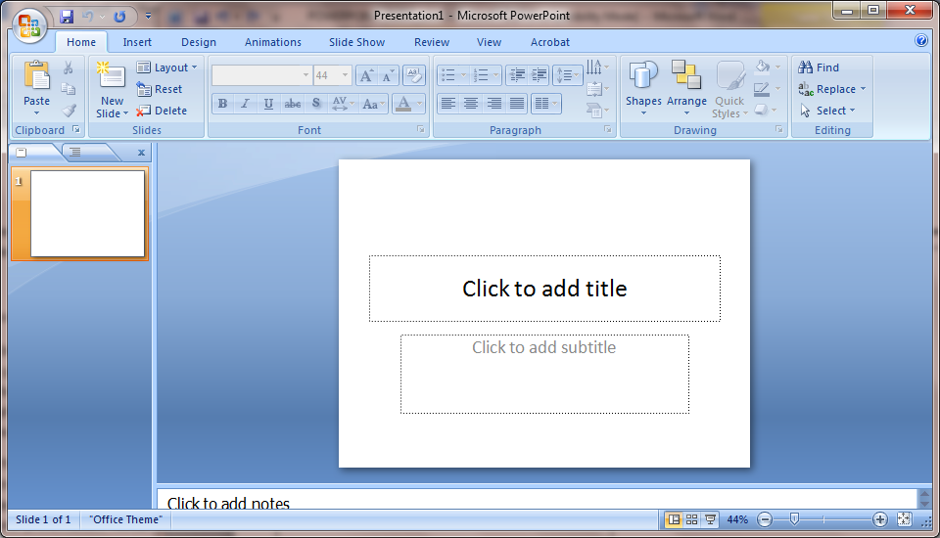

- After opening PowerPoint, it’s a good idea to name and save your presentation right away to avoid risking losing your work. Also, save your changes frequently while working.

To do this, click the Microsoft Office Button and select “Save As.” Name your file, then choose where you would like to save it.

Note: Saving your file to the same folder that holds all images, movies and sounds used in the presentation will help ensure a successful presentation.

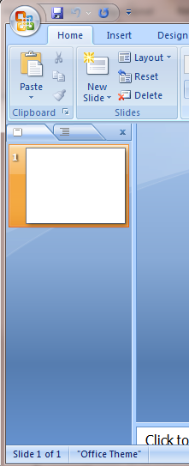
- The Slides tab shows a thumbnail version of each full size slide shown in the Slide pane. After you add additional slides, you can click a thumbnail on the Slides tab to make the slide appear in the Slide pane.

Or you can drag and drop the thumbnails to rearrange the slides in your presentation. You can also add or delete slides on the Slides tab. Click the slide thumbnail and press delete, or right click in the slides tab for more choices.
- In the Notes pane, you can type notes about the current slide, such as information you want to present while the audience views that slide.  When printing your presentation, you can choose to print the “Notes Pages.’ This prints the slide on the top of the page, and the notes on the bottom. | 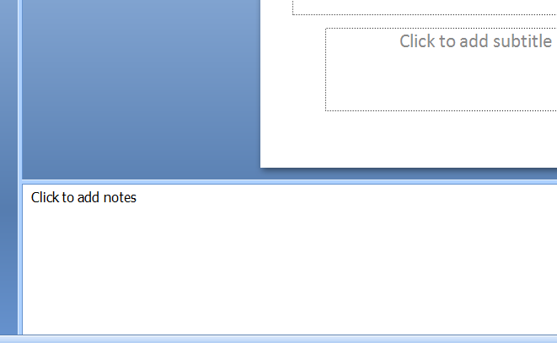
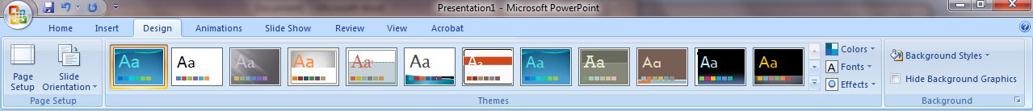

Design Tab Pick a theme color, font, transitions Background

- Once you have your first slide created, you can select a visual theme for your presentation if desired. To do this, go to the Design Tab. You have choices of pre-designed themes. You can use the pull down style menus and select the theme color, font and transitions. You can also select a background style.
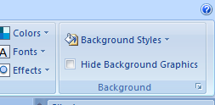
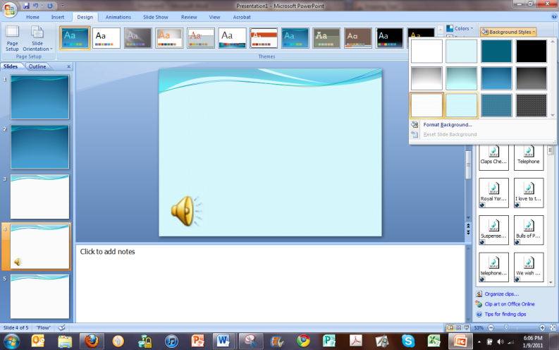
- When you click on the Background Styles menu, the Format Background dialog box will open.
- This dialog box gives you more background options. You can fill the background of the slide with a solid color, gradients, a photograph, or a pre-designed texture.  Note: If you are filling the background with a photo, select a large photo that is a horizontal rectangle so that it fills the slide without distortion . | 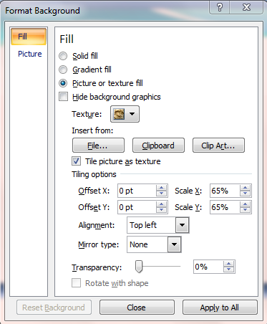
- When you open PowerPoint, it automatically formats the first slide as a title slide.  After creating the title slide, insert a new slide by clicking New Slide. PowerPoint will automatically insert a slide formatted for a title and bulleted list of content.  If you would like to select a different layout, click the Layout button. Or, when adding a new slide, click and hold the New Slide pull down arrow to reveal nine layout options. | 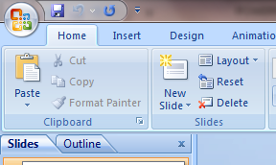
- When the nine built-in layouts appear, click the one that best fits your intended content for the page.  If you insert another slide, it will automatically copy the formatting of the currently selected slide.  If you want to create a custom slide with content that doesn’t fit one of the premade formats, select a Blank slide. | 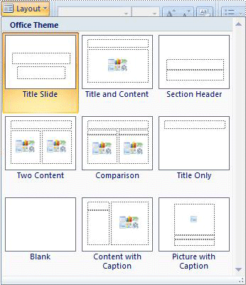
- If you wish to insert media such as clip art, sound, video, charts, pictures, etc., select a layout that includes a content placeholder. These are marked with this graphic.  Click on the icon representing the media you wish to insert. For example, to insert an image, click the image icon and the Insert Picture dialog box will open. | 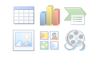  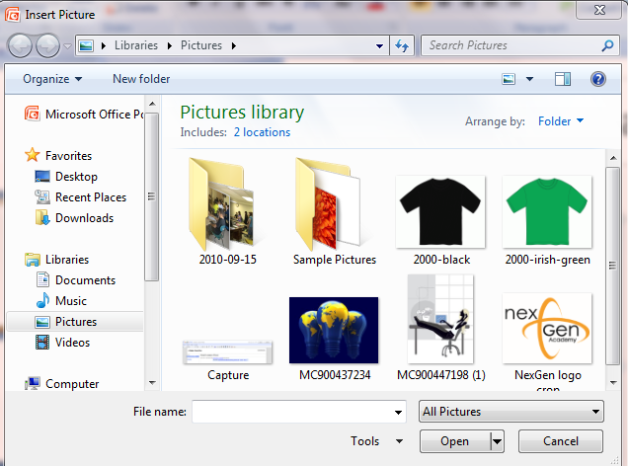
- To remove an unwanted placeholder on any slide, click the line of the placeholder to select it, and then press delete. | 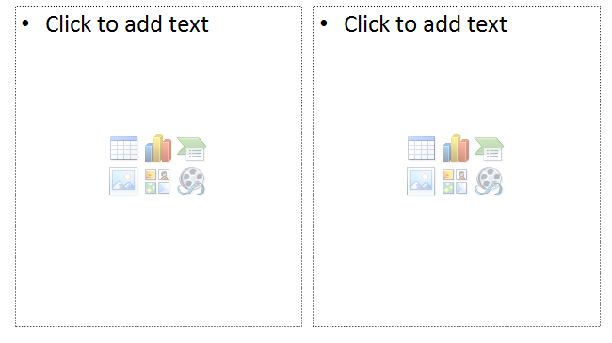
- To change an existing slide’s layout, click on the slide thumbnail in the Slide Tab, open the pull down menu under Layout, and click on the desired layout.
These tools are located under the Home Tab.

