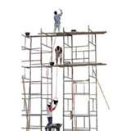
Scaffold Review

Directions: Open this document, type your answers, then print it. Handwritten papers will not be accepted.

- What do you feel are the three most critical attributes / functions of instructional scaffolds and why?

- In what way(s) does your Word scaffold fit those critical attributes / functions?

- Why do you think scaffolds might be especially important when having students work with technology?

