Bloom’s Taxonomy

Higher Level Thinking  Lower Level Thinking | Evaluation  Making a judgment | Example:  - Critiquing a short story or poem using an agreed upon definition of what constitutes a well written short story.
Higher Level Thinking  Lower Level Thinking | Synthesis  Creating something new by combining different ideas | Example:  - Rewriting Goldilocks and the Three Bears from the perspective of the bears.
Higher Level Thinking  Lower Level Thinking | Analysis  Breaking down information into parts to see relationships and importance | Example:  - Analyzing a short story or poem to find the theme.
Higher Level Thinking  Lower Level Thinking | Application  Using information in a new situation | Example:  - Using knowledge of letter sounds to read.
Higher Level Thinking  Lower Level Thinking | Comprehension  Understanding facts or information | Example:  - Knowing the sounds the letter a represents
Higher Level Thinking  Lower Level Thinking | Knowledge  Knowing facts or information | Example:  - Knowing that the symbol a is the letter a.

Higher Order Thinking Skills (HOTS)
Creating | - Generating multiple hypotheses based on given criteria.  - Designing a procedure to accomplish and new task.  - Inventing a product to accomplish a new task. | Building a bridge out of popsicle sticks or toothpicks and glue according to a mathematically-based design which takes into account the strength of materials and design elements such as triangulation.
Evaluating | - Identifying consistency, appropriateness, and effectiveness of principles and procedures.  - Critiquing the consistency, appropriateness, and effectiveness of principles and procedures based upon appropriate tests or criteria. | Developing and applying a mathematically-based test of the strength of the toothpick/popsicle stick bridge design.
Analyzing | - Distinguishing relevant/irrelevant or important/unimportant elements of material.  - Combining related elements or ideas into an organizational structure.  - Recognizing the intent in materials such as a story theme. | Analyzing the strength of various bridge design options such as a bridge deck supported with either a triangulation or a ladder design.
Applying | - Applying a procedure to a familiar task.  - Using a procedure to solve an unfamiliar but related task. | Finding the area of geometric shapes.  Finding the area of a side of a house by combining the areas of various parts minus the areas of the windows and doors.
Understanding | - Paraphrasing materials.  - Classifying items.  - Comparing items.  - Summarizing materials. | Using manipulatives to describe what 2×6 means.
Remembering | - Recalling memorized knowledge.  - Recognizing connections between memorize knowledge and new material. | Reciting the two’s times tables.
Lower Order Thinking Skills

Questions have to be contextualized to be effective

Negative Example | Positive Example
How will all the characters’ lives be different now? | How will the poor woodcutter’s life be different now?
What are the three settings of the story? | A setting is where the story takes place. Right now the two of us are in the setting of a classroom. What is one setting from our story?
What was the wife’s objective in the story? | What was the wife trying to do when she made all those tortillas?
If you were in the wife’s position, what are some different strategies you could have used to accomplish the same purpose? | Imagine you were in the wife’s position. What would you have done to trick the robbers so you could keep the gold?
Tell about a time where you were in a similar situation as the man in the story. What did you do? | [Get real. When would a 4th grader ever have found a bunch of gold and thought it snowed tortillas?] Imagine you found the gold. What would you do?

Questions that are more concrete are more effective

More Abstract | More Concrete
How many more dogs than cats are there? | Suppose the dogs all race over and each one tries to chase a cat! Will every dog have a cat to chase? How many dogs won’t have a cat to chase?
25% of kindergarteners answered this form of the question correctly. | 96% of kindergarteners answered this form of the question correctly.
Hudson, T. (1980, July) Young children’s difficulty with “How many more than are there?” questions (Doctoral dissertation, Indiana University, 1980. Dissertation Abstracts International, 41.
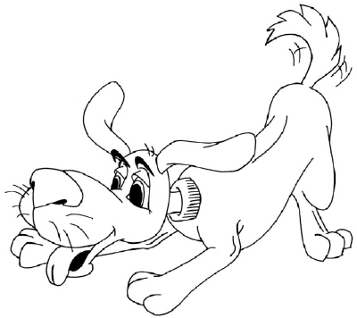
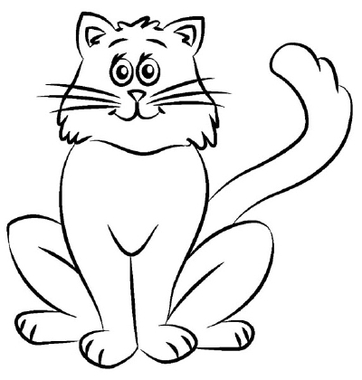
Reading Comprehension Questions Based on Bloom’s Taxonomy

The following are examples of reading comprehension questions written at the different levels of Bloom’s Taxonomy. Within groups, the questions begin at a level suitable for primary grades, and increase in difficulty to reflect questions suitable for upper elementary.

Level 1: Knowledge
- What people were in the story?
- Tell three things that happened in the story.
- Where did the story take place?
- When does the story take place?
- Write 6 facts from the story.
- What time in history did the story take place?

Level 2: Comprehension
- Tell me about the main character – use your own words.
- Tell the main problem of the story and how it was solved.
- Tell another thing that could have happened in the story that would make sense.
- What was the cause of the main event in the story?
- Tell this story in only 3 sentences.
- Explain what is happening in the first picture of the story.
- Tell in your own words what the story is about.
- How did the main character feel at the beginning of the story?
- How did the main character feel at the end of the story?
- Think of a main event in the story. Why did it happen?

Level 3: Application
- What can you do that is like what the person in the story did?
- Tell how you would have solved the problem.
- If you were in this story, what would you do?
- Tell about a time when something similar happened to someone you know.
- Think of a situation that occurred to a person in the story and decide whether you would have done the same thing or something different.
- Select any of the people in the story and think of some things each would do if he came to your school during reading. Or during recess. Or during lunch.
- What would your mother do if she were in the story?

Level 4: Analysis
- Identify the different parts of the story (introduction, development,
climax, resolution.)
- Tell me the parts of the story that could be real.
- What parts of the story are necessary? What parts are not?
- Who is the most important character in the story? The least important?
- What part of the story was the funniest? The most exciting? The saddest?
- Tell what things happened in the story that couldn’t happen in real life.
- Some of the things in the story were true, and some were only opinions. List the things that were true.
- Organize the story into parts and think of a good title for each of the parts.

Level 5: Synthesis
- Make a story like this one but use only your friends as characters in it.
- Make up what would happen if the story continued.
- Make a picture about this story.
- Draw a picture of the place where most of the story took place. Don’t copy the book.
- Be ready to act out the story with no words.
- Make a different problem for the main character to solve.
- Rewrite the story from an animal’s point of view.
- Use your imagination to draw a picture about the story. Then add one new thing of your own that fits but was not in the original story.
- Write another ending to the story that is different from the author’s ending.
- Pretend you are the main character in the story. Write a diary about what happened.

Level 6: Evaluation
- Did you like this story? Why or why not?
- Why do you think the author wanted to write this story? Would you?
Why or why not?
- Could this story happen in another country? On another planet? In the days of the cavemen? Tell why or why not.
- Do you think this is a good story for a ___ grader? Why or why not?
- Compare this story to the last. How are they the same? How are
different?
- Does this story seem interesting to you? Why or why not?
- Was the main character in the story good or bad? Why?
- Compare two characters in the story. Tell which one you think is braver
and why. Or better, and why. Or more cunning and why.
- Compare and contrast the setting in this story and the setting in (Little
Red Riding Hood; the last story we read). Tell which is better and
why.
- Do you think the main character acted in the best way? Why or why
not?
- Was this the best ending for this story? Why or why not?

