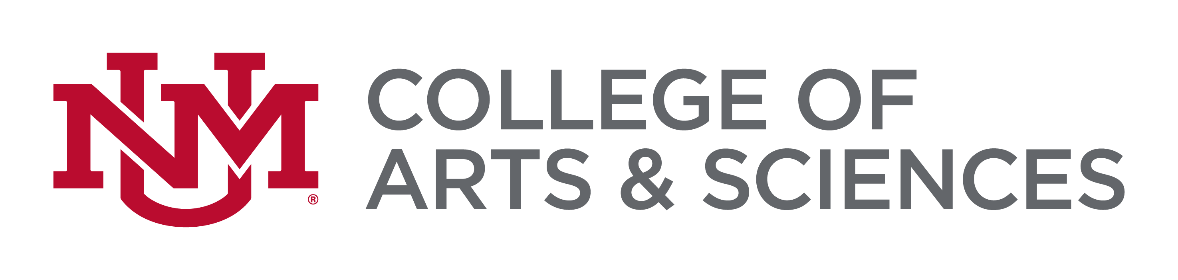
Russell J. and Dorothy S. Bilinski Fellowships
A Program of the Bilinski Educational Foundation

2024 Fellowship Application Cover Sheet

Name Click here to enter text

Address Click here to enter text

Phone Number Click here to enter text

Email Click here to enter text

Gender Identification (optional) Click here to enter text

Race/Ethnicity Click here to enter text

Current Graduate Level UNM Grade Point Average (GPA) Click to enter GPA

Master’s Program Information
M.A. Date Range: Click here to enter text
M.A. Institution: Click here to enter text

Ph.D. Program Information
Ph.D. Date Range: Click here to enter text

Ph.D. Institution: Click here to enter text

Ph.D. Comprehensive Exam Date: Click here to enter text

Ph.D. Prospectus Defense Date: Click here to enter text

Fellowship Application Cover Sheet, Page 2

Abstract of Dissertation Project (250 words)
Click here to enter text

Signature of the Applicant Signature of Advisor
X | X

Advisor Name Click here to enter text

