Student Financial Aid

Prerequisites for Banner Access

Date Issued/Rev: 06/06/2008
General Description: This procedure explains what steps are needed to complete the prerequisites for Banner access.
Responsible Manager: Financial Aid Director
Related References:
Related Procedures:
Related Websites: http://my.unm.edu
Please note - All material will be provided by links from the Employee Life tab once you have logged into the website.

PROCEDURE

Step 1 – Loggin to My UNM at http://my.unm.edu using your UNM Net ID and password.

Note - Pop-up blocker will need to be disabled.

Step 2 - Click on the “Employee Life” tab in the My UNM web page.

Step 3 – Look to the lower right side of the Employee Life page.

Step 4 - Select the ‘Learning Central’ option from the Banner Training section. Please refer to Figure 1.

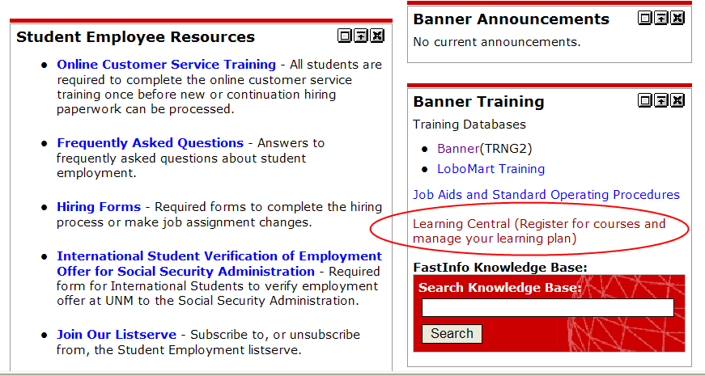

Figure 1 – Link to Learning Central

SECURING PRIVATE DATA and GENERAL NAVIGATION
Step 1 - Login at the upper right in the Learning Central webpage. Please refer to Figure 2.
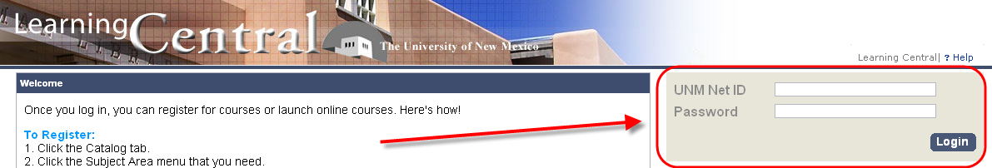
Figure 2 – Learning Central login page
Please Note - All new hires should be able to access learning central with their UNM Net ID and password. If you have a UNM Net ID, and it has been 24 hours since you created it and you still cannot access Learning Central please speak with the Human Resources department at 277-6947.
Step 3 - Verify that your Personal Profile information is correct once you have gained access to Learning Central. This information will be in the top left hand corner of your screen.
Step 4 - Click on the 'Catalog' tab near the top of the page, center. Please refer to Figure 3.
Step 5 - Select the 'Banner General' link within the Catalog tab under the 'Subject Area Menu', the listings for this area will show up on the right under the Items column. Please refer to Figure 3.
Step 6 - Scroll down until you find the course titled "Securing Private Data (Web Course)" and “Banner Fundamentals and Navigation Competency (Web Course)”. Please refer to Figure 3.
Note - If you would rather take the (Instructor-Led) course and there are offerings available, you may do that instead.

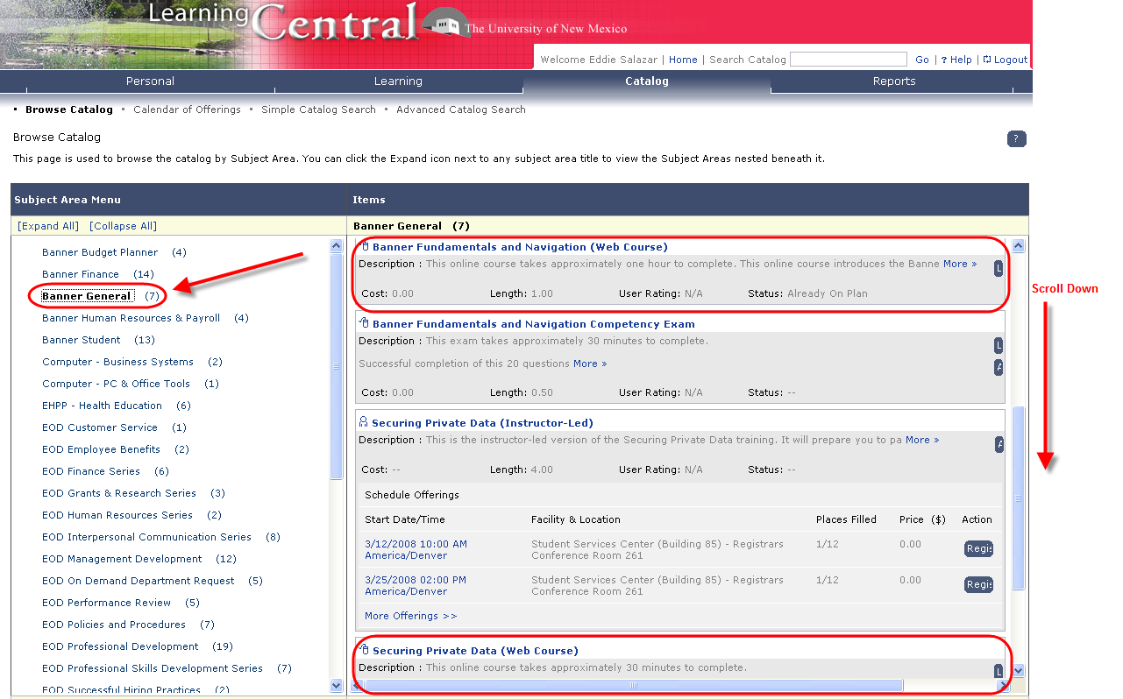
Figure 3 – Learning Central Catalog
Step 7 - Complete the course content section.
Step 8 - Complete the "Securing Private Data - EXAM" and the “Banner Fundamentals and Navigation Competency – EXAM”. The exam is located after the course content/training in the course catalog menu.

Continued on next page…

BANNER AUTHORIZATION REQUEST
Step 1 – Login to http://my.unm.edu. After both exams (Banner Fundamentals and Navigation and Securing Private Data) have been “passed”.

Step 2 - Click on the “Employee Life” tab in the My UNM web page.

Step 3 - Select the link for “Banner Authorization Requests” on the upper right side of the Employee Life page, in the Banner Applications Menu. Please refer to Figure 4.

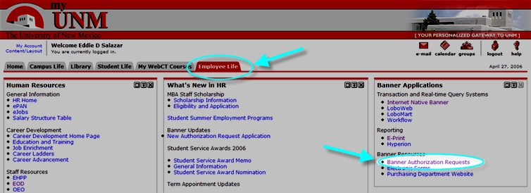

Figure 4 – Employee Life webpage.

Step 4 –When prompted to Log In (again), using your UNM NetID and Password login using your UNM Net ID and password. Please refer to Figure 5.

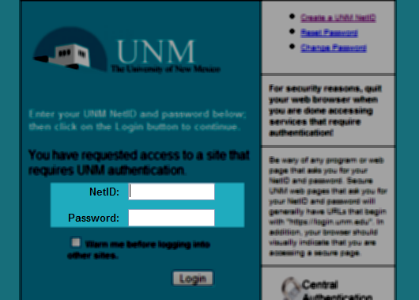
Figure 5 – UNM Login page

Step 5 - Create an authorization request when logged in by clicking “Create Request”. Please refer to Figure 6.

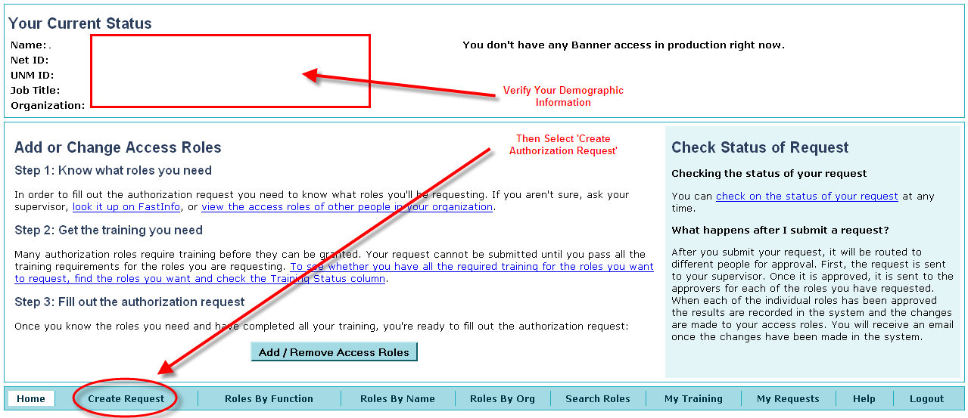Figure 6 – Add or Change Access Roles

Step 6 – Find the ‘Add New Roles’ Box and click ‘Select Roles’. Please refer to Figure 7.

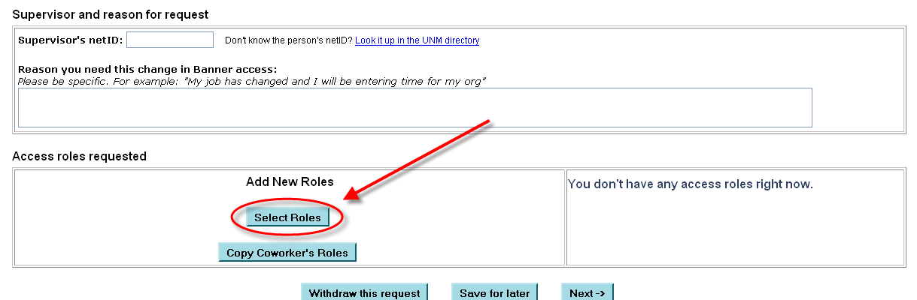
Figure 7 – Access roles requested box.

Step 8 - View the Financial Aid Roles. Please refer to Figure 8.

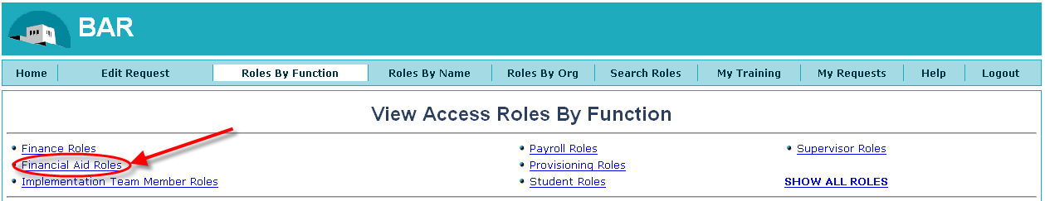
Figure 8 – View Access Roles by Function page

Step 9 - Select the Role(s) that fit your job duty by checking the box next to the role while in the Financial Aid requests.

Step 10 - Scroll to the bottom of the page and select ‘Add Selected Roles to My Request’ once you have selected the Roll(s). Please refer to Figure 9.

Figure 9 – Add Selected Roles to My Request

Step 10 - Return to the previous page once you have selected ‘Add Selected Roles to My Request’.

Step 11 - Fill out all information on the “Supervisor and Reason for Request” box -
  - The UNM NetID for your supervisor
  - Type a reason for the request
  - Confirm the Security Role you are requesting in the “Access Roles Requested” box
Please refer to Figure 10

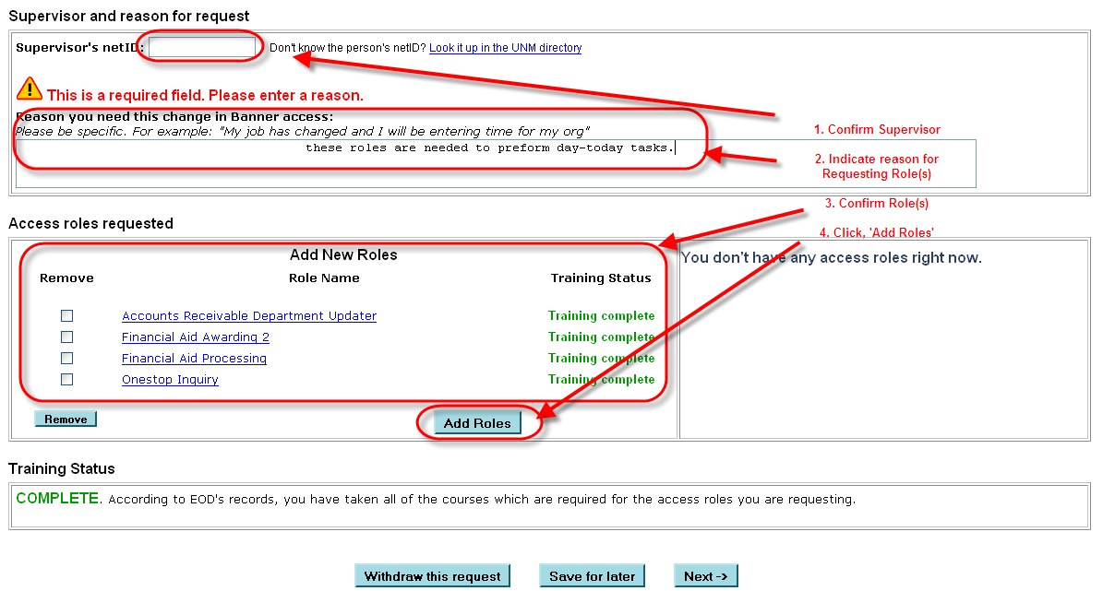
Figure 10 – Supervisor and reason for request page

Step 12 - Click ‘Add Roles’

Step 13 - Verify the Roles requested and Confirm Training is complete for those roles at the next page. Please refer to Figure 11.

Step 14 - Click “Submit Request”. Please refer to Figure 11.

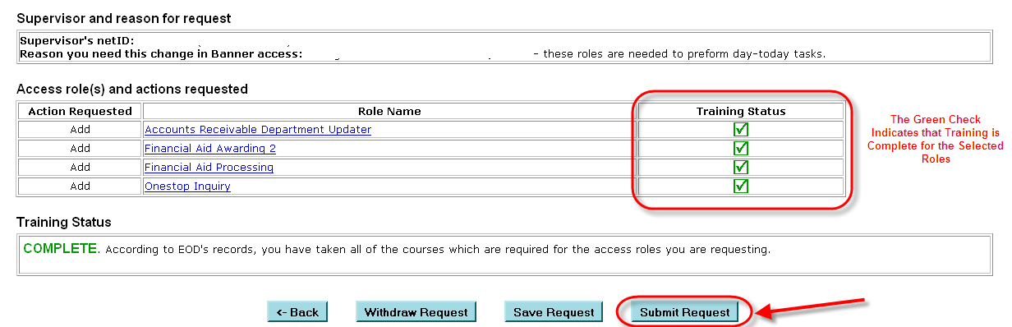

Figure 11 – Verification and Submission of role requests

Step 15 – Wait for the status of your Authorization Request - either “Approved” or “Denied” via e-mail.

-END-

