 | University of New Mexico  Office of Student Financial Aid | 

FATRK-101 Consortium Agreements

Date Issued/Rev: 04/03/2008
General Description: This procedure explains how to log on Consortium Agreements.
Responsible Manager: Financial Aid Director
Related Procedures:
FABU-106 Change_Adjust Budget Component for a Student
FABU-107 Add Budget Component - Individual
Related Forms: RBAABUD
ROAENRL
RRAAREQ
RHACOMM

PROCEDURE
Procedure:
1. Verify that the Consortium Agreement is complete
- Consortium Agreement form has been completed by Host Financial Aid Office and UNM Academic Advisor.
- Verify that the UNM Academic Advisor and the Host Financial Aid Office have signed the form and provided a contact phone number.
- Copy of enrollment at host school
- Copy of payment at host school
2. Go to RRAAREQ
3. Insert record (F6)
4. Type appropriate Consortium Agreement mnemonic (ex. CSORTF, CSORTS, CSORTX; F = Fall, S = Spring, X = Summer) in new record.
5. If Consortium Agreement is complete enter “C” in ‘Status’ column next to the CSORT mnemonic
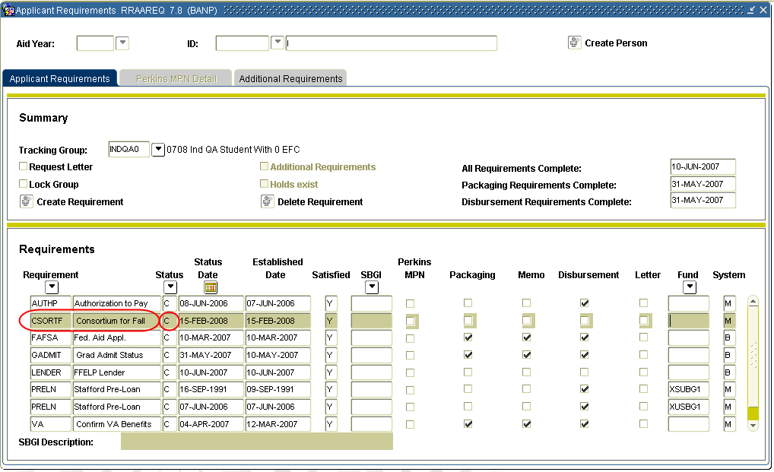
6. If Consortium Agreement is incomplete enter ‘I’ (for “Received Incomplete” status).
- Save (F10) and exit form.
- Go to ROAMESG
- Perform ‘Next block’
- Enter your message explaining why the consortium is incomplete
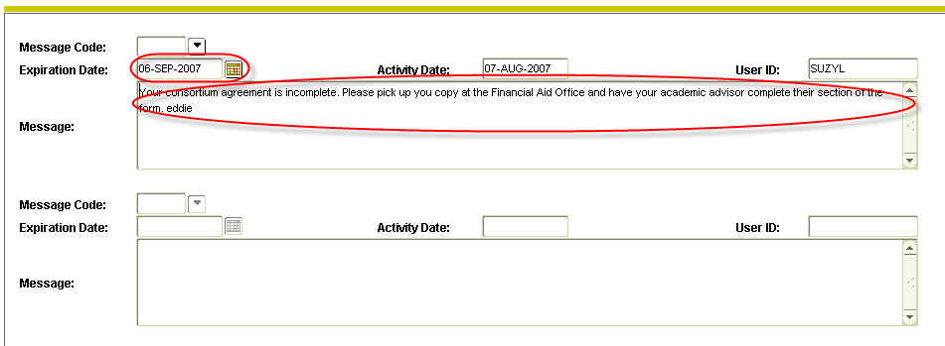
- Save (F10) and exit form
7. Go to RBAABUD
8. Perform Next Block
9. Insert Record (F6)
10. Enter appropriate Consortium Agreement tuition component (FCSO, SCSO, XCSO) and amount (see FABU-107)
11. Reduce UNM tuition, if applicable.
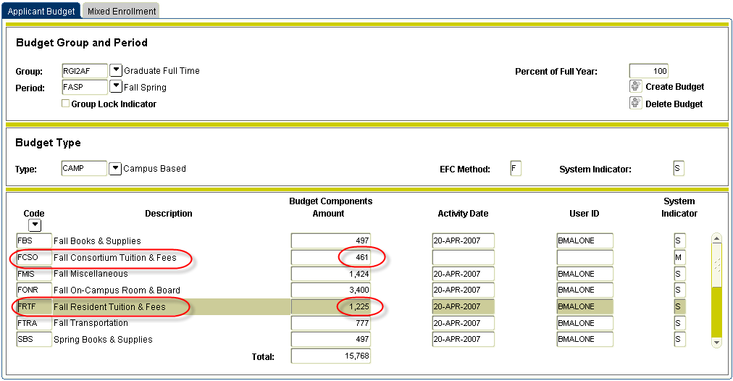
12. Save (F10) and exit form
13. Go to ROAENRL
14. Perform Next Block
15. Enter term code under Financial Aid Hours section (ex. Fall 200x80, Spring 200x10, Summer 200x60 – see Banner Terms)
16. Tab over to Credit, Bill, and Adjusted fields and enter the total number of hours the student is expected to be enrolled in at UNM plus the Host school (so if student is registered for 7 hours at UNM and 6 hours at CNM enter 13 in the Credit, Bill and Adjusted fields)
17. Click in ‘Consortium Indicator’ field, so that a check mark appears
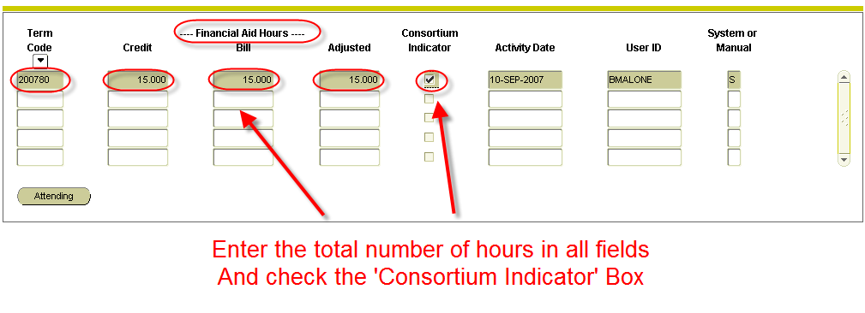
18. Save (F10) and exit form
19. Go to RHACOMM
20. Leave note that should include:
- Host school name
- Hours at host school, including course numbers
- The Number of Credit Hours at the Host school
- Expectation that future aid will not be released without receipt of grades from students at the end of the term
21. Save (F10) and exit form

***Note: A Tracking Code (TRANF, TRANS, TRANX) will be batch posted at the end of the term that will generate an MIL message that will request the grades for the term. This Tracking Code will hold disbursements until it is satisfied.
* * * E N D * * *

Put into practice

Log on the Following CSORT into INTG:

