Student Financial Aid

FATRK-101 GADMIT Resolution

Date Issued/Rev: 04/04/2008
General Description: This procedure explains what steps are needed to complete a request for GADMIT.
Responsible Manager: Financial Aid Director
Related References:
Related Procedures:
Related Forms: SAAADMS
RSIDEGR
RRAAREQ
RHACOMM

***************** NOTE: THERE IS NO REQUIRED FORM FOR THIS ******************

The system will complete the request for GADMIT automatically, unless the most recent Admissions Application does not have an "Application Decision" has a code of "E,QE,JE,ED"

PROCEDURE

Form 1 – SAAADMS

Step 1 - Go to SAAADMS and verify the most recent Admissions Application. Please refer to Figure 1.
Note - To view the most recent Application leave the ‘Term’ field blank.

Step 2 - Perform Next Block. The ‘Application Decision’ Field will not equal a code that represents Fully Admitted Graduate. Please refer to Figure 1.
Note - To be fully admitted as a Graduate Student, the ‘Application Decision’ Field must be equal to E, QE, JE, or ED.

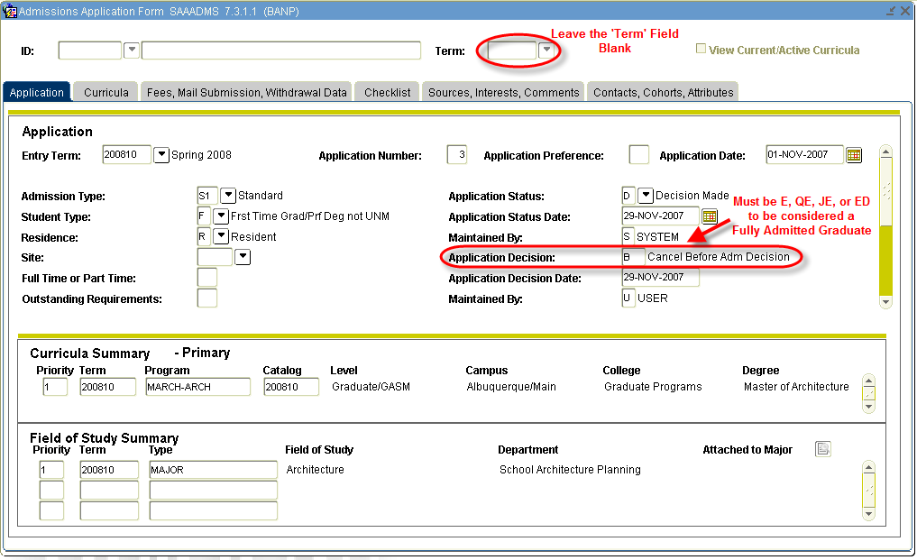
Figure 1 – Admissions Application Form SAAADMS

Step 3 - Scroll Down to prior Admissions Application, verify that ‘Entry Term’ and ‘Application Number’ change.

Step 4 - Verify ‘Application Decision’ is equal to E, QE, JE, or ED (if it is not, continue to Scroll Down to view other Admission Applications). Please refer to Figure 2.

Step 5 - Take note of College and Degree. Please refer to Figure 2.
Note - College MUST be “Graduate Programs”, “Law”, or “Med School”.

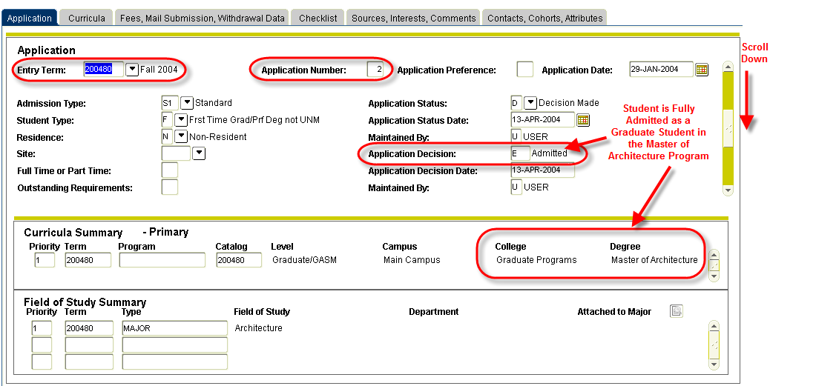
Figure 2 – Application

Step 6 - Exit SAAADMS.

Form 2 – RSIDEGR

Step 1 - Go to RSIDEGR and verify student has not received degree associated with Admissions Application. Please refer to Figure 3.

(In this example, the student should not have received his Master of Architecture degree)
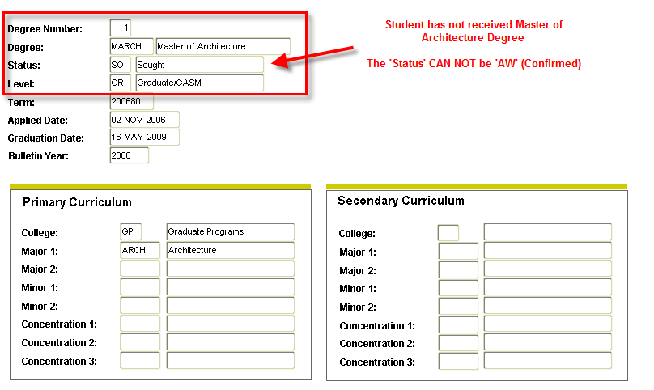
Figure 3 – RESIDEGR

Step 2 - Exit RSIDEGR.

Form 3 - RRAAREQ

Step 1 - Go to RRAAREQ. Perform Next Block. You have now confirmed that the student has been Fully Admitted into a Graduate Program and the student has not yet completed the program.

Step 2 - Identify GADMIT Tracking requirement Code and update status to “C”.

Step 3 - Save (F10) and exit form.

Form 4 – RHACOMM

Step 1 - Go to RHACOMM.

Step 2 - Perform Next Block.

Step 3 - Leave message in the following format:
GADMIT – STUDENT FULLY ADMITTED INTO GRADUATE PROGRAM FOR 200XXX. PURSUING MASTER OF ARCHETECTURE DEGREE. COMPLETED GADMIT ON RRAAREQ.

Step 4 – Save (F10) and exit form.

* * * E N D * * *

