Student Financial Aid

FATRK-110 Pushed ISIR Processing

Date Issued/Rev: 04/04/2008
General Description: This procedure explains how to access, evaluate and process pushed ISIRs.
Responsible Manager: Financial Aid Director
Related References:
Related Procedures: Job Aid-Pushed ISIR RRAAREQ Codes.xls
Related Forms: Access to Pushed ISIR report on eprint.unm.edu
Report Name RZROPSR
Access to CPS
Used to Compare ISIR transactions
RRAAREQ
RHACOMM
RNANAxx
RNAOVxx
ROAMESG

NOTE: Pushed ISIRs with no EFC calculation are not be made current.
Do not make ISIRs with a change in Marital Status current

PROCEDURE
- Access RZROPSR report on Eprint.
  - Eprint can be accessed at the following web address
eprint.unm.edu
- Access Financial Aid reports by selecting
stu_banp – Student/Fin Aid Banner – Production (banp) 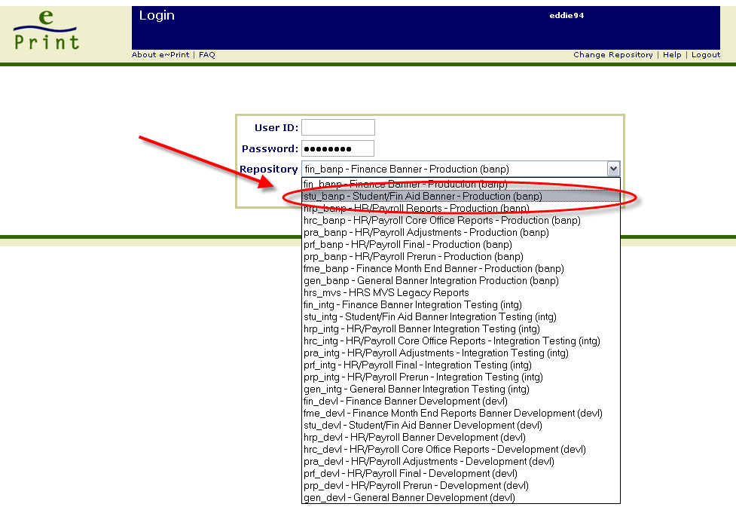
- Select RZROPSR from the report selection menu
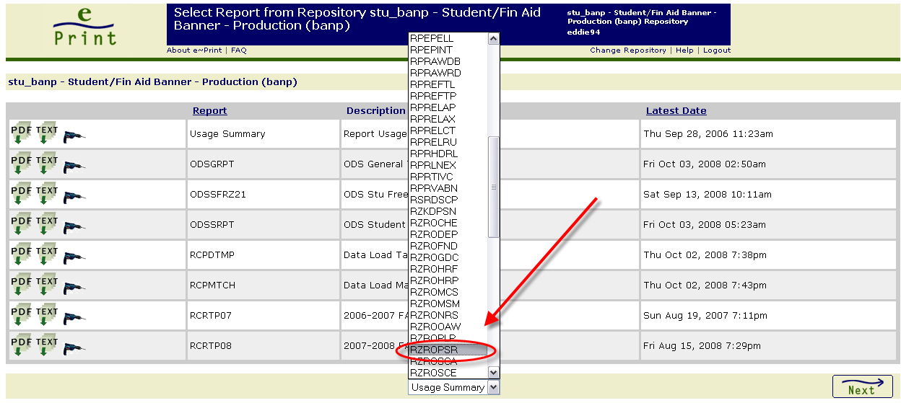
- Select the “PDF” icon for the most recent Pushed ISIR report. Select the “Drill” icon for older reports
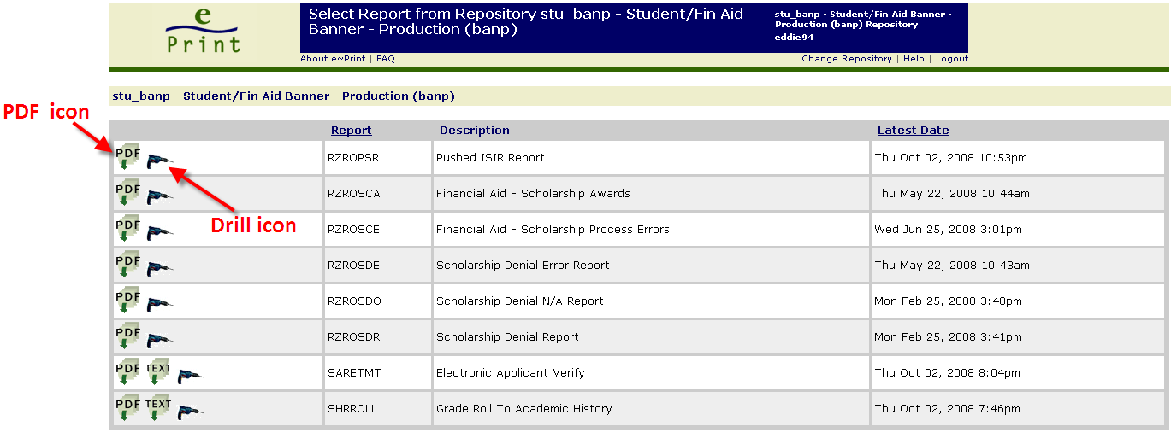
- The report is sorted by branch in Alphabetical Order. The report looks as follows:
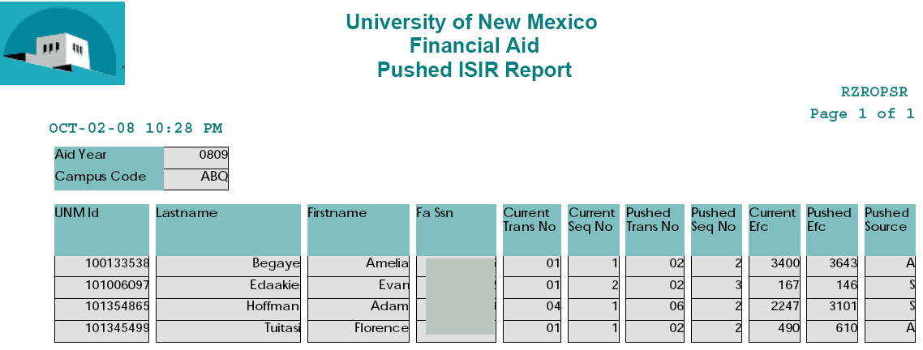
- Access CPS to compare the ‘Current Transaction’ and the ‘Pushed Transaction’
  - CPS can be assed at the following web address:
http://www.fafsa.ed.gov/FOTWWebApp/faa/faa.jsp
UNM’s TG Number is 51495
UNM’s School Code is 002663
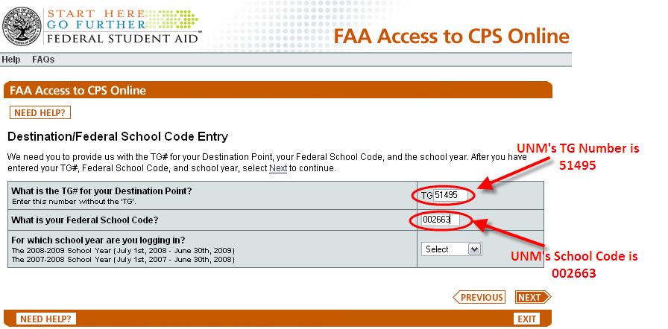
- Once CPS is accessed, enter student data and select the aid year to review.
- Compare the ‘Current ISIR’ and the ‘Pushed ISIR’

* * * E N D * * *

