BANNER ACG

An eligible student may receive an Academic Competitiveness Grant (ACG) of up to
$750 for the first academic year of study and up to $1,300 for the second academic
year of study. To be eligible for each academic year, a student must:

- Be a U.S. citizen;
- Be a Federal Pell Grant recipient;
- Be enrolled full-time in a degree program;
- Be enrolled in the first or second academic year of his or her program of study at a two-year or four-year degree-granting institution;
- Have completed a rigorous secondary school program of study (after January 1, 2006, if a first-year student, and after January 1, 2005, if a second-year student);
- If a first-year student, not have been previously enrolled in an undergraduate program; and
- If a second-year student, have at least a cumulative 3.0 grade point average on a 4.0 scale (as set forth in regulations to be promulgated soon) for the first academic year.

New Comment Codes for Potential ACG Recipients:

268 You reported that you completed a rigorous high school program or state scholars
program that may qualify you for an Academic Competitiveness Grant (ACG)

269 You reported that you completed two or more Advanced Placement (AP) courses or two
or more International Baccalaureate (IB) courses and achieved a score on the exams

270 You reported that you took and passed a series of high school courses that may qualify
you for an Academic Competitiveness Grant (ACG).

271 The Financial Aid Administrator at your college will determine if you are eligible for
an ACG. All follow-up information about your grant eligibility will come from the financial aid office at your college.

Process:
- Population Selection to all students with these comment codes
- Batch Post ‘PENDING’ to ROAUSDF line #2 (“ACG Eligible”)
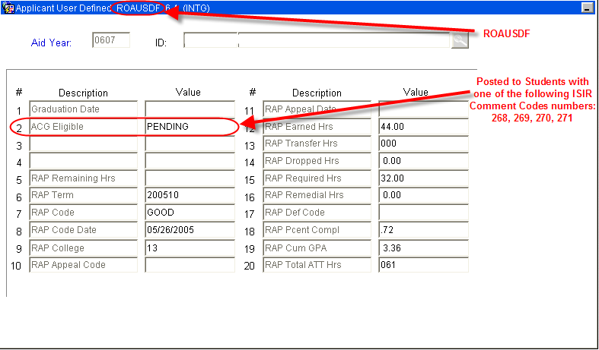

- Pell Eligibility - verified against RPAAWRD. Students must have a Pell award greater than 0.
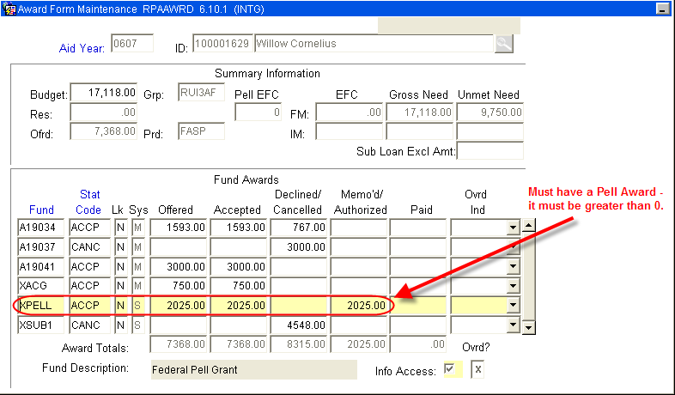

- US Citizen - verified on RNANA07 (if no code exists on RNANA07, Citizenship is verified on the 3rd block of RNARSLT).
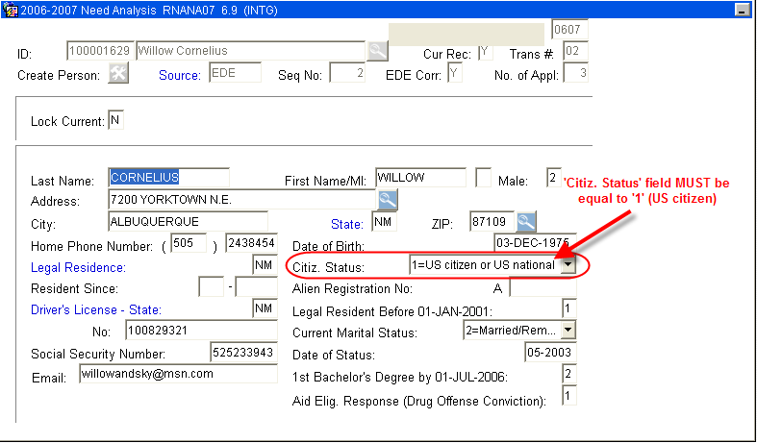
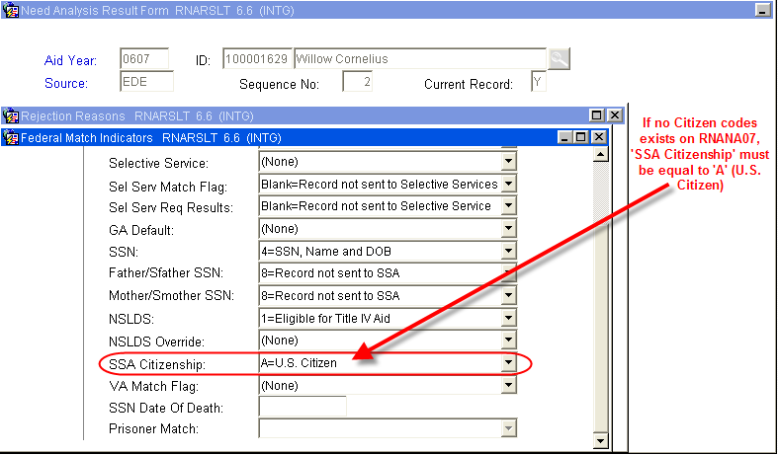
(I can not see any reason that there would not be a code on RNANA07)

- Year in College - verified on the 2nd block of RNANA07
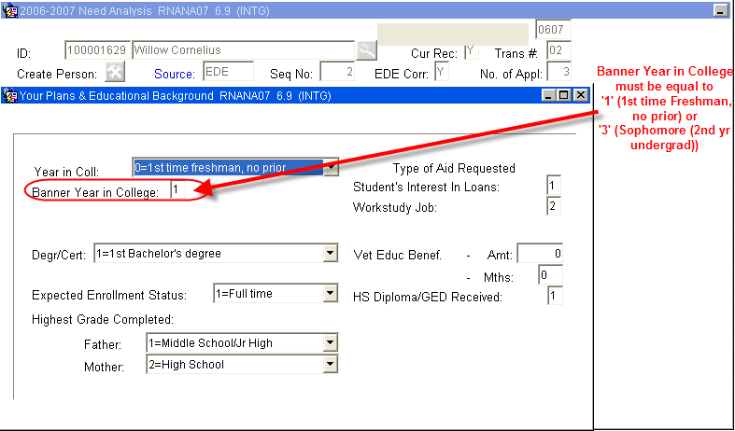
NOTE: RNANA07 Banner Year in College must be ‘1’ or ‘3’
Can not be ‘2’ (Freshman, prior college)

There is a Year in College Override on RPAAWRD (this override will report to COD):
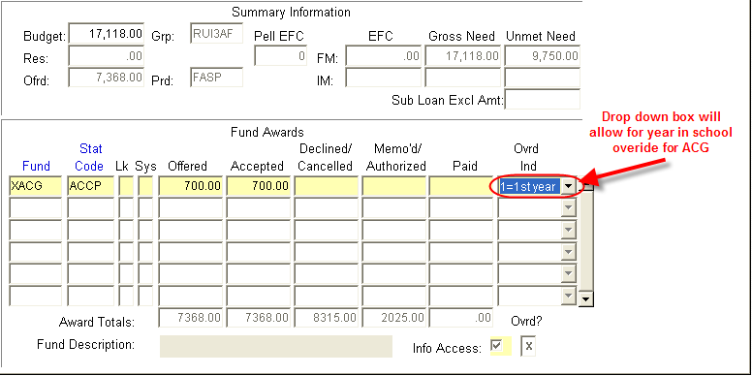

- Rigorous High School Program - verified on ROAHSDT
- Two AP (Advanced Placement) or IB (International Baccalaureate) courses in high school with a minimum passing score of 3 or 4 respectively
- State Scholars Initiatives requirements or a set of courses similar to the State Scholars Initiative.
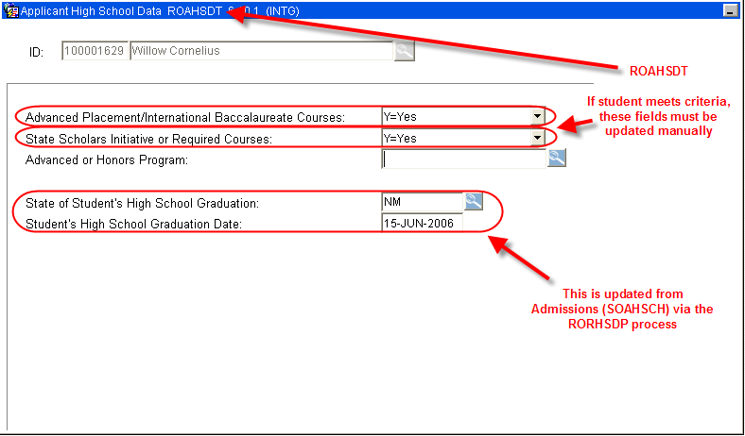
NOTE: New Mexico does not participate in an Advanced or Honors Program (these programs are different from AP or College Bound)

- Full-Time Enrollment - verified by disbursement process on ROAENRL
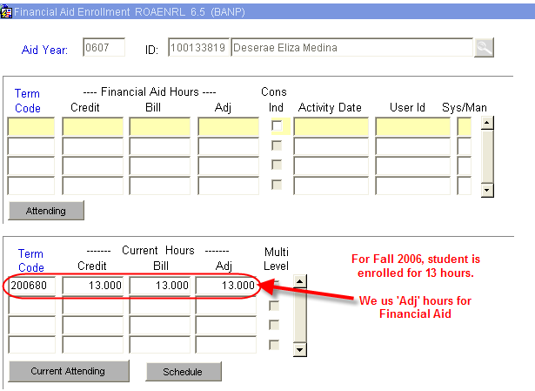

- Enrolled in an eligible 2 year or 4 year program - verified on SGASTDN
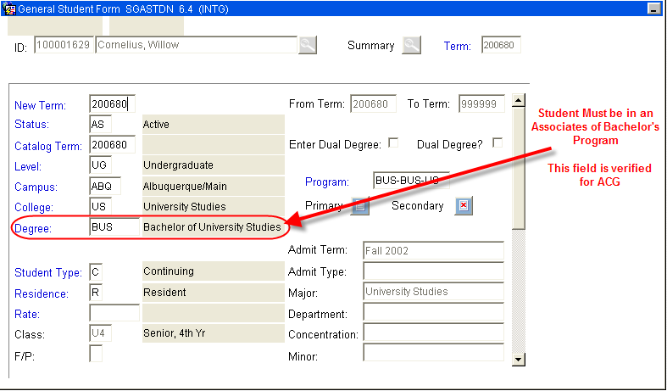

- Verify College GPA (for students between 24 and 48 hours) -
Fund Rule will need to be written to prevent awarding and disbursement.
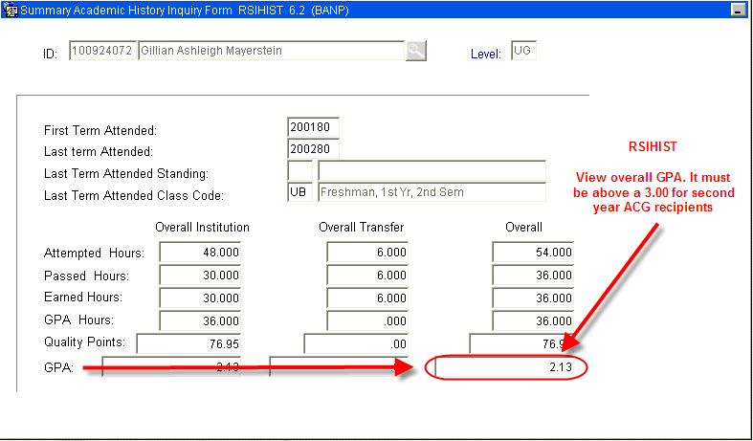

- Award made and Disbursed - RPAAWRD
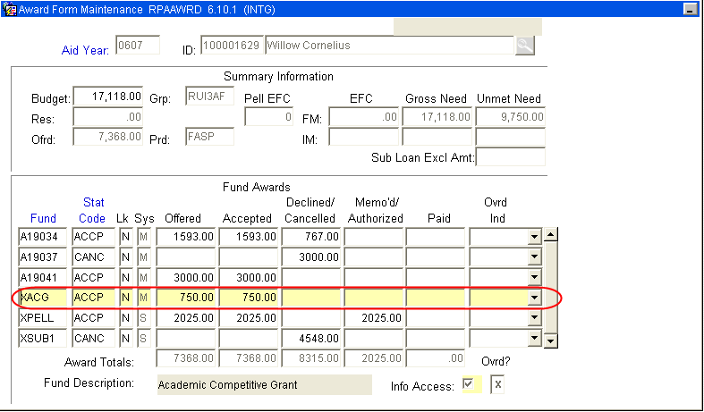

- ROAUSDF Updated via Batch Post:
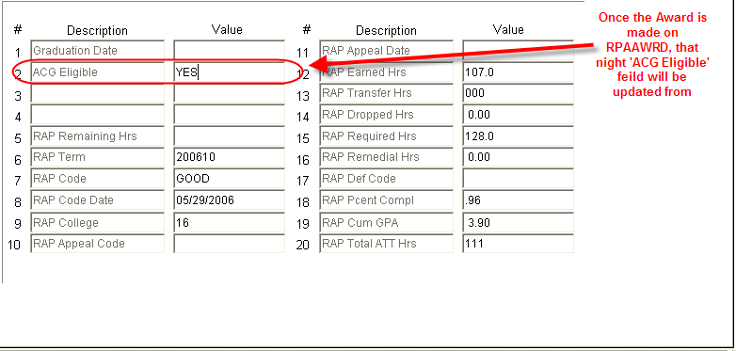

Questions:

Do we want a GPA Awarding and Disbursement rule? Meaning, we can only award and disburse to students with a 3.00 and higher.
If so, at what hours earned do we count GPA? I would suggest after 12.

Do we want two fund codes - one per level? XACG1 for students between 0 and 24 hours and XACG2 for students between 25 and 48 hours

If we award for the year, are we monitoring GPA by semester (similar to Lottery) - a disbursement rule would monitor by semester.

