Student Financial Aid

FA-206 Processing an External Award Letter

Date Issued/Rev: 6/25/2008
General Description: This procedure explains how to award an estimate from an external award letter.
Responsible Manager: Financial Aid Director
Related Procedures:
Related Forms: RRAAREQ
RPAAWRD

PROCEDURE

Step 1 - Verify external award letter for the following items:
  - The student who is issued the award.
  - The amount of the award.
  - The year for which the award is made.
  - The term (i.e. Fall, Spring, Summer)

Step 2 - Access RRAAREQ

Step 3 - Perform ‘Next Block’ twice - to the ‘Non-Coded Requirements’ Block

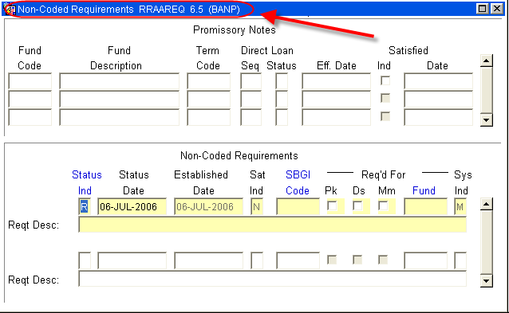

Step 4 - Log the Award Letter in the ‘Non-Coded requirements” portion of the form and note the following:
a. Always enter “C” (for “complete” in the ‘Status Ind’ field b. Tab to the ‘Fund’ Field’ enter the fund code that you are using for awarding.
- For a list of values (F9), double click in the Fund field to search for a “Fund Code”
NOTE: When searching for an Estimate try %Est% or:
NOTE: Most Estimates will be A22006 “Estimated Ext Scholatship”
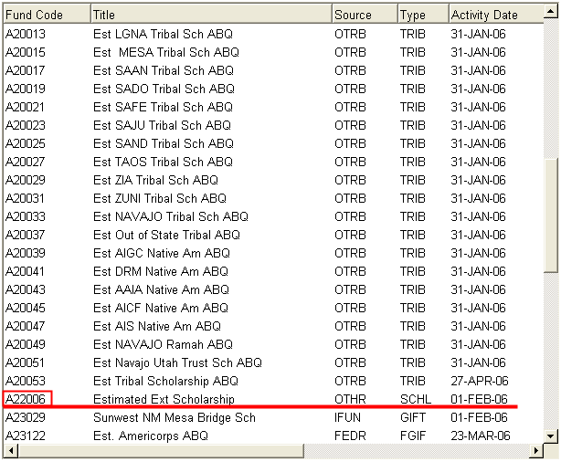

Step 5 - Tab (once) to the ‘Reqt Desc’ field and enter information about the award once the Fund has been entered.
NOTE: there are only 60 spaces to use, try to provide as much information in as little space as possible.

Step 6 – Verify the following:
a. The Source of the Award
b. The Term of the award (i.e. fall only $1000, fall/spg $1000 per semester)
c. And that an Estimate was placed on RRAAREQ - “EST RRAAREQ”

Step 7 - ‘Save’

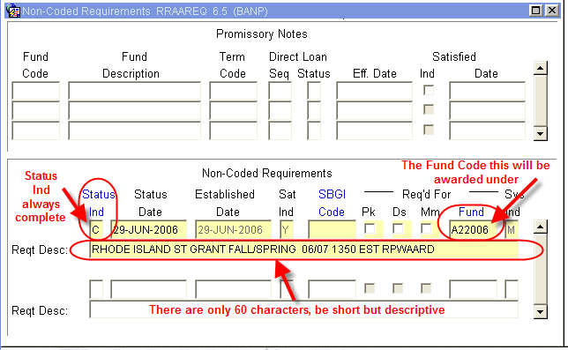

Step 8 - Access RPAAWRD and award the Estimate with the Fund Code placed on RRAAREQ.

Step 9 - Save
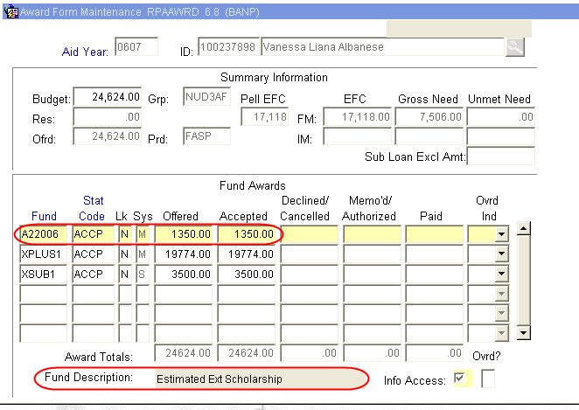

Step 10 - Verify estimate does not create an Over Award. If Over Award is created, follow the procedure for correcting Over Award.

Step 11 - Suppress the award letter if there is no Over Award. Otherwise an award letter will be sent.

~ Fin ~

