Student Financial Aid

FA-209 PROCEDURE to Process a Tribal Check
For Officers

Date Issued/Rev: 06/27/08
General Description: This procedure explains how to process a Tribal Check.
Responsible Manager: Financial Aid Director
Related Procedures:
Related Forms: RRAAREQ
ROAMESG
ROASTAT
ROAENRL
SGASTDN
RHACOMM

PROCEDURE

Step 1 - Confirm Check Log and Student Eligibility.
Step 2 - Access RRAAREQ - Check Log. Please refer to Figure 1.

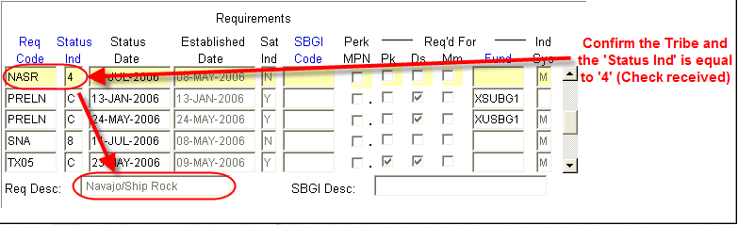
Figure 1 – Check Log

Step 3 - Confirm certification in next block on form RRAAREQ. Please refer to Figure 2.

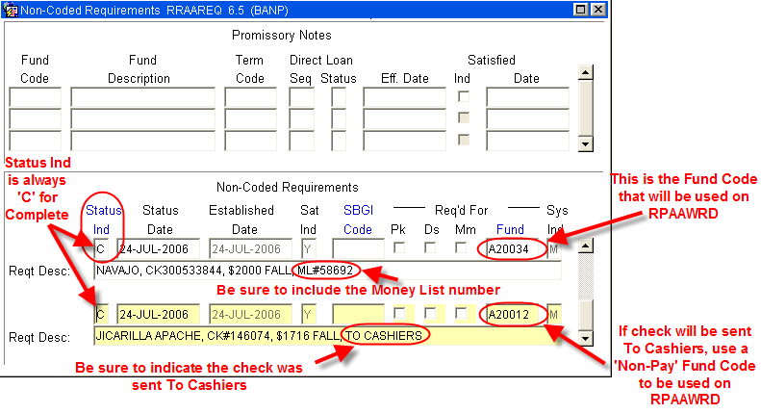
Figure 2 – RRAAREQ Form

Step 4 - Access RPAAWRD and confirm Estimate Award. Please refer to Figure 3.

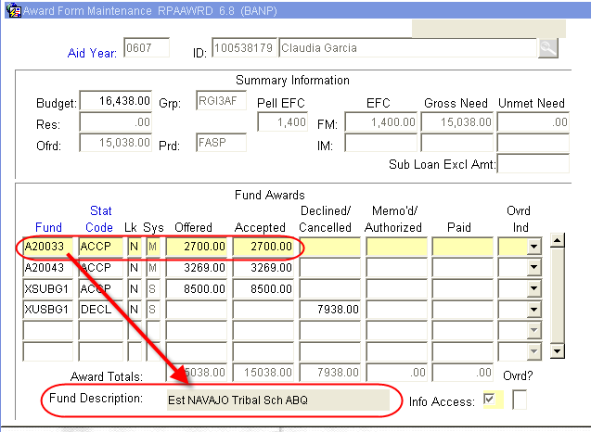
Figure 3 – RPAAWRD Form

Step 5 - Access ROAENRL and confirm enrollment. Please refer to Figure 4.

Please note - If the student is enrolled less than full-time: contract Tribe to confirm fund eligibility on a less than full-time status.
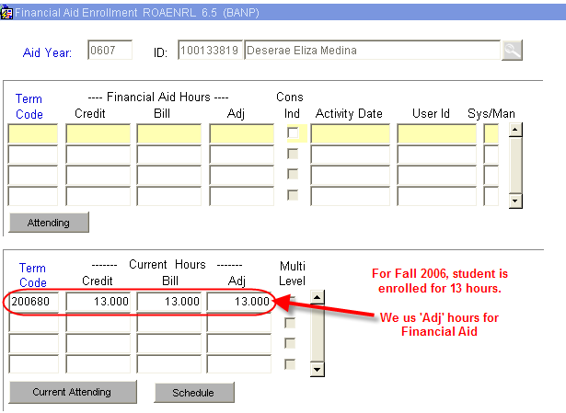
Figure 4 – ROAENRL Form

Step 6 - Access ROASTAT, and verify SAP status on second block. Please refer to Figure 5.

Please note - If Student is NOT Meeting Satisfactory Academic Progress: contract Tribe to confirm fund eligibility based on current SAP status.

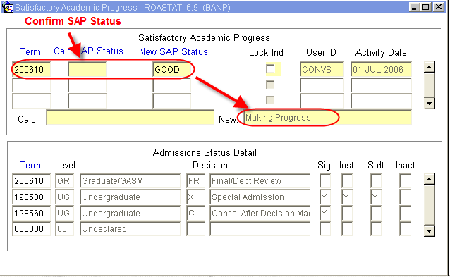
Figure 5 – ROASTAT Form

Step 7 - Access RPAAWRD. Please refer to Figure 6.

Figure 6 – RPAAWRD Form

Step 8 - Adjust estimate as needed.

Step 9 - Create award using Fund Code written on Check Stub (Also found on the second block of RRAAREQ).

Please note - If over award is created, follow over award reduction procedure.

Step 10 - Access RHACOMM:

Step 11 - Leave note with the following information and in the following format:
        - Term of Award
        - Award Letter Received
        - Tribe/Organization
        - Indicate Estimate on RPAAWRD
        - Awaiting Check from Tribe/Organization

Please note – It is suggested practice to use the following example on RHACOMM:

FALL AWARD LETTER RECEIVED FROM NAVAJO NATION. EST. ON RPAAWRD. CHECK FORTHCOMING FROM NAVAJO NATION.

~ Fin ~

