Student Financial Aid

FAPK-123 Awarding Pell Automatically

Date Issued/Rev: 06/30/08
General Description: This procedure explains how to
Responsible Manager: Director of Financial Aid
Related Forms:
ROAIMMP Applicant Immediate Process Form

PROCEDURE
Step 1 - Go to ROAIMMP.

Step 2 - Type the student’s UNM identification number.

Step 3 - Select “Next Block”

Step 4 - Click the box next to Immediate Pell Calculate for Immediate Pell Calculation.
Please refer to Figure 1.

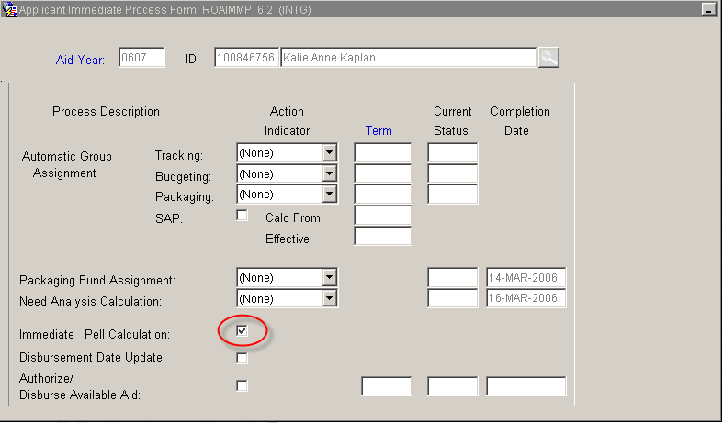
Figure 1 – Immediate Pell Calculation

Step 5 - Select “Save”
Step 6 - Select “Exit”
* * * E N D * * *

