 | Student Financial Aid
 | FAPK-108 Package a Fund Manually | Date revised/updated: 6/25/08
General Description:
This procedure explains how to package a fund manually.
Responsible Manager: Director of Financial Aid.
Related Forms:
RPAAWRD Award Maintenance
The procedure begins on the next page.

PROCEDURE

Step 1 - Type RPAAWRD and press ENTER from the direct access field of the main menu. Do NOT click on the magnifying glass.

Step 2 - Type the student’s Banner identification number. ID is required.

Step 3 – Verify the correct student is found.
  - If yes, continue.
  - If not, go to UNM-100 or use on-line search tools and locate correct student.

Step 4 - Select “Next Block”

Step 5 - Choose next action:

- If the student has not already been offered funds, the cursor displays in a blank row when the form is accessed.
- If not, move the cursor to a row and select “Insert Record.”

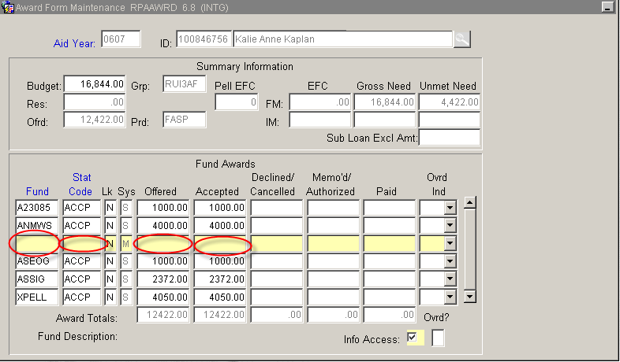

Step 6 - Type the fund code or click in the field to select from the pop-up window. The fund code is required.

Step 7 - Move to Award Status by using the “Tab” or “Enter” key.

Step 8 - Type the code for the fund being offered or click on STAT CODE to display the status codes. Highlight the selection and click on “Select.” The award status is required.

Step 9 - Enter the amount of the fund being offered. NOTE: Decimals and commas are not needed. The offer amount is required
.
Step 10 - Accept amount, conditions may apply, see below:
  - If the student has accepted the fund, or it has been auto-accepted by Banner, no entry required. Auto populates when saved.
  - If not, enter the amount accepted.

Step 11 - Select “Save.”

Step 12 - Select “Auto Help.”

Step 13 - Save, when saved the award validation process starts and verifies that the student meets the eligibility requirements for the fund(s). If the student is not eligible to receive a fund, a message displays in the gray Auto Help bar stating why the student is ineligible. Delete this fund from the student’s awards (Use the Remove Record function or the tool bar button).

Step 14 – Add, to add more funds to a package return to step 1. Move to Step 15 when all funds are added.

Step 15 - Select “Exit” if done with adding funds.

* * * E N D * * *

