- Overall Status of Your Financial Aid
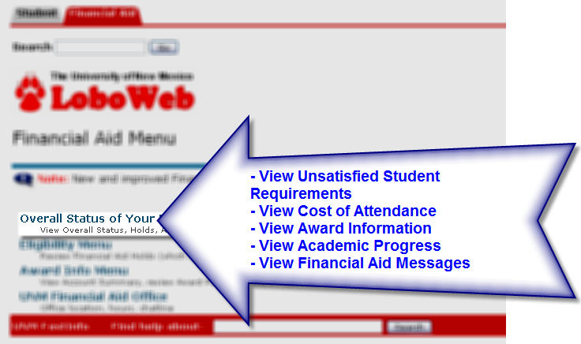
__________________________________________________________________________________________
- Eligibility Menu
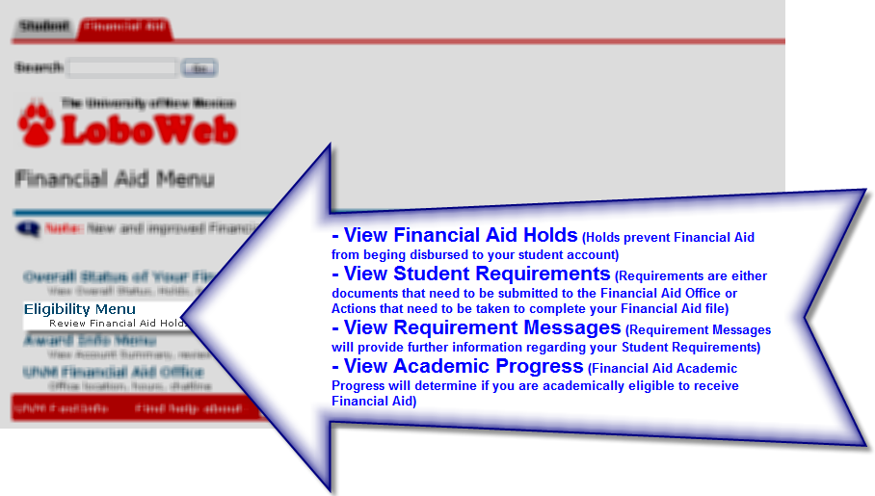
- Award Info Menu
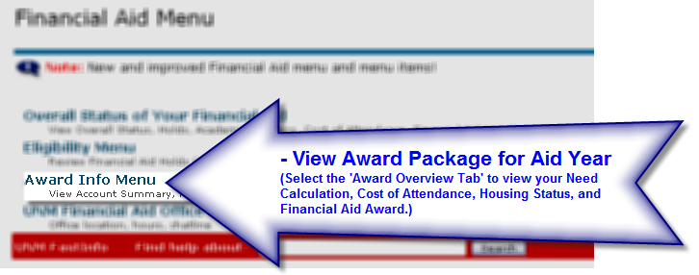
__________________________________________________________________________________________
- Award Overview Tab
