 | LINK Financial Aid | 

FALN-106 Loan Adjustment

Date Issued/Rev: 11/03//05
General Description: This procedure explains how to adjust a loan after it has been guaranteed, but before funds have arrived for disbursement.
Responsible Manager:
Related Procedures: FAPK-109 Change the Offered Amount of a Fund
FAPK-112 Changing the Term Distribution of a Fund
Related Forms: RPAAWRD
RPAELAP

1. Go to RPAAWRD
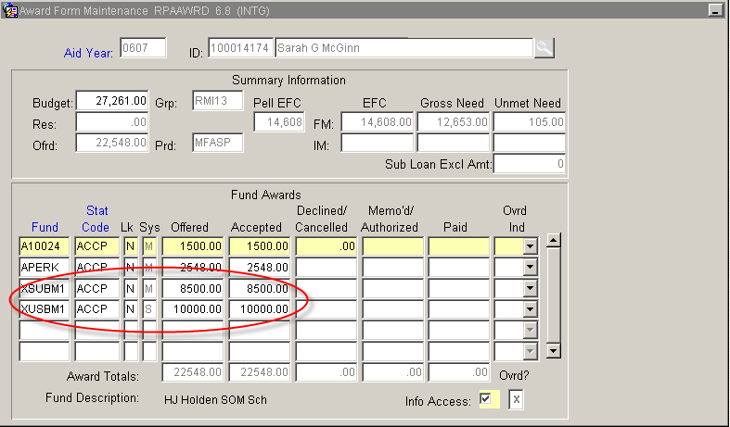
2. Adjust loan for dollar amount, and/or term distribution (See FAPK-109 and FAPK-112 for instructions specific to these tasks.)
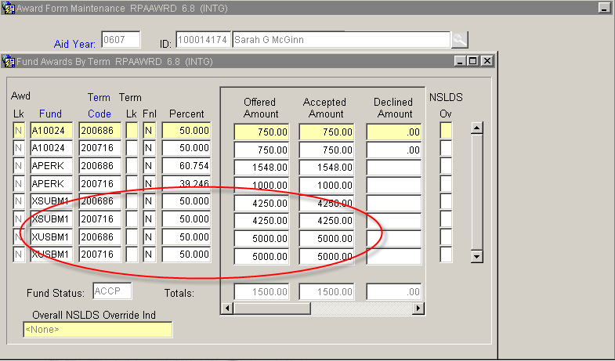
3. Save and Exit
4. Go to RPAELAP
5. Perform Next Block function
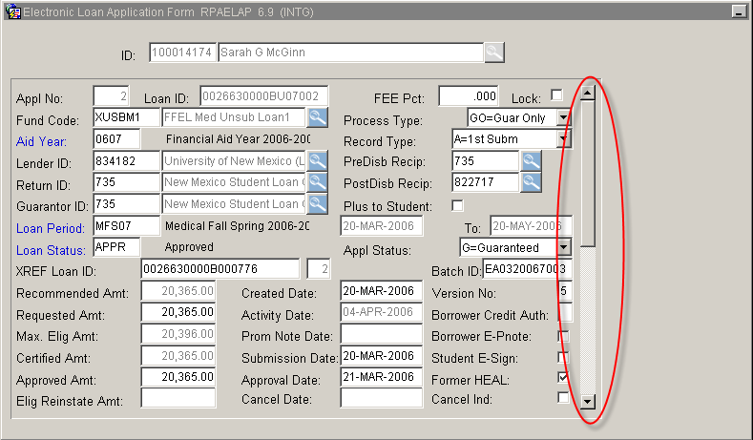
6. Use the scroll bar to find the loan(s) you want to adjust
7. Perform “Next Block” function five times to get to the Disbursement Schedule block.
8. To reduce a loan amount:
a. Click in the REVISED GROSS AMT field.
b. Enter the revised amount for the term.
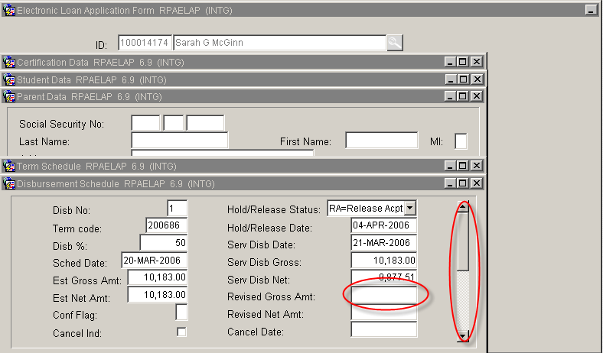
c. To adjust additional terms for the same loan – use scroll bar to get to other terms.
d. Save and Exit
9. To cancel a loan disbursement:
a. Click in the CANCEL IND field
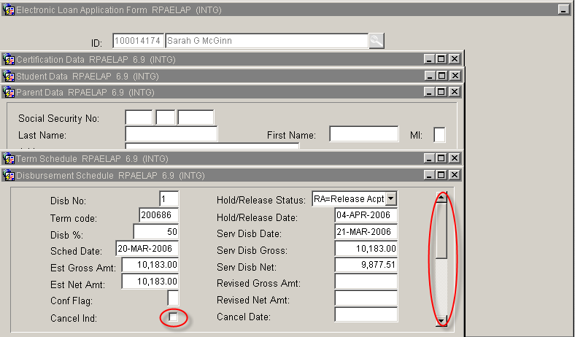
b. To adjust additional terms for the same loan – use scroll bar to get to other terms.
c. Save and Exit

*** END ***

