Student Financial Aid

FALN - 107 Changing Lender from Default Lender

Date Issued/Rev: 9/24/07
General Description: This procedure explains how to change the default lender to another lender for a FFELP loan.
Responsible Manager: Financial Aid Director
Related Procedures: FAPK-108 Package a Fund - Manually
Related Forms:
RPAAWRD
RPAELAP

Lender codes set up in system:
Lender | Banner Lender ID
Bank of America | 824421
Citibank | 826878
NMSL (Undergraduate Only) | 822717
Sallie Mae | 802218
UNM as Lender (Graduate Students Only) | 834182
Wells Fargo | 807176

If you have any lender that you need to use – we will need to set them up. Let your manager know, if you have the need for this.

1. Award loan on RPAAWRD (see FAPK-108)
2. Go to OPTIONS and select CREATE LOAN APPLICATION
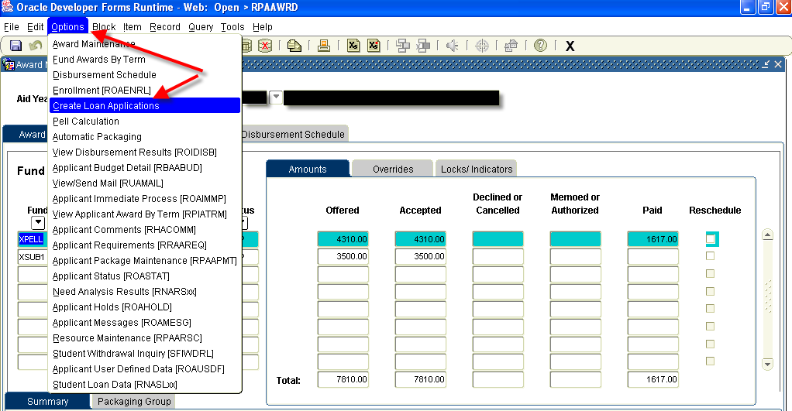
3. This will open RPAELAP

4. Go to LENDER ID and RETURN ID field and enter the new lender code in each space
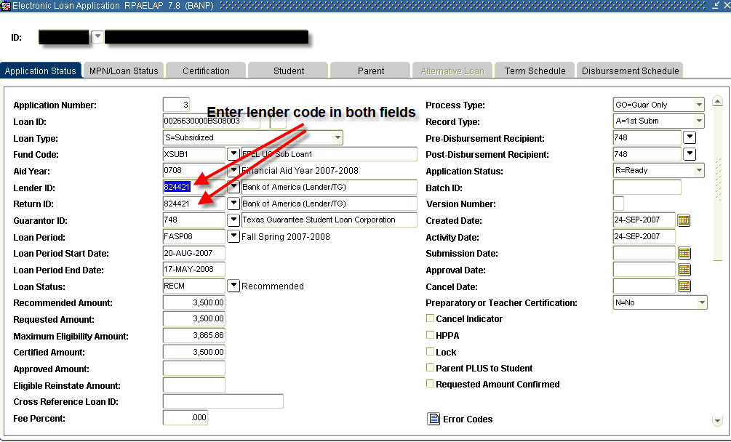
5. Save
6. Access RRAAREQ – IF there is a request for ‘Lender’ update Status to ‘C’ (Complete) – this will satisfy the request and remove it from LoboWeb.
7. Save
* * * E N D * * *

