Student Financial Aid

FALN – 111 Cancel One Term of a Loan and Increase Another

Date Issued/Rev: 7/01/08
General Description: This procedure explains how to cancel one term of a loan, and then increasing another term for the same loan. This can only be performed on a GUARANTEED LOAN.
Responsible Manager: Financial Aid Director
Related Procedures: FAPK – 109 Change the Offered Amount of a Fund
FAPK – 112 Change the Term Distribution of a Fund
Related Forms:
RPAAWRD
RPAELAP

NOTE: This action can only be performed on a GUARANTEED LOAN.

PROCEDURE

NOTE: The first two steps are covered in FAPK – 109 and FAPK – 112. For details, please refer to these SOPs.

Step 1 - Go to RPAAWRD.

Step 2 - Adjust the loan.

Step 3 – Go to RPAELAP.

Step 4 - Go to Term Schedule block for loan you want to adjust. Please refer to Figure 1.

Step 5 - Change the LOAN PERCENT.

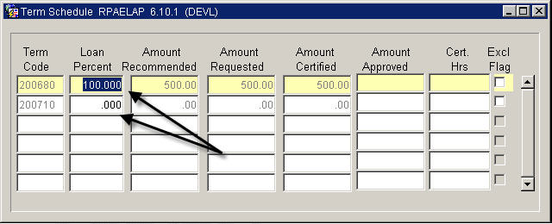
Figure 1 – RPAELAP Form

Step 6 - SAVE

Step 7 - Go to the Disbursement Schedule block. Please refer to Figure 2.

Step 8 – Change the DISB % for all applicable terms. Please refer to Figure 2 and Figure 3.

NOTE: DO NOT SAVE until you have made all DISB% adjustments.

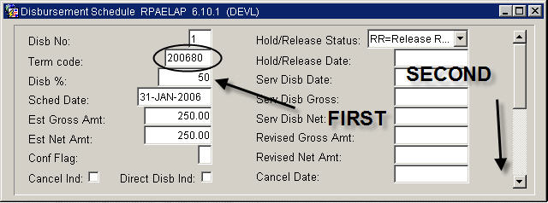
Figure 2 – Disbursement Schedule in RPAELAP Form

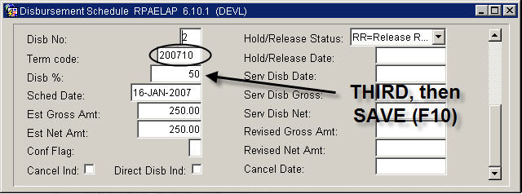
Figure 3 – Disbursement Schedule in RPAELAP Form

Step 9 - SAVE

Step 10 - Go to the term you want to cancel.

Step 11 - Check the CANCEL IND. Please refer to Figure 4.

NOTE: The CANCEL DATE will auto-populate.

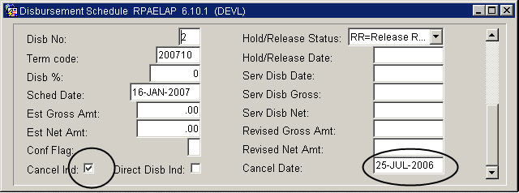
Figure 4 – Disbursement Schedule RPAELAP

Step 12 - SAVE
Step 13 - Adjust REVISED GROSS AMT on terms you want to increase. Please refer to Figure 5.

NOTE: You do not have to enter the zero for the term you canceled – the cancel indicator will do it automatically.

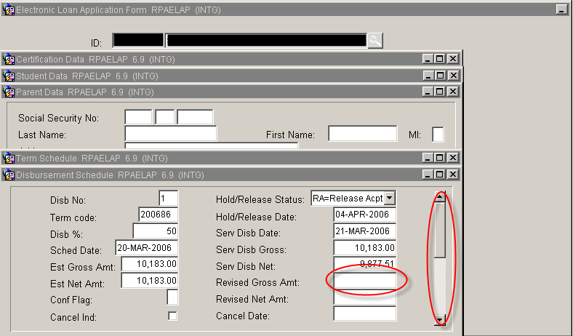
Figure 5 – Disbursement Schedule RPARLAP

Step 14 - SAVE
* * * E N D * * *

