Student Financial Aid

FALN 112 – Returning Funds for Non-Disbursed FFELP Loans

Date Issued/Rev: 02/07/07
General Description: This procedure explains how to return loan funds for a loan when we have received the funds, but it has not yet disbursed.
Responsible Manager: Financial Aid Director
Related Procedures:
Related Forms: RPALDSB
RPAAWRD
ROAIMMP
ROIDISB

PROCEDURE
Procedure:
1. Go to RPALDSB, perform next block.
2. Go to the loan and term for which you want to make the adjustment. The feed indicator will be set to ‘Y’ for any undisbursed loan that we have funds for.
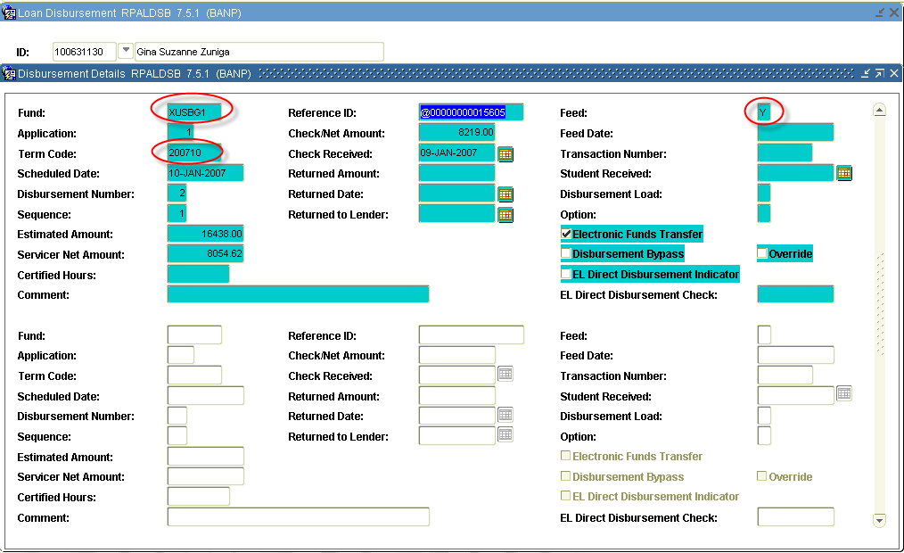

3. Enter the (1) returned amount, and (2) reason for the return. The (3) date will autopopulate.
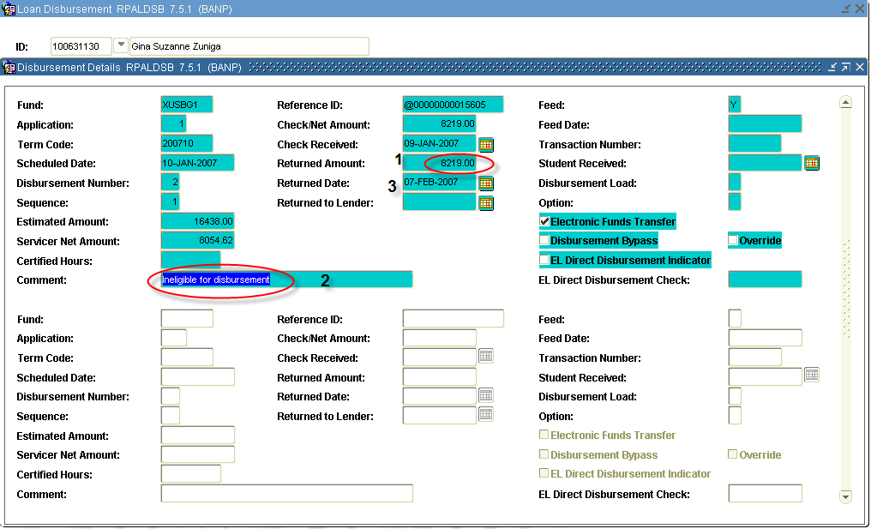
4. Save the record.
5. Go to ROAIMMP.
6. Run disbursement for the term you are adjusting.

7. Go to RPALDSB to verify that the transaction went through. (Note: You DO NOT need to do this if the fund is to be fully returned. You will only need to do this if you are returning a portion of the funds.) The feed indicator will be ‘F’, if the transaction processed.
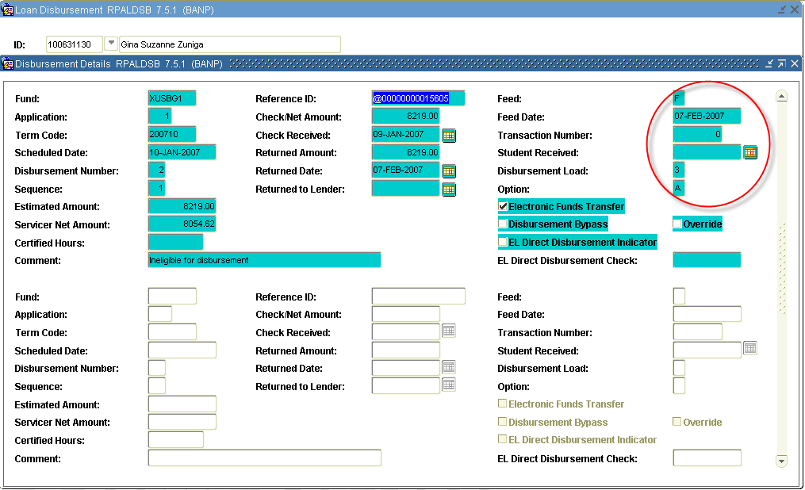
8. If the transaction did not go through, go to ROIDISB, for the term in question, to determine the reason.

* * * E N D * * *

