Student Financial Aid

FALN 117 – Hold and Release Processing

Date Issued/Rev: 09/24/07
General Description: This explains how Hold and Release processing works.
Responsible Manager: Financial Aid Director
Related Procedures: NA
Related Forms: RPAELAP
ROIDISB

- FFELP loans are sent in a HOLD REQUESTED status (Disbursement Schedule of RPAELAP).
NOTE: Currently, we are sending Texas Guarantee lender loans (Bank of America, Citibank, Wells Fargo) in RELEASE REQUESTED status.
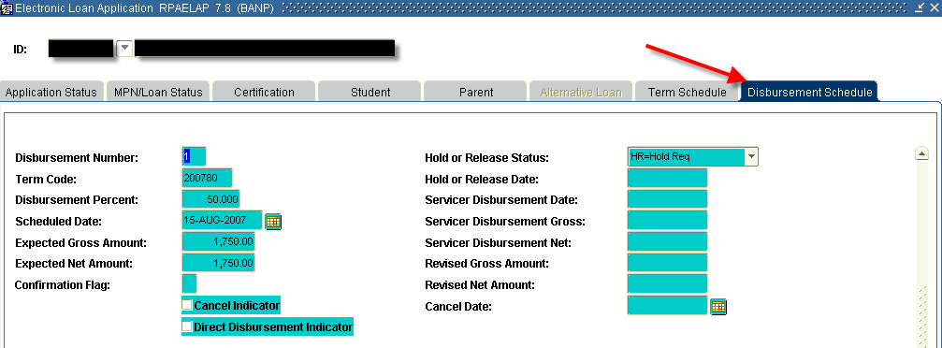
- When creating (only when creating) a loan application, you can change the status from HOLD REQUESTED to RELEASE REQUESTED, if you want the loan sent to the lender/guarantor in a release status.
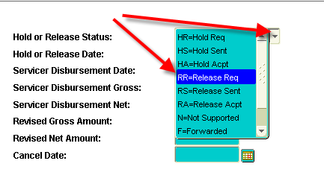

- We receive a response file within 24 hours. The response file updates the Hold/Release status. If we send the loan in a HOLD REQUESTED status, we will receive a HOLD ACCEPTED response. (We would receive a RELEASE ACCEPTED response if we sent it in RELEASE REQUESTED status.)
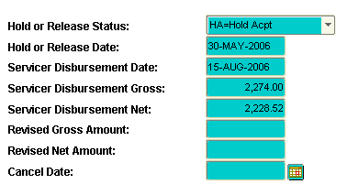
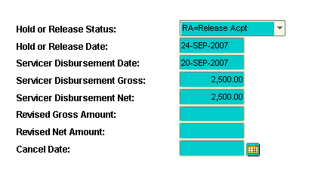

4. Nightly, the system reviews all loans in a HOLD ACCEPTED status. If there are no reject codes on ROIDISB for the loan type, and the date of disbursement has arrived, a RELEASE SENT status will appear on the loan. The response file updates the status to RELEASE ACCEPTED, within 24 hours. (Generally, for NMSL/UNM as Lender loans, the funds will arrive in the afternoon on the same day the release was sent.)
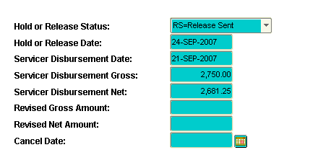

* * * E N D * * *

