
Student Financial Aid
FALN 123 – Uploading EFT files to Banner
Date Issued/Rev: 1/3/08

General Description: This explains how you will upload all of the EFT files that we receive to Banner each morning and afternoon. You will do this after downloading and saving them onto your desktop from the AES School Portal.

Responsible Manager: Financial Aid Director

Related Procedures: N/A

Related Forms: N/A

1. You must first log on to https://www5.unm.edu/pls/unm/gzvupld.home with your UNM USER ID and PASSWORD. This will log you in to the Banner Data Upload/Download site.

2. On the main page you want to select “Upload Files” from the menu on the top left corner of the page.

3. You will now be taken to a page where the menu below will appear. To upload an EFT file, click FINAID_LOAN_EFT_ROSTER_UPLOAD.

Type of File to Upload | Description | Log
FINAID_0607_DATALOADS | Finaid dataload directory for 0607 EDE daily files | Log
FINAID_0708_DATALOADS | Finaid Daily 0708 EDE file loads | Log
FINAID_LOAN_EFT_ROSTER_UPLOAD | Use to upload roster files (clreout.xxx) from cmweb.pheaa.org to Banner Financial Aid Directory for Processing | Log
FINAID_LOAN_FILES_TO_UPLOAD | Files downloaded from cmweb.pheaa.org to be uploaded for processing in Banner INB | Log
FINAID_LOAN_RESP_FILES_TO_UPLOAD | Response files downloaded from cmweb.pheaa.org to be uploaded for processing in Banner INB | Log
SAR_BOOKSTORE_FEED | SAR Bookstore Feed Upload | Log
SAR_BURSAR_FEED | SAR Bursar Feed Upload | Log
SAR_COLLECTIONS | SAR Assign Banner ID to Collection Agency | Log
SAR_GALLUP_BOOKSTORE_FEED | SAR Gallup Bookstore Feed Upload | Log
SAR_HOUSING_FEED | SAR Housing Feed Upload | Log
SAR_PARKING_FEED | SAR Parking Feed Upload | Log
SAR_STUDENT_HEALTH_CENTER_FEED | SAR Student Health Center Feed Upload | Log
SAR_TSRCBIL_UPLOAD | UPLOAD SPLIT TSRCBIL .LIS FILE | Log
SAR_VALENCIA_BOOKSTORE_FEED | SAR Valencia Bookstore Feed Update | Log

4. Click on the BROWSE button to find the EFT file you are uploading to Banner. Select the file and click OPEN.

5. When the file name appears in the field next to the BROWSE button hit SUBMIT.

6. Next you will log onto Banner and go to RPREFTL
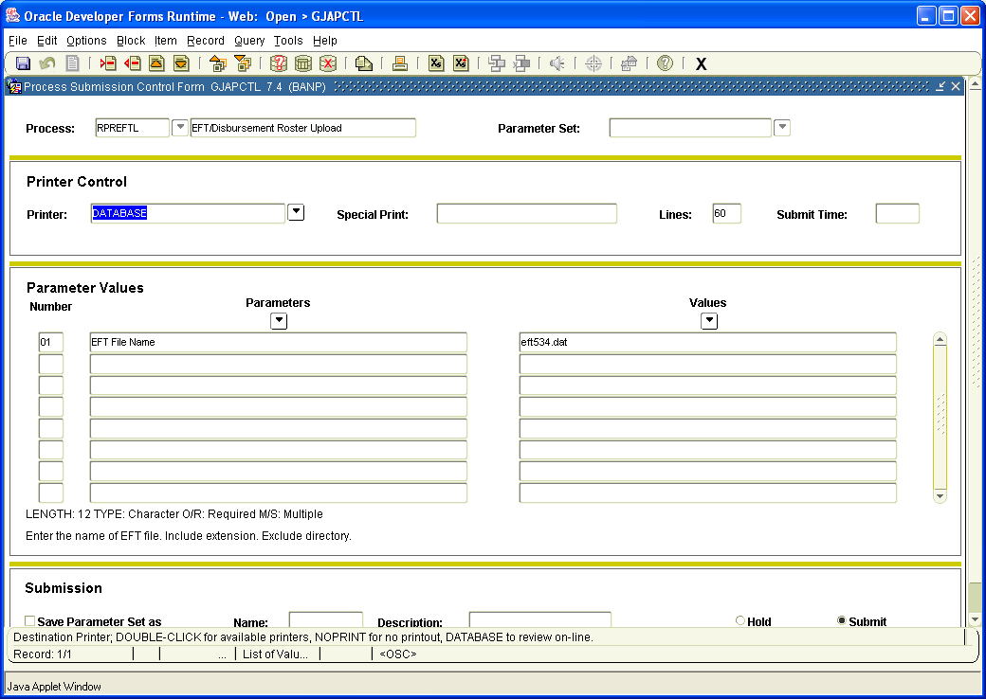

7. Next block once and then place your cursor in the first box of the VALUES field (the eft###.dat will be highlighted). You will need to update the number so that it matches the EFT file you just downloaded (if “eft534.dat” is currently showing, you will more then likely update it to “eft535.dat”).

8. Next you will click in the box next to “Save Parameter Set as” which appears in the bottom left corner of the screen. Once this is done hit SAVE or F10.

9.

