Student Financial Aid

FALN 124 – ESBS Instructions

Date Issued/Rev: 03/14/07
General Description: This explains how to update ESBS
Responsible Manager: Financial Aid Director
Related Procedures: Job Aid-Loan Balance
Job Aid-Lender Contact Information
Related Forms: RPAAWRD
RPAELAP

NOTE:
- ESBS Can be used to update Loan Certifications for ALL lenders on UNMs Preferred Lender List.
Lender | Banner Lender ID
Bank of America | 824421
Citibank | 826878
NMSL | 822717
Sallie Mae | 802218
UNM as Lender (Graduate Students Only) | 834182
Wells Fargo | 807176

- Only one adjustment can be made to a disbursement
  - (i.e. A Fall disbursement is reduced on ESBS. The student returns to make another reduction for Fall, the disbursement record will be frozen from the first transaction)
  - This is only for multiple reductions. Multiple increases are handled through multiple awards (RPAAWRD) and multiple loan applications (RPAELAP).

KNOWN ISSUE:
- Missing Hold/Release codes.
  - If a prior term has been disbursed and the H/R code is null, then you cannot make any other adjustments via ESBS for that loan, you must contact the lender via phone or email. See Job Aid-Lender Contact Information for lender contact information.

Begin Process
1. Go to the New Mexico School Portal:

https://connections.pheaa.org/portal/newmexico/school/school_portal.cfm

2. Enter your login and password. Select SUBMIT.

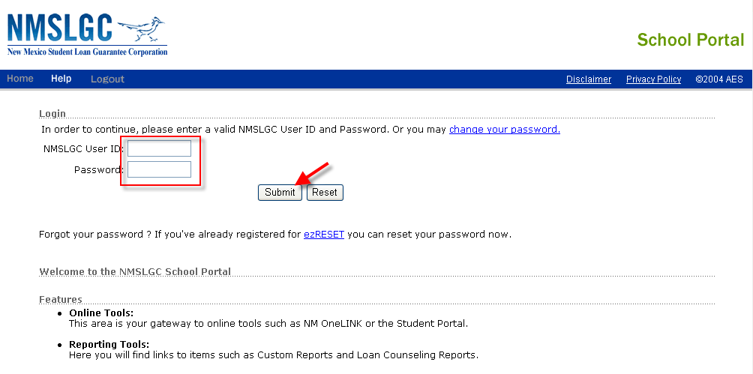
3. Select eCourier SBS (School Based System)

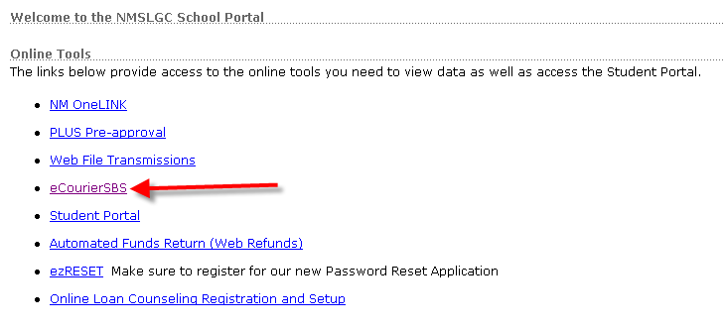

4. Enter student’s Social Security Number (SSN) and select SEARCH

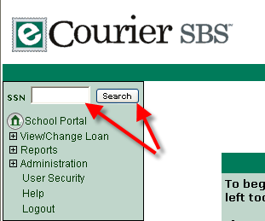

5. Select loan you wish to modify or cancel (NOTE: ONLY GUARANTEED LOANS CAN BE CANCELED.)

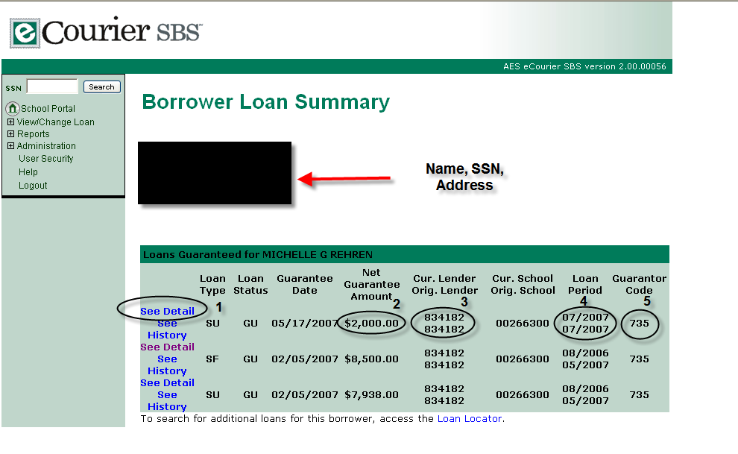
Use these fields to confirm the loan you are working on:

1. SEE DETAIL – selects the loan
2. Net Guarantee Amount
3. Current Lender on loan
4. Loan Period
5. Guarantor Code

6. Change fields as appropriate

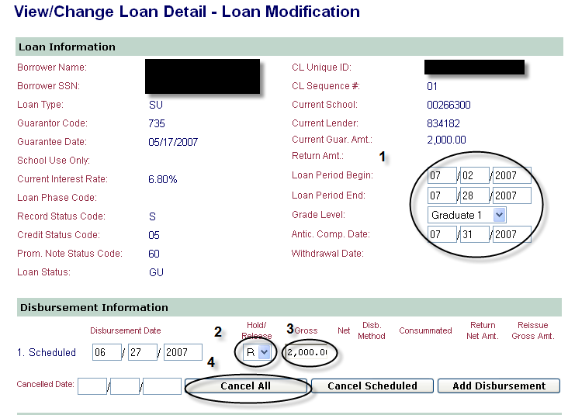
***NOTE: IF HOLD/RELEASE CODE IS BLANK (NULL), YOU MUST CONTACT THE LENDER DIRECTLY

1. Change loan period or graduation date
2. Set a loan to (R)elease, or (H)old – for disbursement
3. Reduce loan amount
4. Cancel all disbursements

7. Update changes
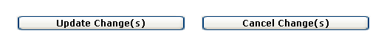
8. Confirm Changes
***END***

