RPAELAP
‘Application Status’ Tab

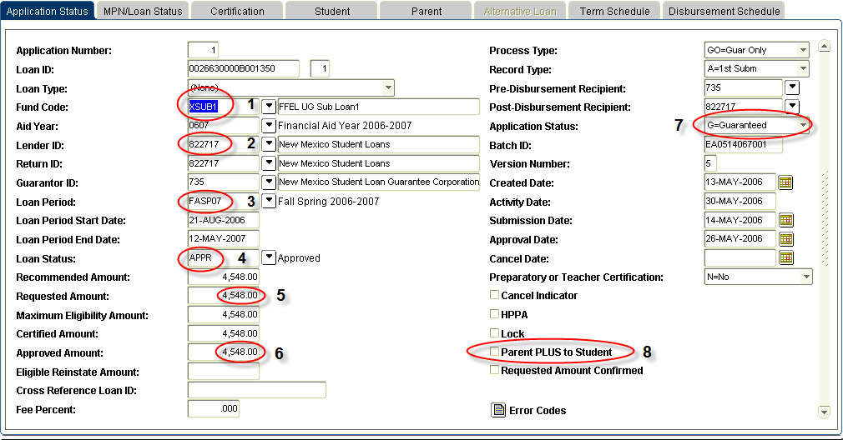
1 – Fund code – pulled from RPAAWRD
2 – Lender ID:
Can only update with one of our preferred lenders all other Lenders MUST be certified outside of Banner. See Job Aid-xxxxxx

Lender | Banner Lender ID
Bank of America | 824421
Citibank | 826878
NMSL | 822717
Sallie Mae | 802218
UNM as Lender (Graduate Students Only) | 834182
Wells Fargo | 807176
These code can be used for Graduate Students who do not want UNM as Lender

3 – Loan Period – auto-populates from the aid period on RBAABUD and RPAAWRD
4 – Loan status – starts at RECM (recommended), after loan is guaranteed it will change to APPR (approved)
5 – Requested amount – pulled from RPAAWRD
6 – Approved amount – is ‘Blank’ until the Loan Application has returned from lender after Guarantee
7 – Application status:
Code | Description
‘R=Ready’ | Loan Application has not yet been sent to guarantee agency. Should change to SENT that evening when extract process runs.  You could delete this record, if it was created in error. THIS IS THE ONLY TIME YOU CAN DELETE A RPAELAP RECORD.
‘S= Sent’ | Loan Application has been sent to the guarantee agency. We are awaiting a response.  NO ADJUSTMENTS can be made to the loan application when the loan is in this status.
‘A=Application Accepted’ | Guarantor has approved the Loan Application but has not received a Master Promissory Note (MPN) for the student. The student has to complete a MPN with the Lender.
‘G=Guaranteed’ | NMSL/UNM as Lender – loan approved, prom note on file.  Texas Guarantee lenders – does not indicate promissory note status – loan is guaranteed  CHECK 2nd Block for MPN  Sallie Mae/USA Funds – loan approved, No Prom Note on file
‘B=PN Rcvd/Appr’ | Sallie Mae/USA Funds – loan approved prom note on file
‘P=Pending’ | Possible problem with the loan approval, or a missing prom note. We will need to contact NMSL for these types.
‘D=Denied/Rejected’ | Loan Denied – Confirm Eligibility OR money has n\not yet been returned.
‘T=Terminated’ | Canceled by the Student Financial Aid Office.  The ‘Loan Status’ must also be “CANC – Canceled’

8 – Parent PLUS to Student (XPLUS1) – check ONLY when awarding an XPLUS1
Leave blank for all other loans, including Plus to Parent XPLUP1

Certification block
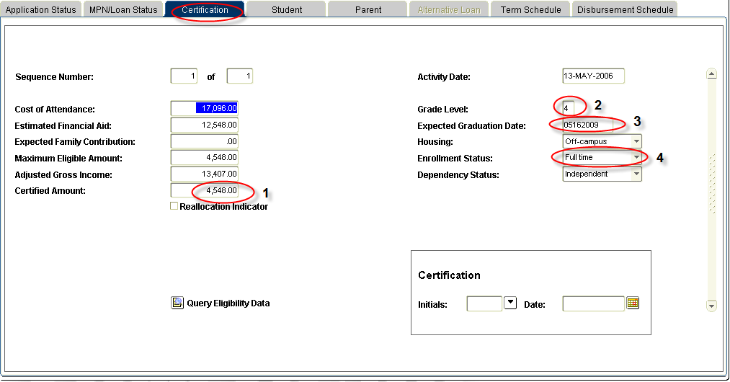

1 – Certified Amount – only place to adjust, cannot adjust on the 1st block.
2 – Grade Level – where to update if the grade level changes
3 – Expected Graduation Date – must be equal to or greater than loan period end date
4 – Enrollment Status – must be greater than ‘less than half time’

Student Information block

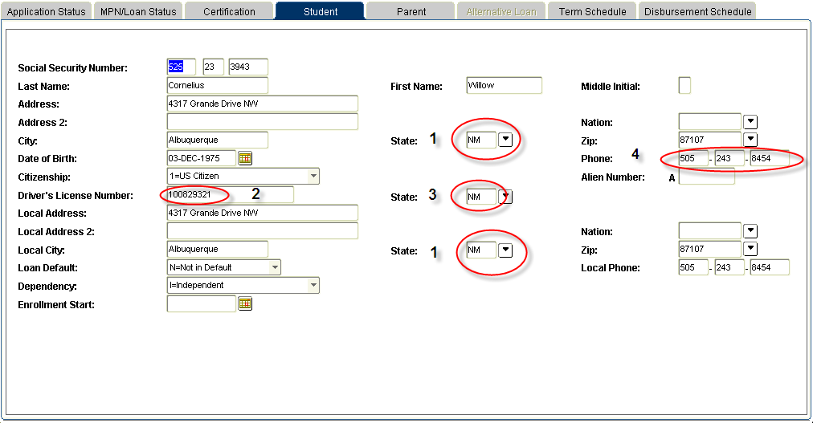

ALL of These Fields are Required for the Loan to Transmit

1 – Address State (Note: This is requested twice – local and primary.) This is pulled from SPAIDEN.
2 – Driver’s License Number. This is pulled from RNANAxx. When updating this field, complete DRIVE on RRAAREQ, and update the DL # on RNANAxx.
3 – Driver’s License State. This is pulled from RNANAxx. When updating this field, complete DRIVE on RRAAREQ, and update the DL # on RNANAxx.
4 – Phone Number. This is pulled from SPAIDEN. Must contain 10 digits.

Parent information block

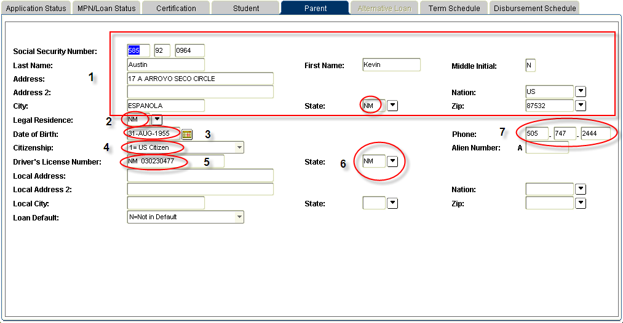

1 - Parent Name, SSN, Address
2 - Legal Residence
3 - Date of Birth
4 – Parent’s Citizenship
5 – Driver’s License Number
6 – Driver’s License State
7 – Phone Number. Must be 10 digits.

Term Schedule block

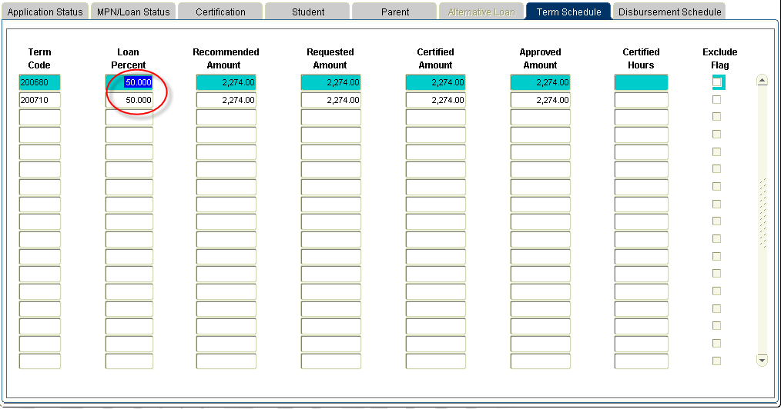

Shows how the award is divided by term.

Disbursement block

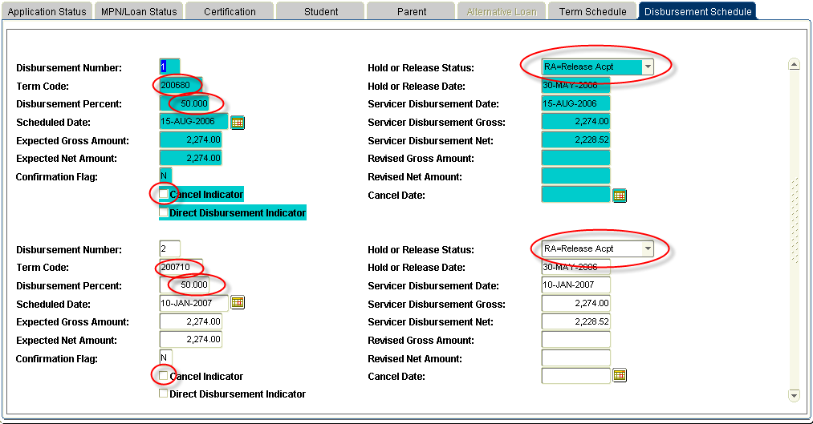

Separate record for each term.

Disbursement Percent is adjustable. This drives the MEMO process.
Adjusting the ‘Disbursement Percent’ will adjust the percent on the ‘Term Schedule’ Tab on RPAELAP and adjust the percent on RPALDSB.
IT DOES NOT AFFECT the loan application received by the Lender.

THE ‘Cancel Indicator’ Box SHOULD NEVER BE CHECKED
If we receive money on a loan that has the CANCEL INDICATOR checked for that term, the money will not release, and there will not be a message on ROIDISB.

The ‘Cancel Indicator’ Box is locked by term, when we are within 4 of the SERVICER DISBURSEMENT DATE (with the exception of the DISBURSEMENT PERCENT). As a result, if we need to remove a CANCEL INDICATOR after the record is locked, it must be done by our ITS staff.

Hold or Release Status – driven by the hold and release process.
DO NOT update these fields – it will not go out with the change files.

