Student Financial Aid

FA-204 Special Circumstances (Approval)

Date Issued/Rev: 07/07/08
General Description: This procedure explains how to log Special Circumstances.
Responsible Manager: Financial Aid Director
Related Procedures:
Related Forms: RRAAREQ
ROAMESG
ROAPELL
RNAPR07
(RNARSLT)
RHACOMM
RNANA07

PROCEDURE

Step 1 - Verify the Special Circumstance is complete and approved.

Step 2 – Verify a FAFSA is on file in Banner.

Step 3 - Go to RRAAREQ

Step 4 - Insert record

Step 5 - Type the Special Circumstance mnemonic “SCAPI/SCAPD” (SCAPI = Special Circumstance for Independent Students; SCAPD = Special Circumstance for Dependent Students) in new record.

NOTE: If the Special Circumstance is completed and approved, an EDE will be sent to override the current ISIR information.

Special Circumstances

Step 1 - Enter “C” in Status Ind” field for the Special Circumstance. Only if you will be sending the EDE.

Step 2 - Change the FAFSA “Status Ind” to “E” - indicating that an EDE will be sent.
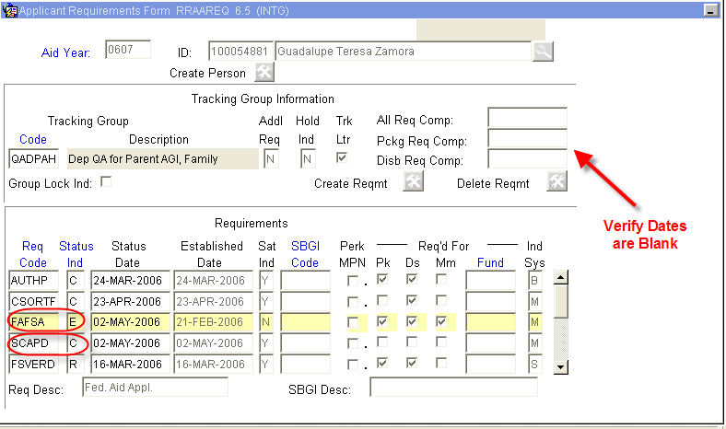

Step 6 – Uncheck the “Trk Ltr” box.

NOTE: A checked box will generate a MIL.

Step 7 - Lock the Tracking Group to ensure the corrections do not affect the requested tracking docs when returned. Please Refer to Figure 2.

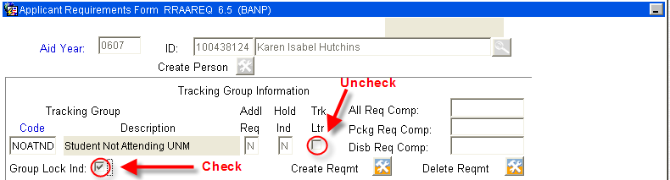

Figure 2 – Applicant Requirements Form RPAAREQ
Step 8- Enter “I” (for ‘Received Incomplete’ status) or “A” (for Additional Information Needed”) if Special Circumstances is incomplete.
Step 9 - Save
Step 10 - Exit
Step 11 - Go to ROAMESG - to send an active message to the student.
Step 12 - Perform “Next block”
Step 13 - Tab to “Date” field (leave Message Code field blank).
Step 14 - Enter date you want message to expire. Please refer to Figure 3.

NOTE: If no date is entered, the Message will remain active for 1 month.

Step 15 - Enter a message explaining why the Special Circumstances is incomplete. Please refer to Figure 3.
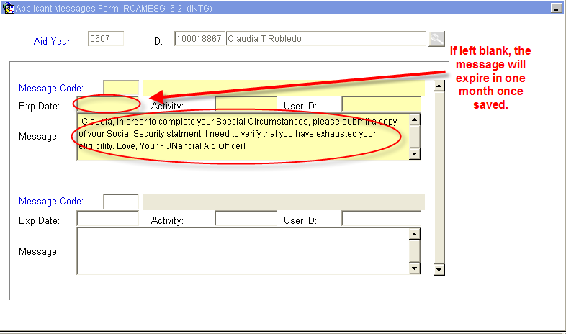
Figure 3 – Applicant Messages Form ROAMESG
Step 16 - Save
Step 17 - Exit
Step 18 - Go to ROAPELL to note the current EFC.
Step 19 - Perform “Next block”

NOTE: Please note the EFC currently on ROAPELL. The Primary Pell EFC (INAS Calculation) will change once the Special Circumstance is saved. When the EDE returns, the Primary SAR EFC (ISIR EFC) will match. Please refer to Figure 4.

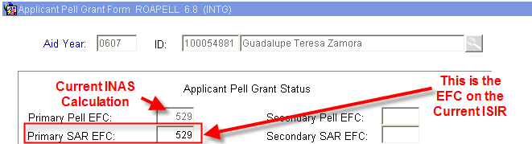
Figure 4 – EFC in ROAPELL

Step 20 - Go to RNAPR07

Step 21 - Tab to “FM Srce” Field and indicate “SIM” (this is to first simulate an EFC). Do this before performing Next Block. Please refer to Figure 5.

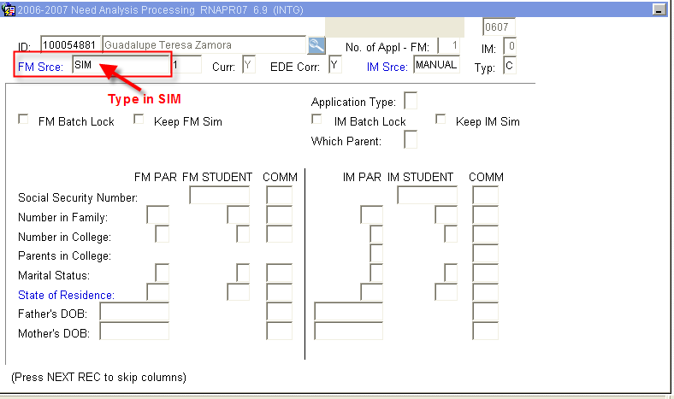
Figure 5 – Need Analysis Processing

Step 22 - Perform “Next block”

Step 23 - Enter the amounts that will be changing as a result of the Special Circumstances in the “FM PAR” Fields or the “FM STUDENT” Fields. Please refer to Figure 6.

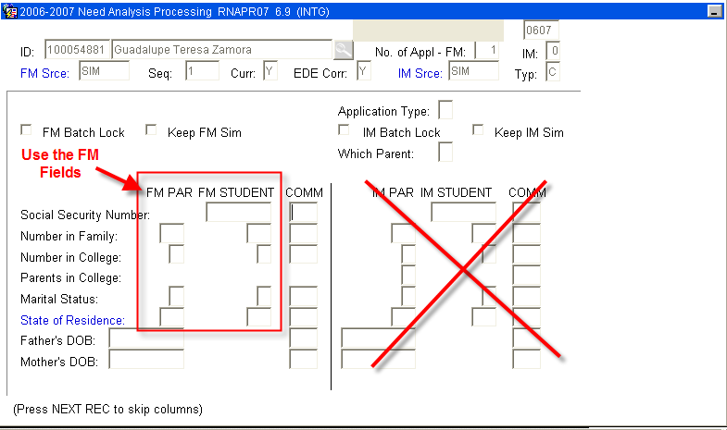
Figure 6 – Need Analysis Processing

NOTE: Most of Special Circumstance changes will take place on the Second Block of RNAPR07 (note the scroll bar to access the Work Sheet A, B, C information).

Step 24 – Scroll down to find any untaxed income. Please refer to Figure 7.

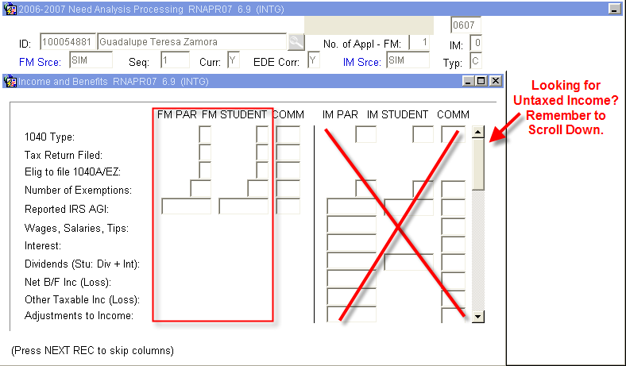
Figure 7 – Income and Benefits

Step 25 - Save when changes are entered.

Step 26 – Verify the ‘Status Bar’ indicates.

Step 27 - Recalculate need by selecting “Calculate Need” from the Options Menu (or Quick Key F3). Please refer to Figure 8.

NOTE: This action will result in a Need Analysis Calculation and you will be automatically taken to RNARSLT.
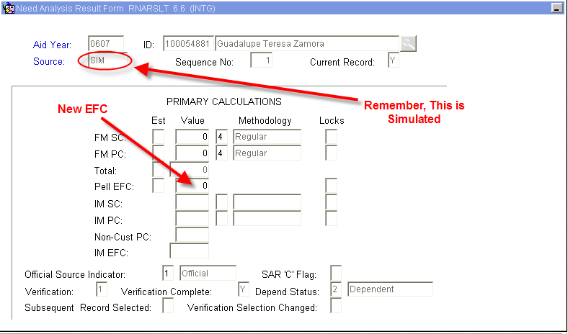
Figure 8 – Need Analysis Result Form

Step 28 - Exit and you will be returned to RNAPR07.

Step 29 - Return to the First Block of RNAPR07 - to keep the Special Circumstance Changes and generate an EDE.

Step 30 – Check the “Keep FM Sim” Box. Please refer to Figure 9.

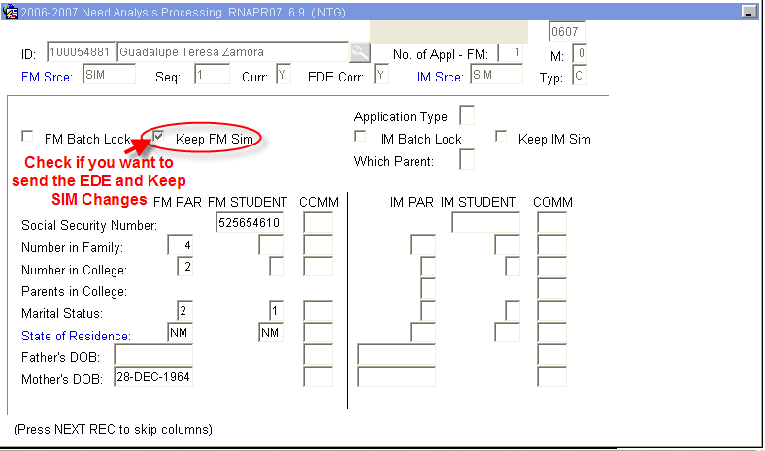
Figure 9 – Need Analysis Processing

Step 31 - Save

Step 32 – Verify the ‘Status Bar’ indicates (An EDE will be sent).

Step 33 - Access ROAPELL.

Step 34 - Verify EFC changes. Please refer to Figure 10.

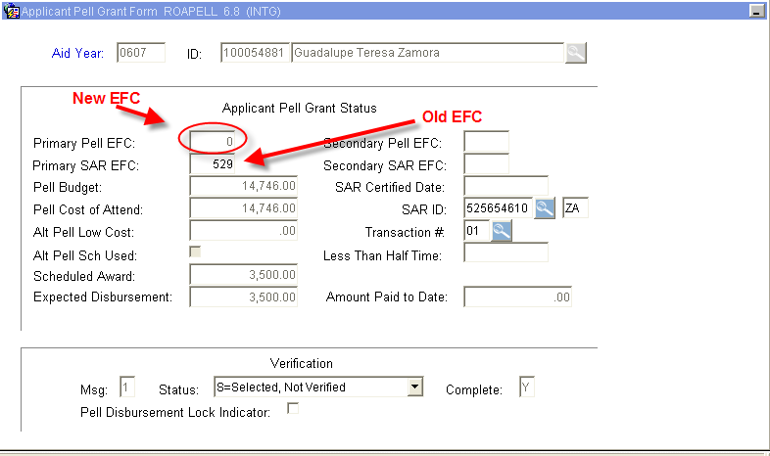
Figure 10 – Applicant Pell Grant Form - EFC

Step 35 - Access RNANA07 to indicate Professional Judgment was used by updating the “Prof. Judgdment Used” Field with a “Y” - (the last Block of RNANA07). Please refer to Figure 11.

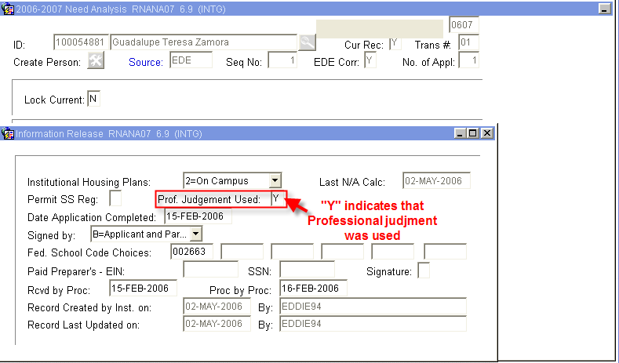
Figure 11 – Information Release

Step 36 - Save

Step 37 - Access RHACOMM, leave message regarding:
  - Decision on Special Circumstance
  - Reason EDE was sent

Step 38 - Wait for EDE to return - turn-around time is between 2 and 4 days. If EDE appears to take an excessive amount of time to return. Please notify a manager.

NOTE: When the EDE returns, the FAFSA on RRAAREQ will update from ‘E’ to ‘C’ with the date of the return and the EFCs on ROAPELL will match.
* * * E N D * * *

