Student Financial Aid

FA-203 Override Independency (Approval)

Date Issued/Rev: 07/07/06
General Description: This procedure explains how to override independency.
Responsible Manager: Financial Aid Director
Related Procedures:
Related Forms: RRAAREQ
ROAMESG
RNAOV07
(RNARSLT)
RHACOMM
RNIMS07

PROCEDURE
Step1 - Verify the Independency Petition is complete and approved and a FAFSA is on file in Banner.

NOTE: If FAFSA is not on file. STOP here! Submit documentation to Processor for STAGE 0.

Step 2 - Go to RRAAREQ.
Step 3 - Insert record
Step 4 - Type the Independency Petition mnemonic “INDPET” in new record.

NOTE: If the Independency Petition is complete and approved, an EDE will be sent to override the dependency.

Step 5 - Enter “C” in Status Ind” field for the Independency Petition. Please refer to Figure 1.
Step 6 - Change the FAFSA “Status Ind” to “E” - indicating that an EDE will be sent. Please refer to Figure 1.

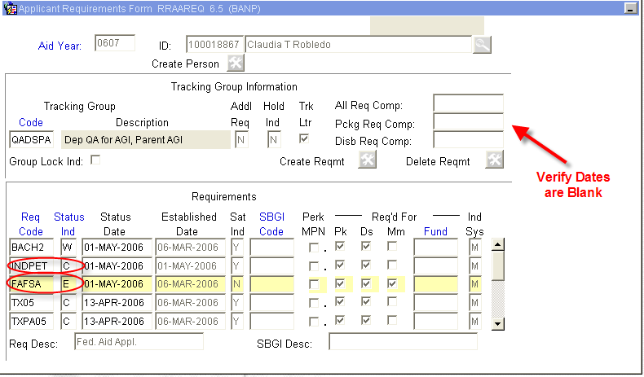
Figure 1 – Applicant Requirements Form
Step 7 – Verify that the “Trk Ltr” box is unchecked (if not, uncheck it). Please refer to Figure 2.
NOTE: A checked box will generate a MIL.

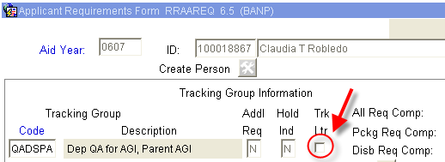
Figure 2 – Applicant Requirements Form

Step 8 - Enter “I” (for ‘Received Incomplete’ status) or “A” (for Additional Information Needed”) if Independency Petition is incomplete.

Step 9 - Save

Step 10 - Exit

Step 11 - Go to ROAMESG to send an active message to the student.

Step 12 - Perform “Next block”

Step 13 - Tab to “Date” field (leave Message Code field blank). Please refer to Figure 3.

Step 14 - Enter the date you want the message to expire (if no date is entered, the Message will remain active for 1 month). Please refer to Figure 3.

Step 15 - Enter your message explaining why Independency Petition is incomplete. Please refer to Figure 3.

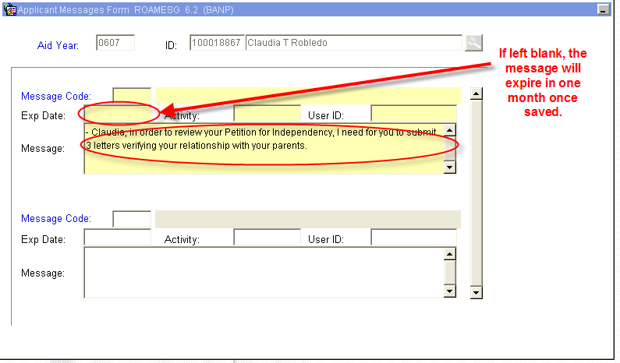
Figure 3 – Applicant Messages Form

Step 16 - Save

Step 17 - Exit
Step 18 - Go to RNAOV07

Step 19 - Perform “Next block”

Step 20 - Enter ‘I’ for Independent in the Dependency Field. Please refer to Figure 4.

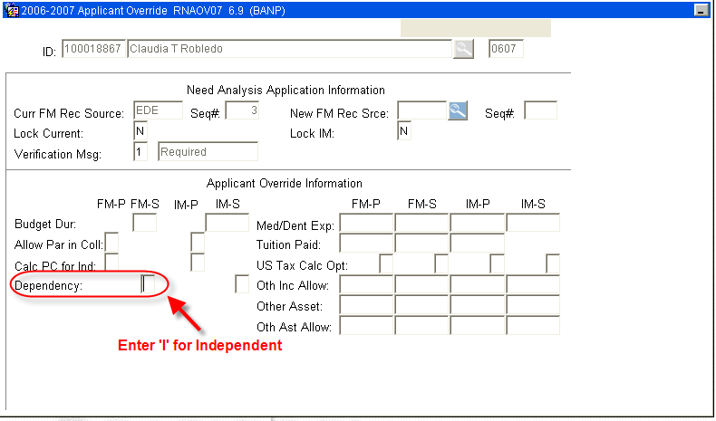
Figure 4 – Applicant Override

Step 21 - Save (by saving you will be generating an EDE to override the dependency status).

Step 22 – Verify the ‘Status Bar’ indicates.

Step 23 - Recalculate need by selecting “Calculate Need” from the Options Menu (or Quick Key F3). Please refer to Figure 5.
NOTE: This will perform a Need Analysis Calculation and you will be automatically taken to RNARSLT.
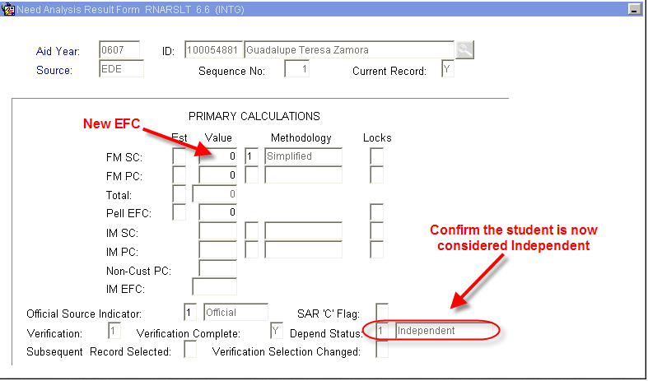
Figure 5 – Need Analysis Result Form

Step 24 - Exit you will return to RNAOV07.
Step 25 - Exit again, you will return to the main Banner Menu.
Step 26 - Access RHACOMM, leave message regarding:
  - Decision on Independency Petition
  - EDE was sent to override Independency Status
Step 27 - Wait for EDE to return - turn-around time is between 2 and 4 days. If EDE appears to take an excessive amount of time to return, please notify a manager.

NOTE: When the EDE returns, the FAFSA on RRAAREQ will update from ‘E’ to ‘C’ with the date of the return. When the EDE returns, you can also verify the Independency update on the second block of RNIMS07. Please refer to Figure 6.
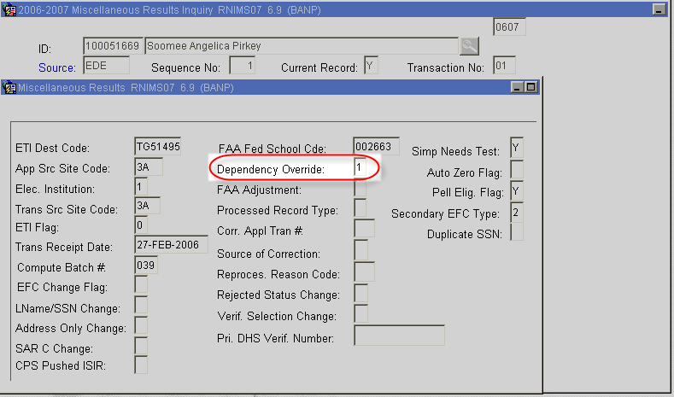
Figure 6 – Verify Results
* * * E N D * * *

