Student Financial Aid

FA-107 Alternate Summer Awarding

Date Issued/Rev: 07/07/08
General Description: This procedure explains how to award loans for the students awarded with summer treated as a header semester.
Responsible Manager: Financial Aid Director
Related Procedures: FABU-101 Immediate Assignment to a Budgeting Group
FABU-104 Change Aid Period for Student
FABU-107 Add Budget Component
FAPK-101 Immediate Assignment to a Packaging Group
FAPK-104 How to Offer an Award Package using Automatic Packaging Process
FAPK-108 Package a Fund Manually
Related Forms: RBAABUD
RNAOV07
RPAAWRD
ROAENRL

PROCEDURE

Step 1 - Budget and award student for normal aid period (ie Fall/Spring). See FABU-101, FAPK-101, and FAPK-104.

Step 2 - Go to RBAABUD.

Step 3 - Change aid period (see FABU-104) to applicable term (ie ASFASP, ASFA). Please refer to Figure 1.

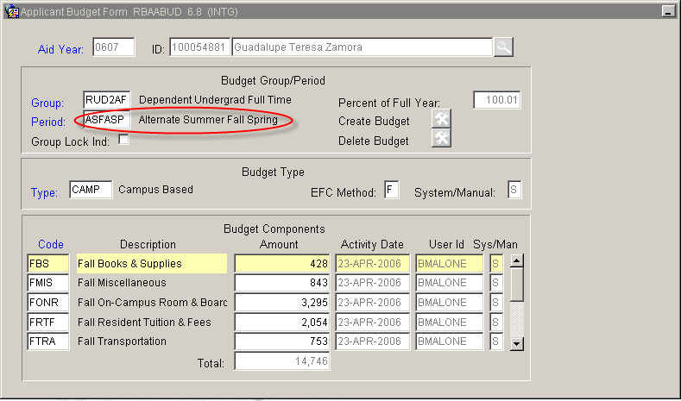
Figure 1 – Applicant Budget Form

Step 4 - Adjust EFC for new budget duration on RNAOV07 (see FABU-104).

Step 5 - Add budget components for new summer term (see FABU-107). Please refer to Figure 2.

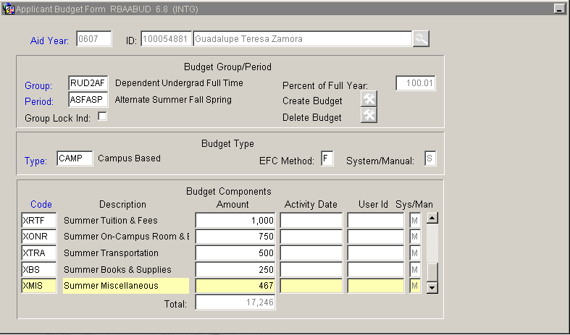
Figure 2 – Applicant Budget Form

Step 6 - Go to RPAAWRD.

Consider the following for the next appropriate action:

a. If FFELP loan exists and has been guaranteed then adjust loan on RPAAWRD and RPAELAP.
b. If FFELP loan exists and has not been guaranteed then delete loan on RPAAWRD and RPAELAP. Re-award loan(s) on RPAAWRD.
c. If no FFELP loan exists then award loan as you would any other aid (see FAPK-108)

Step 7 - Go to ROAENRL. Please refer to Figure 3.

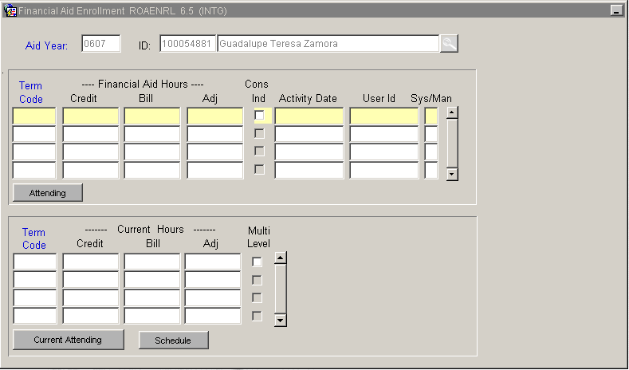
Figure 3 – ROAENRL

Step 8 - Enter Term Code (yyyy61) (ex:200661, 200761, etc). Please refer to Figure 4.

Step 9 - Enter Credit, Bill, and Adjusted hours for the hours a student is anticipated to be enrolled for during the summer term. Please refer to Figure 4.

Step 10 - Click the CONS IND box. Please refer to Figure 4.
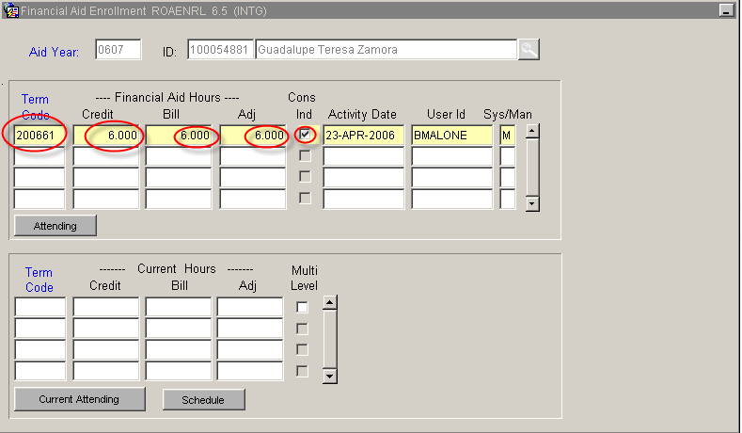
Figure 4 – ROAENRL

Step 11 - Save

Step 12 - Exit

Step 12 - Go to RHACOMM and enter a comment. Please refer to Figure 5.

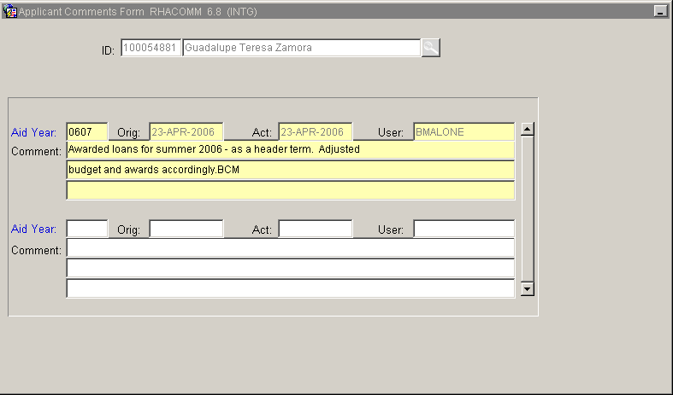
Figure 5 – Applicant Comments Form
* * * E N D * * *

