Student Financial Aid

FA-201 Creating a Manual RNANAxx Record

Date Issued/Rev: 07/07/08
General Description: This procedure explains how to log on Consortium Agreements.
Responsible Manager: Financial Aid Director
Related Procedures:
Related Forms: RNANA07
(ROAPELL)

PROCEDURE
Step 1 - Verify FAFSA is complete and signed by the student (and parent if dependent).

Step 2 - Go to RNANA07.

Step 3 - Enter Student ID - if no ISIR exists, MANUAL will populate in the Source Field. Please refer to Figure 1.

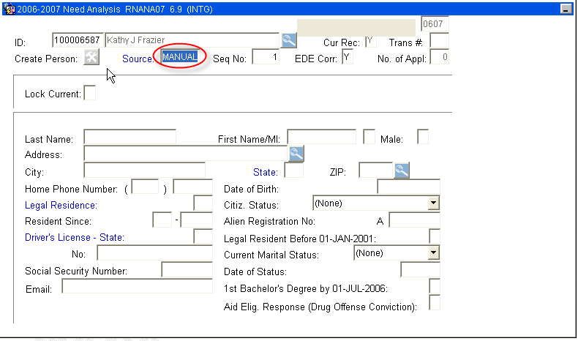
Figure 1 – Need Analysis

NOTE: IF SOURCE FIELD READS “EDE” - STOP! ISIR - EXISTS FOR STUDENT

Step 4 - Perform “Next block” after MANUAL Source Field is confirmed.

Ste 5 – Wait to receive confirmation that a record does not exist for this student.
Step 6 - Click “OK”. Please refer to Figure 2.

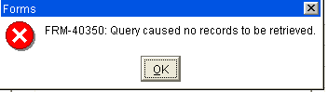
Figure 2 – Alert Message

Step 7 - Enter all FAFSA student data - RNANA07 contains 5 blocks of information.

Step 8 - SAVE after all information is entered.

Step 9 - Select “Calculate Need” from the Options Menu - to perform an INAS Need Calculation on the MANUAL record.
NOTE: When the Calculation is complete you will automatically be taken to ROAPELL to vies the “Estimated EFC”. Please refer to Figure 2.
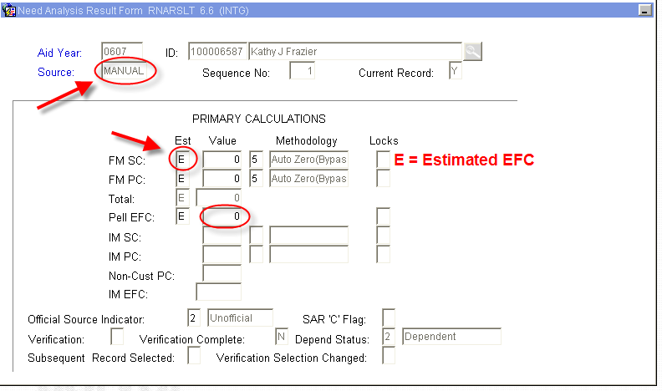
Figure 2 – Need Analysis Result Form

Step 10 - Exit to return to RNANA07.

Step 11 - Exit to return to main Banner Menu.

NOTE: The student will not be picked up by Tracking, Budgeting or Awarding - this will have to be done manually.
* * * E N D * * *

