Student Financial Aid

FA-221 Overriding the Current ISIR Record

Date Issued/Rev: 07/08/08
General Description: This procedure explains how to override the current ISIR Transaction with a different ISIR Transaction.
Responsible Manager: Financial Aid Director
Related Procedures:
Related Forms: RNAOV07
RNIAPPL
ROAIMMP
ROAPELL
RPAAWRD
NOTE: RNIAPPL will provide a list of all ISIR and EDE transactions for a Financial Aid Applicant
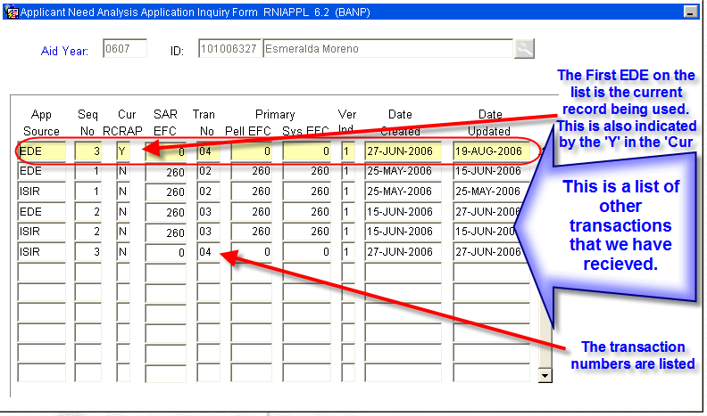

PROCEDURE

Step 1 - Access RNAOV07.
Step 2 - Identify if current ISIR Record is locked. Please refer to Figure 1.

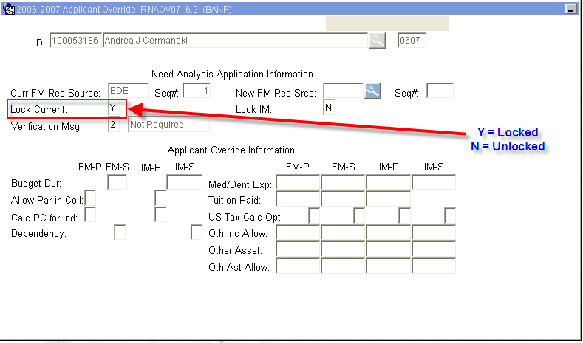
Figure 1 – Applicant Override

Step 3 - Unlock the Current ISIR by changing the ‘Lock Current’ to ‘N’ if the ‘Lock Current” is equal to ‘Y’ (meaning the ISIR is Locked).

Step 4 - SAVE (F10).

Step 5 - ‘click’ on the search button (F9) for the ‘New FM Rec Srce’ field to access all ISIRs on record for the student (this will bring up RNIAPPL). Do this after the Current ISIR Record is unlocked. Please refer to Figure 2.

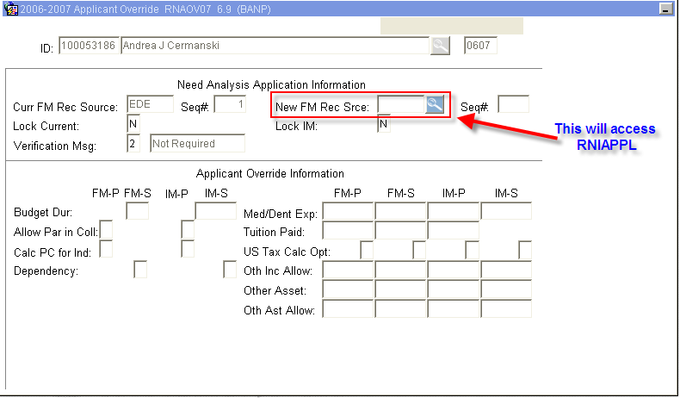
Figure 2 – Applicant Override

Step 6 - Identify and highlight the EDE source that you would like to make current On RNIAPPL.
Step 7 - ‘Select’ (Shift F3 or ‘double click’) the EDE transaction to be loaded as current. Please refer to Figure 3.

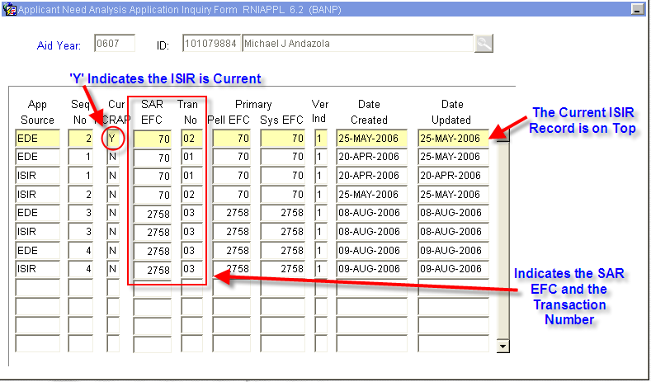
Figure 3 – Applicant Need Analysis Application Inquiry Form

NOTE: ONLY SELECT the EDE RECORDS – ISIRs can not be loaded.

Step 8 –Note the ‘New FM Rec Srce’ field on RNAOV07. After the EDE transaction is selected. Please refer to Figure 4.

NOTE: This field will indicate the Banner Sequence Number which may be different from the Transaction Number.

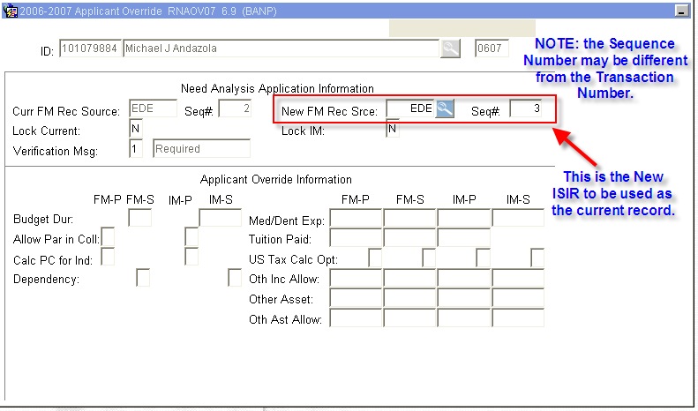
Figure 4 – Applicant Override

Step 6 - Save (F10).

Step 7 - Verify the message.

Step 8 - Go to ROAIMMP.

Step 9 - Perform “Next block”

Step 10 - Refer to Figure 5. The student will need to be guided through these three Processes IN ORDER:
Process 1 - Tracking followed by SAVE (F10).
- Access RRAAREQ to see if additional documents were requested as a result f the ISIR transaction change.
Process 2 - Needs Analysis Calculation followed by SAVE (F10).
- After running the Need Analysis Calculation, the system will go to RNARSLT to confirm EFC.
- Exiting RNARSLT will return to ROAIMMP
Process 3 -Only if document verification is complete - Immediate Pell Calculation followed by SAVE (F10).
- NOTE: this process will award re-award Pell. Only award if verification is complete.

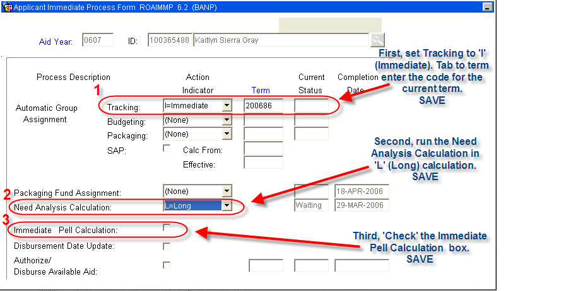
Figure 5 – Applicant Immediate Process Form

Step 11 - Exit ROAIMMP.

Step 12 - Access RRAAREQ to verify if additional tracing documents were requested.

Step 13 - Access RPAAWRD.

Step 14 - Confirm Pell Award.

Step 15 - Notify Awarding Officer of EFC Change to verify award eligibility.

* * * E N D * * *

