Student Financial Aid

FA - 105 Summer Budgeting and Awarding

Date Issued/Rev: 05/15/08
General Description: This procedure explains how to budget and award students for the summer term.
Responsible Manager: Financial Aid Director
Related References: Job Aid-2008 Summer Aid and Loan Periods
Job Aid-2008 Summer Budgets and Components
Job Aid-0708Pell Chart
Related Procedures: FABU – 104 Change Aid Period for Student
FABU – 107 Add Budget Component – Individual
FAPK – 108 Packaging a Fund Manually
FAPK – 112 Change the Term Distribution of a Fund
FALN – 103 Award an Electronic Loan to a Student
FALN – 107 Change Lender
Related Forms: ROAENRL
RBAABUD
RNAOVxx
RPAAWRD
RPAELAP

SPECIAL PROCESSING FOR LOANS
In addition to checking NSLDS, make sure you consider any loans awarded in 08-09 (upcoming year awards) that may not yet be reflected on NSLDS.

DETERMING SUMMER PELL ELIGIBILITY
Pell Grant awarding for the summer follows the same general eligibility rules as fall/spring awarding. If the student has already received their full Pell Grant over the course of the fall and spring semesters (either at UNM or elsewhere) the student is not eligible for any additional Pell over the summer term.

NOTE: NSLDS MUST be checked for each student. This will ensure that we take into account any aid awarded by any other institution. If the student has been awarded elsewhere, pay close attention to the percentage of Pell they were previously awarded and award based on that number. However if a student did not receive all the Pell they were eligible for, use the following formula to determine their award:
1. Determine if student is Pell eligible (first bachelors, degree seeking, EFC eligible, SAP)
2. Determine weeks enrolled for summer, Annual Pell, and summer enrollment status.
3. Calculate maximum award (see 2007-2008 Pell chart for annual award for summer enrollment status)
Annual award for summer enrollment status X (times) the number of weeks enrolled for summer/32 = Maximum Summer Pell award
Example 1: Student enrolled for 6 hours for summer with zero EFC, enrolled 8 weeks
$4310 (annual full-time Pell Award) x 8 (weeks enrolled)/32 = $1077
Example 2: Student for 3 hours for summer with a zero EFC, enrolled 4 weeks
$2155 (annual half-time Pell Award) x 4 (weeks enrolled)/32 = $269

4. Determine maximum remaining Pell eligibility. Subtract fall and spring Pell amounts received from annual maximum award.
Maximum Annual Pell Award based on Full Time and Student EFC - (minus) Annual award received fall/spring
Example: 0 EFC Student received $2155 fall + $1616 spring ($3771 total)
$4310 - $3771 = $539
5. Determine summer award. Award summer maximum award (#3), or remaining eligibility (#4), which ever is LESS.

Total EFC Calculation
- Adjust the Budget Duration on RNAOVxx for the total number of months the student is enrolled this academic year – not to exceed 12.
- To determine the Total EFC for the loan period, divide the Total EFC on RNARSxx by the budget duration on RNAOVxx. Multiply by the number of months in the loan period.
Example: Total EFC on RNARSxx is 1200, Budget Duration on RNAOVxx is 11 months
Student enrolled for 2 months of summer
1200 (Total EFC) divided by 11 (Budget Duration) = 109 X (times) 2 (Summer Months) = 218 Summer EFC
NOTE: Independent Students, the Total EFC does not change for budget durations greater than 9 months.

PROCEDURE
Procedure:
1. Receive summer request form from student.
2. Verify student’s enrollment (including hours and weeks enrolled) on ROAENRL
3. Select summer term (e.g. 200860 – Summer 2008) in CURRENT HOURS section of ROAENRL
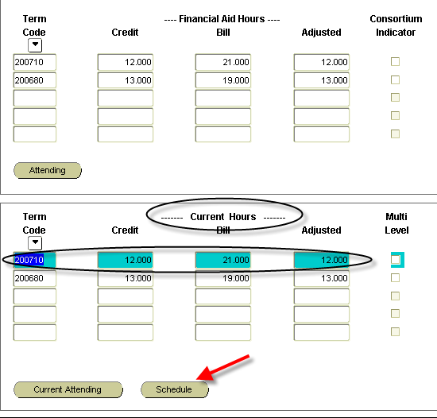
4. Click SCHEDULE button, to display weeks of enrollment for the term.
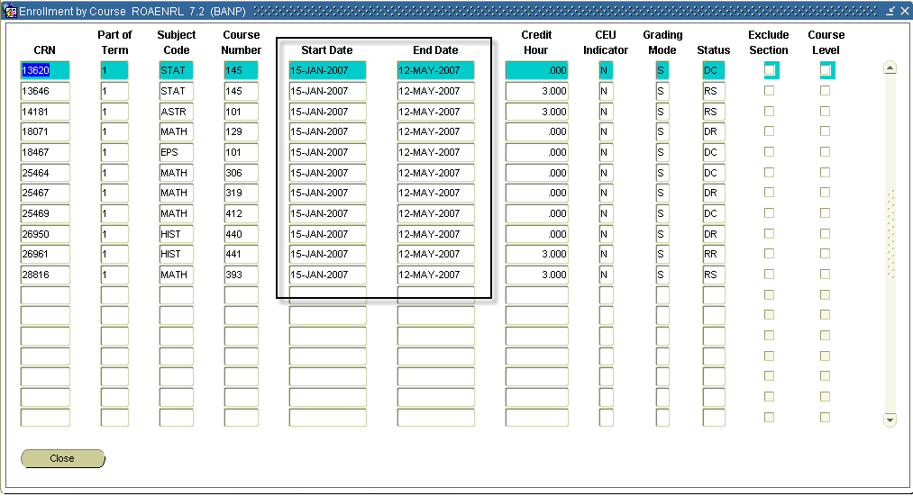
5. Calculate the amount of weeks that student is enrolled from START DATE to END DATE.
- Summer 2008 examples
  - June 9, 2008 – July 5, 2008 – 4 weeks (First Four Weeks)
  - June 9, 2008 – July 19, 2008 – 6 weeks
  - June 9, 2008 – August 2, 2008 – 8 weeks
  - July 7, 2008 – August 2, 2008 – 4 weeks (Second Four Weeks)
6. Determine appropriate aid period (see Job Aid-2008 Summer Aid and Loan Periods).
7. Go to RBAABUD
8. Next block into the form, then previous block twice to get to aid period field (or click in aid period field)
9. Enter appropriate aid period code.
10. Select CREATE BUDGET budget.
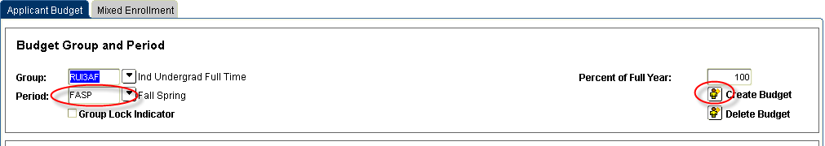
11. Next block to bottom of form.

12. Insert the summer budget components (see Job Aid-2008 Summer Budgets and Components).
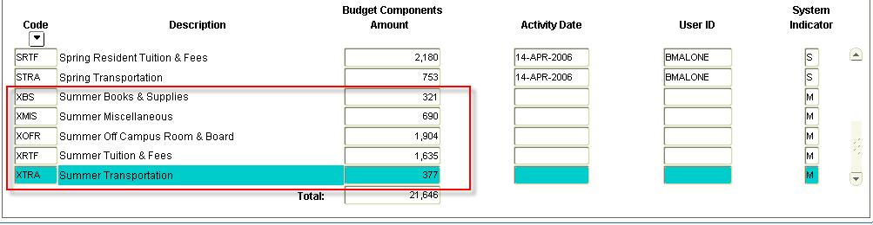
13. Save
14. Go to RNAOVxx (for summer 2008 – use RNAOV08)
15. Next block and unlock the record by changing the Y to N in the LOCK CURRENT RECORD field.
16. Save
17. Next block and change the BUDGET DURATION under FM-STUDENT to the appropriate months (see Job Aid-2008 Summer Aid and Loan Periods).
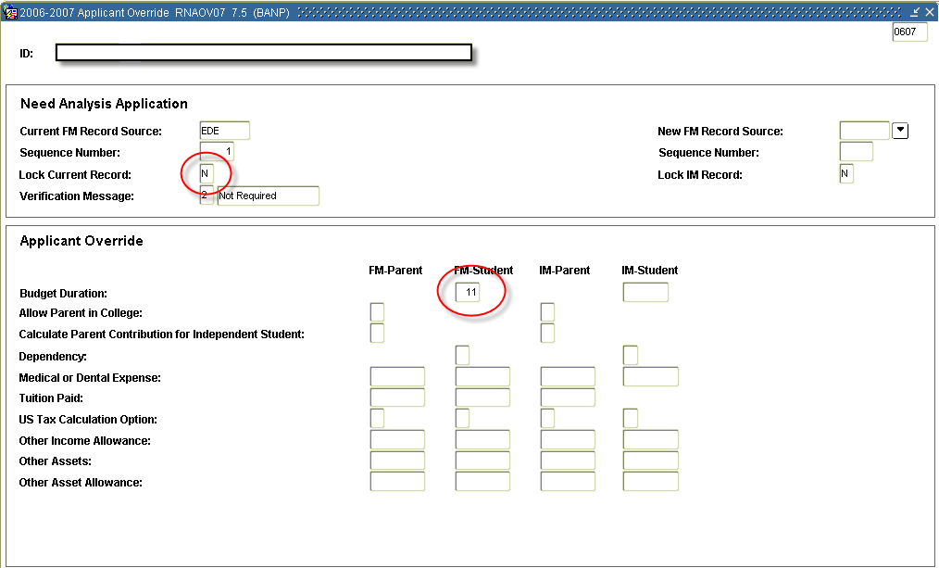
18. Save
19. Select OPTIONS from menu

20. Select CALCULATE NEED (or use F3, and not OPTIONS, to CALCULATE NEED)

21. You will be taken to RNARSxx (RNARS08 for summer 2008) to review the new EFC. (Note: This will only change for dependent students exceeding nine months. However, you still need to perform this step.)
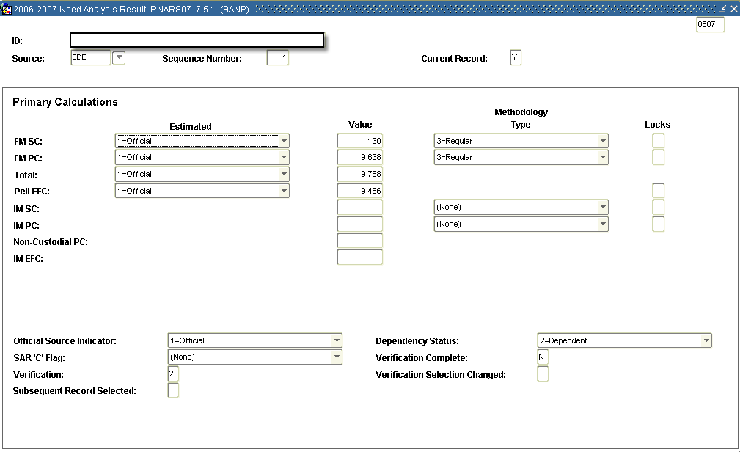
22. Exit form (you will return to RNAOVxx – exit that form, as well.)
23. Go to RPAAWRD
24. If you are adding onto an existing award – go directly to the second block (AWARD BY TERM block).
- If you are creating a new award, enter it on the first block first (when you award it in this fashion it will distribute it according to the aid period – continue onto the AWARD BY TERM block in order to verify that the award is distributed as you intended.)
25. On the AWARD BY TERM block, go to the award(s) you need to adjust.
26. If the summer term does not exist for the award you are adjusting, INSERT RECORD.
27. Enter the term (e.g. 200860), OFFERED, ACCEPTED, and LOAD fields.
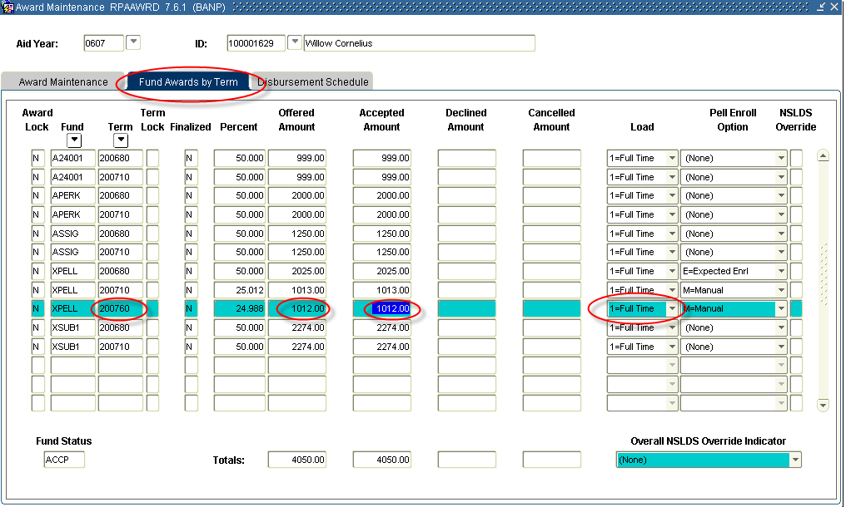

Load | Full Time | ¾ Time | ½ Time
Hours | 6 | 4 | 3

28. Save.

SPECIAL PROCESSING FOR LOANS
1. In addition to checking NSLDS, make sure you consider any loans awarded in 08-09 that may not yet be reflected on NSLDS.
2. If you have increased, or awarded a loan, go back to the first block.

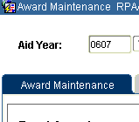

3. Select OPTIONS, then CREATE LOAN APPLICATION (this will take you to RPAELAP).
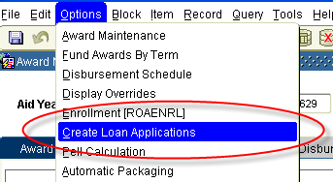
4. On RPAELAP, enter the appropriate LOAN PERIOD (see Job Aid-2008 Summer Aid and Loan Periods).
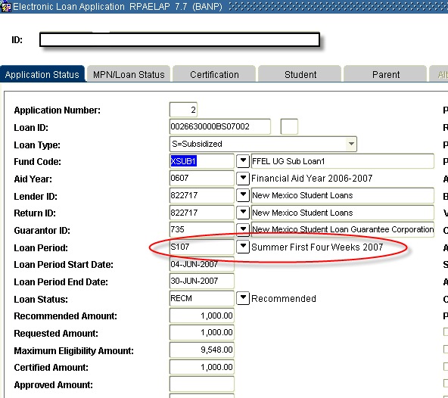

5. Save

********************************* UPDATE - EXPANDED ELIGIBILITY********************
NEW LOAN LIMITS EFFECTIVE JULY 1, 2008
- Freshmen now eligible for $2,000 “additional loan amount” prior to PLUS (still no more than $3,500 in subsidized funds). Total additional rises to $6,000 if student is denied a PLUS.
- Sophomore now eligible for $2,000 “additional loan amount” prior to PLUS (still no more than $3,500 in subsidized funds). Total additional rises to $6,000 if student is denied a PLUS.
- Undergraduate Dependent Students aggregate increases to $31,000 (no more than $23,000 can be subsidized).
- Undergraduate Independent Students aggregate increases to $57,500 (no more than $23,000 can be subsidized).
- NO CHANGE to Graduate limits
- Teacher Certificate maximum lowers to $11,500 (no more than $5,500 in subsidized funds).
- Other non-degree students working on pre-requisites have been raised to $11,500 (no more than $5,500 in subsidized funds).
- These increases cannot be disbursed until July 1, 2008. As a result, the student must still be enrolled for the summer term, in order to be considered for the increase.
- However, the student’s full budget can be used when considering loan eligibility (i.e. their full continuous period of enrollment).

When awarding these amounts, you would do all the steps listed above, in addition to the steps listed below:

1. On RPAAWRD, you will need to award the new amount, then select Y in the OVERRIDE field for that fund, and SAVE.
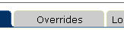
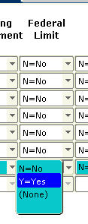
2. When you create the loan application, you will still need to change the loan period (if applicable). However, the loan will CERTIFY for zero dollars. Go to the CERTIFICATION tab and enter the proper certification number. YOU WILL HAVE TO DO THIS FOR ANY LOAN THAT USES THESE EXPANDED ELIGIBILITY AMOUNTS. This should only occur during the 2008 summer, as these changes are in Banner for the 08-09 year. (Sungard decided not to make these amount changes for the 06-07 year, to limit the possibility of awarding and disbursing the higher amounts prior to July 1, 2008.)
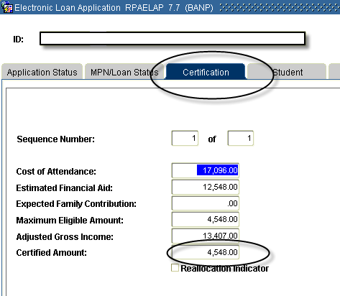

The Loan Period MUST be SUEX08

***END***

