Student Financial Aid

FA-207 Processing an External Check Made

Payable to UNM ONLY (Money List)

Date Issued/Rev: 07/08/08
General Description:
This procedure explains how to process an external check made payable to UNM only. Money List
Responsible Manager: Financial Aid Director
Related Procedures: Adding money to a fund
Related Forms: RRAAREQ
RPAAWRD
ROAENRL
SGASTDN
(RFRMGMT)

PROCEDURE to process an external check made payable to UNM ONLY.

Step 1 - Verify external check.

Step 2 - Date Stamp the check.

Step 3 - Access RRAAREQ. Please refer to Figure 1.

Step 4 - Confirm Officer Certification.

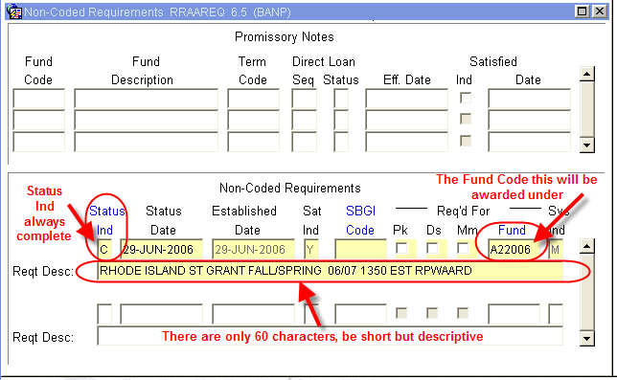
Figure 1 – Non-Coded Requirements

Step 5 - Access RPAAWRD.

Step 6 - Confirm Estimate Award. Please refer to Figure 2.

NOTE: Estimate Outside Loans are FUND CODE: XENT4L.

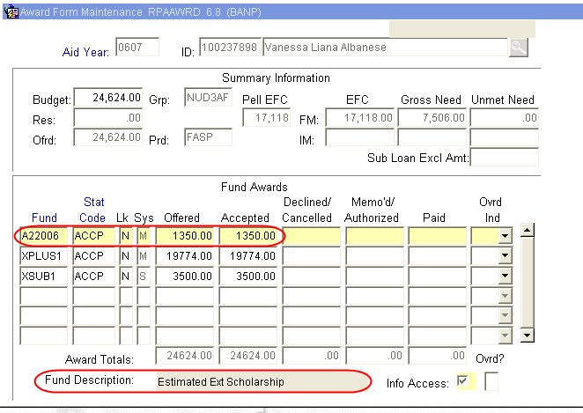
Figure 2 – Award Form Maintenance

Step 7 - Access ROAENRL.
Step 8 - Confirm Enrollment. Please refer to Figure 3.

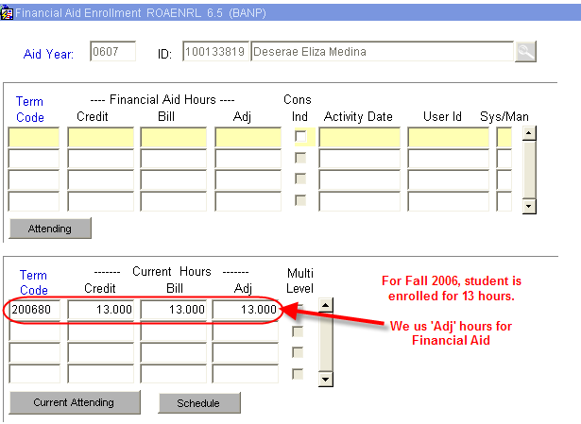
Figure 3 – Financial Aid Enrollment

Step 9 - Access SGASTDN.
Step 10 - Verify College. Please refer to Figure 4.

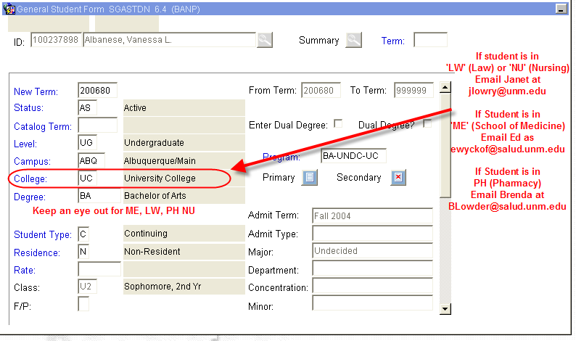
Figure 4 – General Student Form
Step 11 - Access RRAAREQ for a Log Check.

Step 12 - Perform ‘Next Block’ twice - to the ‘Non-Coded Requirements’ Block. Please refer to Figure 5.

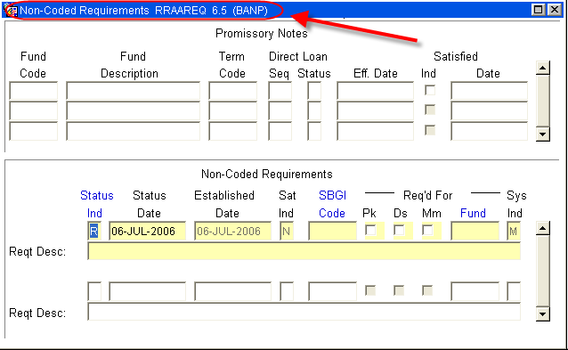
Figure 5 – Non-Coded Requirements

Step 13 - Log the Check in the ‘Non-Coded requirements” portion of the form:

Step 14 - Enter “C” (for “complete” in the ‘Status Ind’ field).

Step 15 - Tab to the ‘Fund’ Field’.

Step 16 - Enter the fund code that you are using for awarding.
    - For a list of values (F9), double click in the Fund field to search for a “Fund Code”. Please refer to Figure 6.

This is a list of all the current External Fund Codes (as of July 6, 2006)
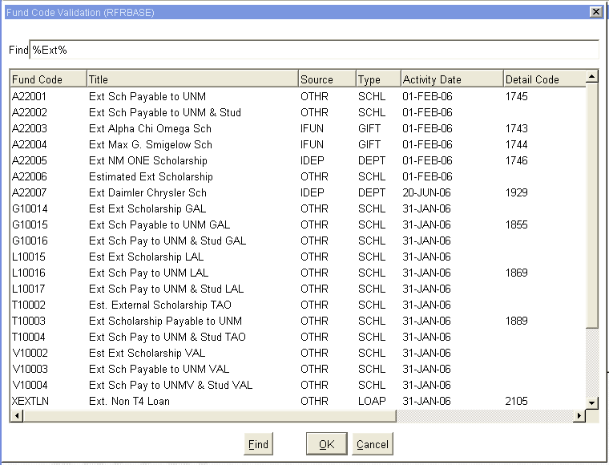
Figure 6 – Fund Codes

NOTE: When searching for an External fund Code enter %Ext%, refer below.

Step 17 - Tab (once) to the ‘Reqt Desc’ field after the Fund has been entered. Please refer to Figure 7.
Step 18 - Enter the following information about the award:

NOTE: there are only 60 spaces to use, try to provide as much information in as little space as possible
- The Source of the Award
- Check Number
- The Term of the award (i.e. fall only $1000, fall/spg $1000 per semester)
- The Money List Number, if any
- Indicate if the Check was sent to Cashiers for signature
Step 19 - ‘Save’

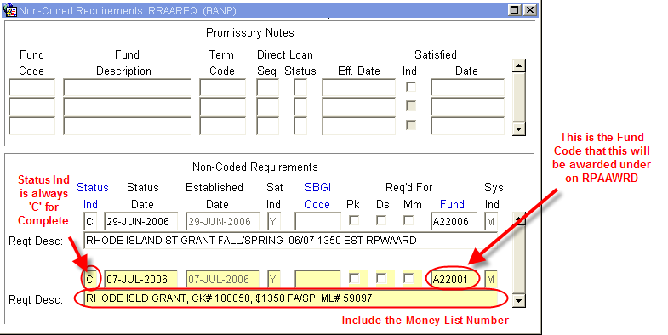
Figure 7 – Non-Coded Requirements

Step 20 - Access RFRMGMT.

Step 21 - Add money to Fund if needed (follow fund increase procedures).

Step 22 – Perform the following on the physical check:
      - Endorse Check with UNM Stamp
      - Write Fund Code for RPAAWRD
      - Banner Index Code
      - Student’s Name
      - Students UNM ID
      - The Term of the Award
      - The Money List Number

Step 23 - Copy the check four times and distribute copies to the appropriate places:
1. 1 copy to officer
2. 1 copy for money list copy
3. 1 copy for money list original
4. 1 copy for check file

Step 24 – Complete the Money List.

Step 25 - Copy the Money List.

Do we want a message to student that we have received the check?? Any idea on turnaround time?

~ Fin ~

