Student Financial Aid

FA-208 PROCEDURE to process an external check made
Payable to UNM and The Student (Or Student Only)

Date Issued/Rev: 07/08/08
General Description: This procedure explains how to process an external check made payable to UNM and the Student (or Student Only). Non Money List
Responsible Manager: Financial Aid Director
Related Procedures:
Related Forms: RRAAREQ
ROAMESG
RRAAREQ
ROAENRL
SGASTDN

PROCEDURE to process an external check made
Payable to UNM and the Student

Step 1 – Verify the external check.

Step 2 - Date Stamp the check.

Step 3 - Highlight the SSN and UNM ID, term, and year on physical Check (Add as Appropriate).

Step 4 - Access RRAAREQ.

Step 5 - Confirm the Officer Certification. Please refer to Figure 1.

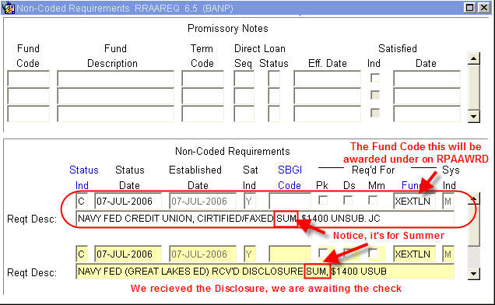
Figure 1 – Non-Coded Requirements

Step 6 - Access RPAAWRD.
Step 7- Confirm the Estimate Award. Please refer to Figure 2.

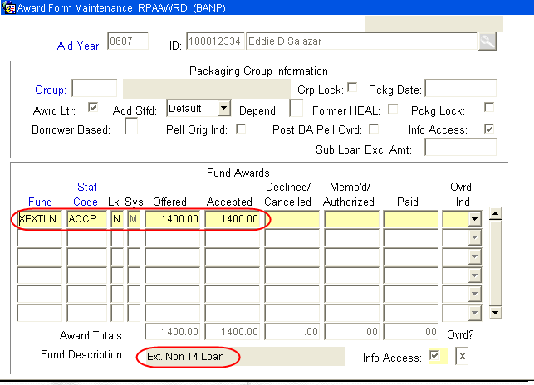
Figure 2 – Award Form Maintenance

Step 8 - Access ROAENRL.
Step 9 - Confirm Enrollment. Please refer to Figure 3.
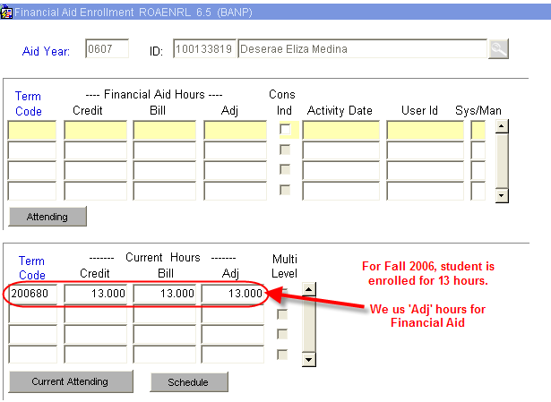
Figure 3 – Financial Aid Enrollment

Step 10 - Access SGASTDN.

Step 11 – Verify the College. Please refer to Figure 4.

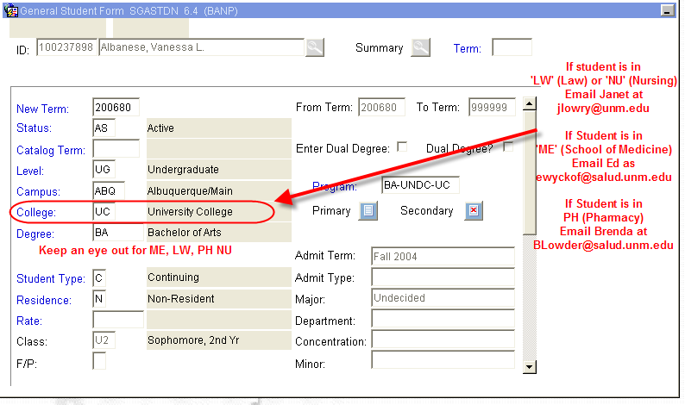
Figure 4 – General Student Form
Step 12 - Access RRAAREQ for a Log Check.

Step 13 - Perform ‘Next Block’ twice - to the ‘Non-Coded Requirements’ Block. Please refer to Figure 5.

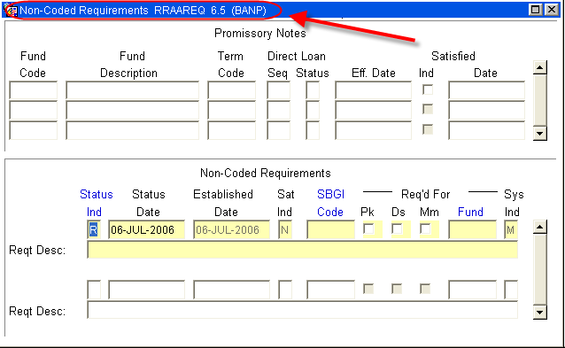
Figure 5 – Non-Coded Requirements

Step 14 - Log the Check in the ‘Non-Coded requirements” portion of the form.

Step 15 - Enter “C” (for “complete” in the ‘Status Ind’ field. Please refer to Figure 6.

Step 16 - Tab (once) to the ‘Reqt Desc’ field. Please refer to Figure 6.

Step 17 - Enter information about the award:

NOTE: there are only 60 spaces to use, try to provide as much information in as little space as possible
- The Source of the Award
- Check Number
- The Term of the award (i.e. fall only $1000, fall/spg $1000 per semester)
- The Money List Number, if any
- Indicate if the Check was sent to Cashiers for signature

Step 18 - ‘Save’

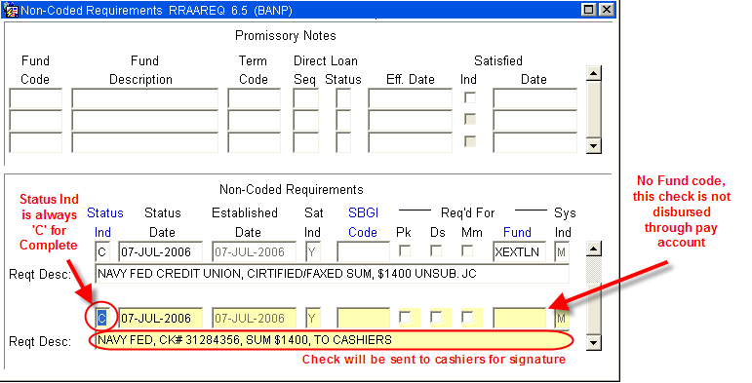
Figure 6 – Non-Coded Requirements

Step 19 - Access ROAMESG to enter a message to the student. Please refer to Figure 7.

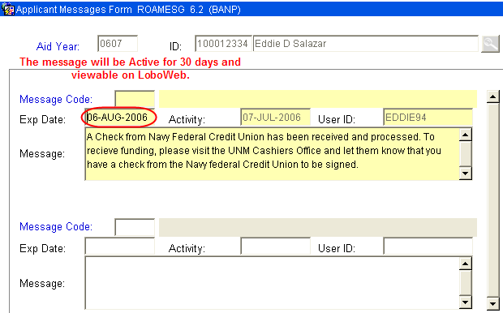
Figure 7 – Applicant Message Form

NOTE: You may also send the student an email by accessing RNANA07 - the email address is on the first block.

Step 20 - Separate Check from the Stub.
Step 21 - Write SCAN ONLY on Check Stub.
Step 22 - Write Officer Name on Check Stub.
Step 23 - Make two copies and distribute them to the following people:
      - Officer
      - File
Step 24 - Deliver Check to the Cashiers Office.

NOTE: Checks are held at Cashiers Office in the “Grey Box” for student signature.

~ Fin ~

