Student Financial Aid

FA-209 PROCEDURE to Process a Tribal Check
For FUNDS

Date Issued/Rev: 07/09/08
General Description: This procedure explains how to process a Tribal Check.
Responsible Manager: Financial Aid Director
Related Procedures:
Related Forms: RRAAREQ
ROAMESG

PROCEDURE to Process a Tribal Check

Step 1 - Verify external check.

Step 2 - Date Stamp the check stub.

Step 3 – Highlight the following information on the physical check stub:
1. SSN
2. UNM ID
3. Tribe
4. Term
5. Year

Step 4 - Access RRAAREQ Log Check

Step 5 - Identify the Needs Analysis Documentation on the First Block of RRAAREQ - the Needs Analysis name should correspond to the Tribe making the Check Payment. Please refer to Figure 1.

NOTE: If NO Needs Analysis exists: search for the appropriate Tribe and set ‘Status Ind’ to ‘4’ (Check Received). IF MORE THAN ONE Needs Analysis exist: Be sure that you update the Needs Analysis that is tied to the Check that you logging.

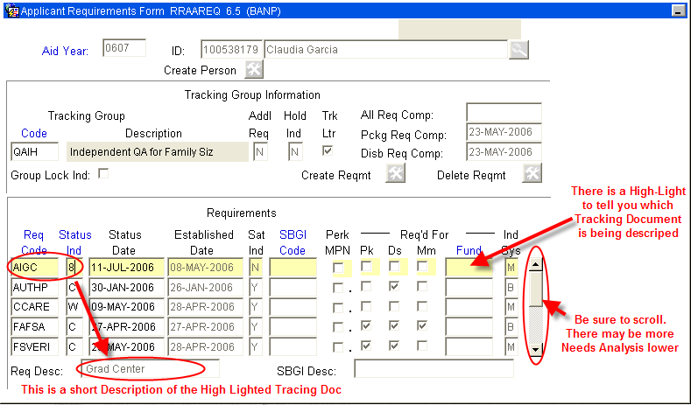
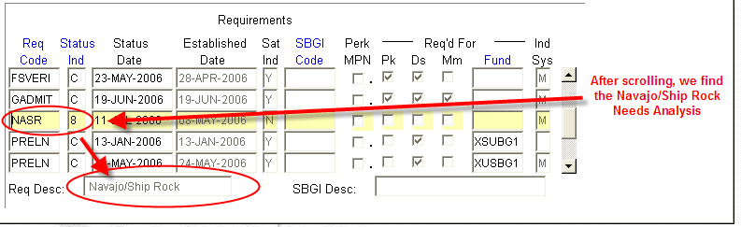
Figure 1 – Applicant Requirements Form

Step 6 - Update the Needs Analysis “Status Ind” with the code of ‘4’ (Check Received). Please refer to Figure 2.
Step 7 – Verify this has displayed on self-service that the Check for this Needs Analysis has been received and suppress the Missing Information Letter. Please refer to Figure 2 and 3.

NOTE: You may double click in the “Status Ind” field for a list all values. ***Numbers are used for the logging of Checks and Needs Analysis.

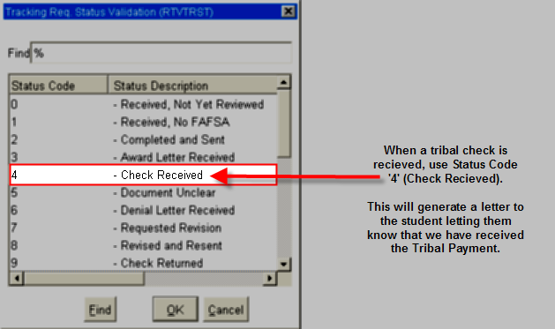
Figure 2 – Tracking Req Status Validation
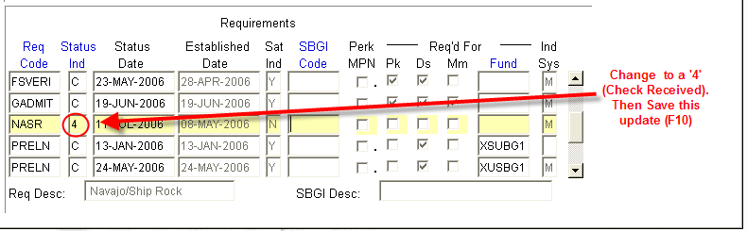
Figure 3 – ‘Status Ind’
Step 8 - Save (F10)

Step 9 - Perform ‘Next Block’ - to the ‘Non-Coded Requirements’ Block. Please refer to Figure 4.

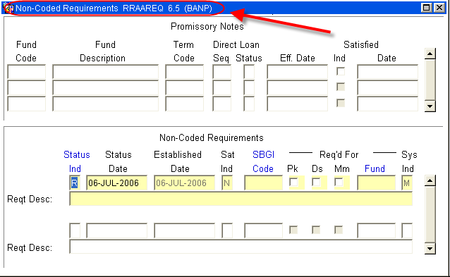
Figure 4 – Non-Coded Requirements

Step 10 - Log the Check in the ‘Non-Coded requirements” portion of the form.

Step 11 - Enter “C” for “complete” in the ‘Status Ind’ field.

Step 12 - Tab to the ‘Fund’ Field.

Step 13 - Enter the fund code that you are using for awarding.

Additional resources: For a list of values (F9), double click in the Fund field to search for a “Fund Code”, This is the Fund Code the Officers will be using to award and ties the disbursement to the FOAPAL.
NOTE: When searching for a Tribal Fund Code, try searching on a few letters that abbreviate the Tribe or the fist three letters of the Tribe.
For Example: For Navajo try: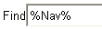
For Santo Domingo try:
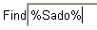
Step 14 -Select which fund code to use after the Description is found. Please refer to Figure 5.
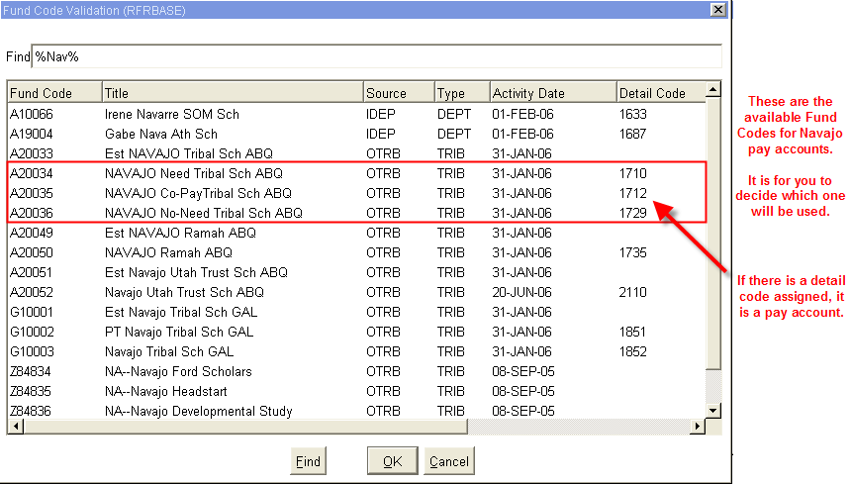
Figure 5 – Fund Code Validation

Step 15 - Tab (once) to the ‘Reqt Desc’ field and enter information about the award after the Fund has been entered.
NOTE: there are only 60 spaces to use, try to provide as much information in as little space as possible
- The Source of the Award
- Check Number
- The Term of the award (i.e. fall only $1000, fall/spg $1000 per semester)
- The Money List Number (if any)
- Indicate if the Check was sent to Cashiers for signature
Step 16 - ‘Save’

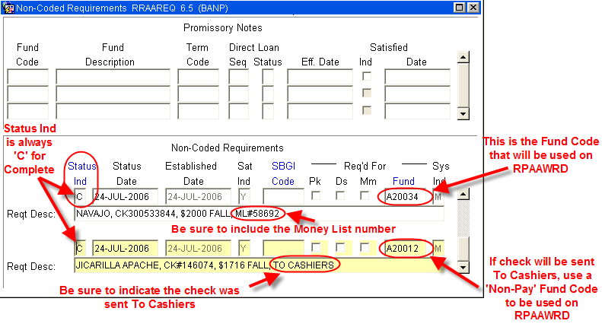

IF DISBURSED THROUGH A PAY ACCOUNT (MONEY LIST):

Step 1 - Access RFRMGMT
Step 2 - Add money to Fund if needed (follow fund increase procedures).
Step 3 – Perform the following actions on physical check stub:
      - Endorse Check with UNM Stamp
      - Check Number
      - Tribe
      - Term of Award
      - Write Fund Code for RPAAWRD
      - Banner Index Code
      - Students’ Name
      - Students’ UNM ID
      - The Money List Number

Step 4 - Copy check stub 3 times and distribute appropriately:
1. For Office records
2. For Copy of Money List
3. For Officer - forward copy to Officer for verification and awarding

Step 5 - Complete the Money List.
Step 6 - Copy Money List for Office records

IF CHECK IS TO BE SENT TO CASHIERS:

Step 1 - Access ROAMESG
Step 2 - Create a message to student. Please refer to Figure 7.

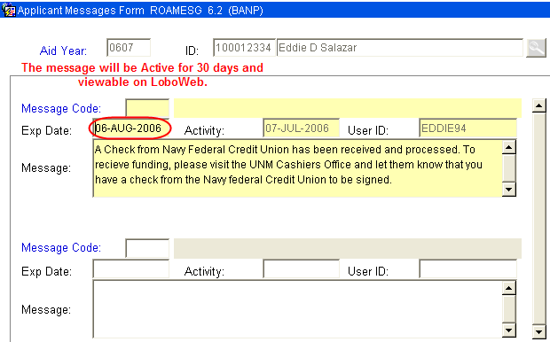
Figure 7 – Applicant Message Form

NOTE: You may also send the student an email by accessing RNANA07 - the email address is on the first block.
Step 3 – Separate the check from the stub.
Step 4 - Endorse check with UNM Stamp (if applicable).
Step 5 – Perform the following actions on the physical check stub:
1. Check Number
2. Tribe
3. Term of Award
4. Write Fund Code for RPAAWRD
5. Banner Index Code
6. Students’ Name
7. Students’ UNM ID
Step 6 - Copy the check stub 2 times and distribute them appropriately:
1. Office records
2. For Officer (include Officer Name) - forward copy to Officer for verification and awarding
Step 7 - Deliver check to Cashiers Office

NOTE: Checks are held at Cashiers, in the “Grey Box” for student signature.

~ Fin ~

