Student Financial Aid

FA-211 Searching for a Fund Index Number

Date Issued/Rev: 07/10/08
General Description: This procedure explains how to search for a fund index number.
Responsible Manager: Financial Aid Director
Related Procedures:
Related Forms: RFRBASE
TSADETC

PROCEDURE
Step 1 - Access RFRBASE.

NOTE: This form may appear first. Please refer to Figure 1.
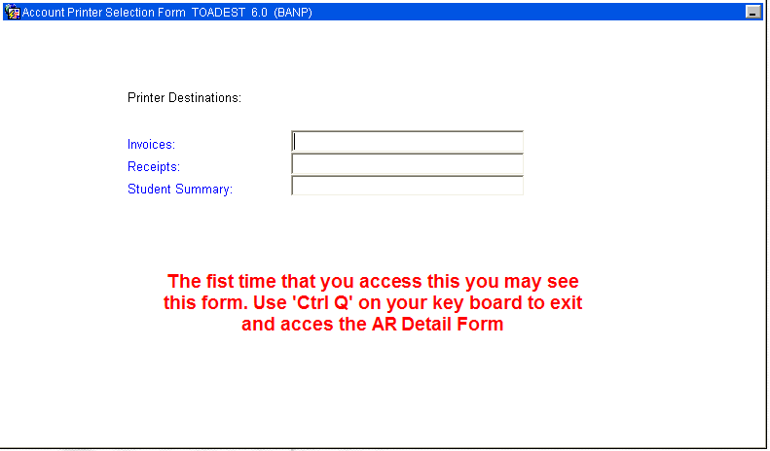
Figure 1 – Account Printer Selection Form

Step 2 - Click on ‘AR Detail’ to access Accounts Receivable information. Please refer to Figure 2 and 3.

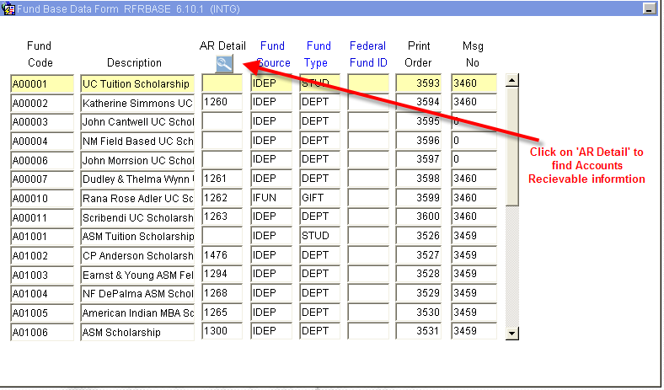
Figure 2 – Fund Base Data Form

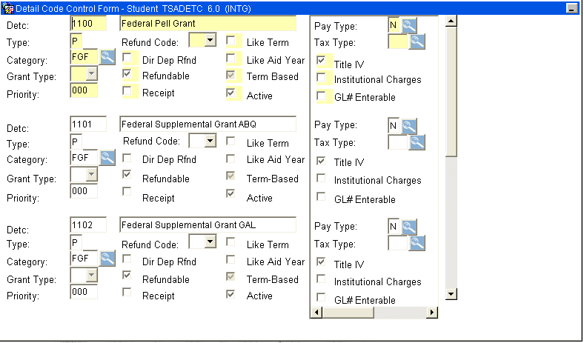
Figure 3 – Detail Code Control Form - Student

Step 3 - Press F7 (Enter Query).

Step 4 - Enter a short ‘Name’ of the account you are searching for. Please refer to Figure 4.

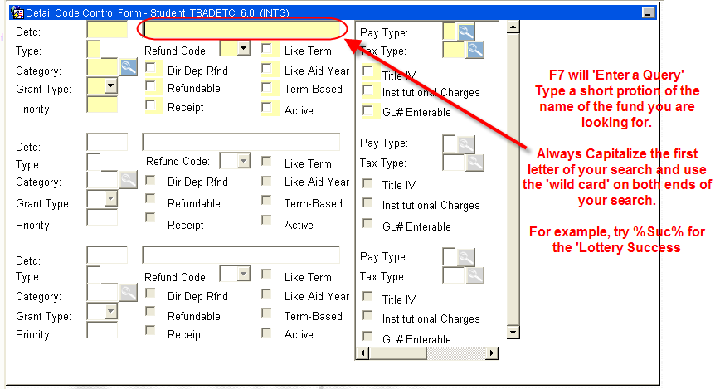
Figure 4 – Detail Code Control Form

Step 5 – Press F8 to ‘Execute the Query’. Please refer to Figure 5.

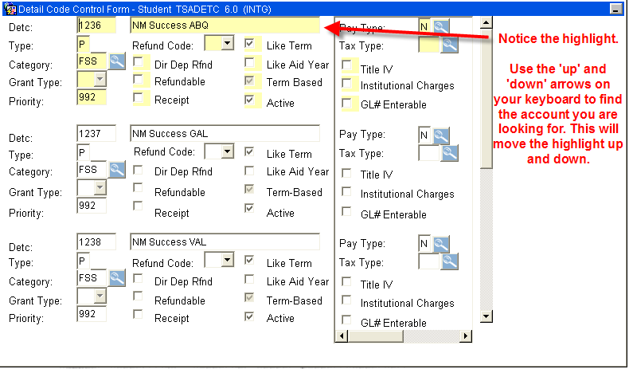
Figure 5 - Detail Code Control Form

Step 6 - Perform ‘Next Block’ to bring up Finance Information on this account after the account is found (and highlighted). Please refer to Figure 6.

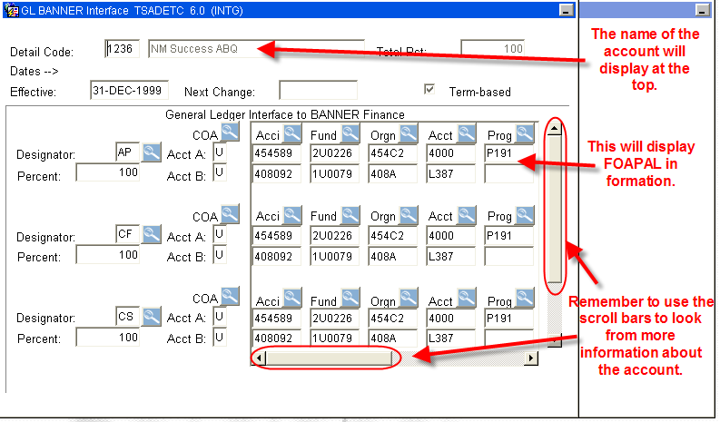
Figure 6 – GL Banner Interface

