Student Financial Aid

FA-221 PROCEDURE to process an external check made
Payable to UNM and The Student (Or Student Only)
For Scholarships

Date Issued/Rev: 07/10/08
General Description: This procedure explains how to process an external check made payable to UNM and the Student (or Student Only). Non Money List
Responsible Manager: Financial Aid Director
Related Procedures:
Related Forms: RRAAREQ
ROAMESG
RRAAREQ
ROAENRL

PROCEDURE to process an external check made
Payable to UNM and The Student

Step 1 – Verify the external check.

Step 2 - Date Stamp the check stub.

Step 3 - Access RPAAWRD.

Step 4 - Confirm Estimate Award. Please refer to Figure 1.

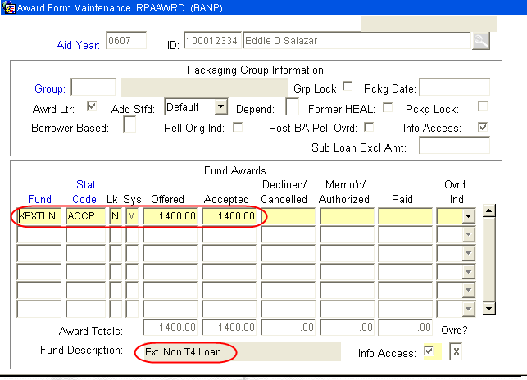
Figure 1 – Award Form Maintenance

Step 5 - Access ROAENRL.

Step 6 - Confirm the student’s enrollment status. Please refer to Figure 2.

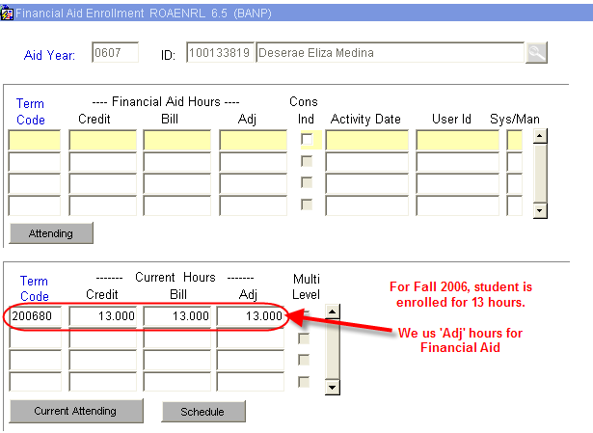
Figure 2 – Financial Aid Enrollment

Step 7 - Access RRAAREQ Log Check.

Step 8 - Perform ‘Next Block’ twice - to the ‘Non-Coded Requirements’ Block. Please refer to Figure 3.

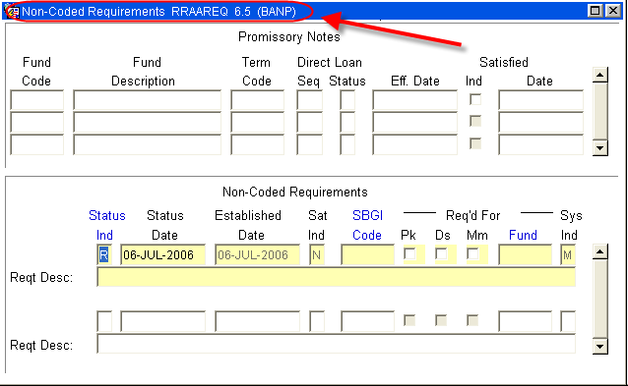
Figure 3 – Non-Coded Requirements

Step 9 - Log the Check in the ‘Non-Coded requirements” portion of the form.

Step 10 - Enter “C” (for “complete” in the ‘Status Ind’ field.

Step 11 - Tab (once) to the ‘Reqt Desc’ field.

Step 12 - Enter the following information about the award:

NOTE: there are only 60 spaces to use, try to provide as much information in as little space as possible. Please refer to Figure 4.

- The Source of the Award
- Check Number
- The Term of the award (i.e. fall only $1000, fall/spg $1000 per semester)
- Indicate if the Check was sent to Cashiers for signature

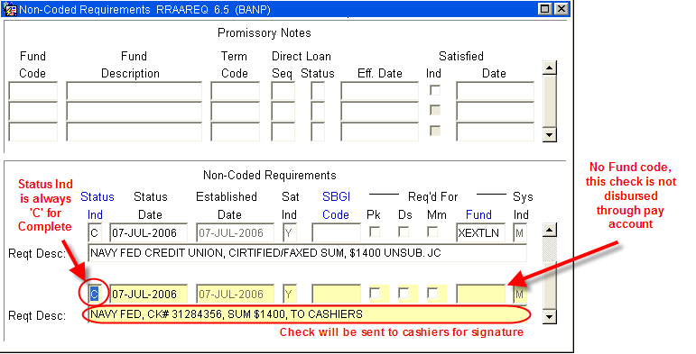
Figure 4 – Non-Coded Requirements

Step 13 - Save

Step 14 - Access ROAMESG to enter a message to the student. Please refer to Figure 5.

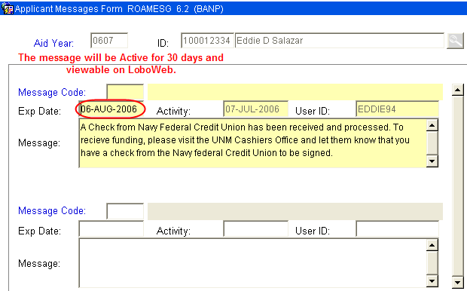
Figure 5 – Applicant Messages Form

NOTE: You may also send the student an email by accessing RNANA07 - the email address is on the first block. You may also access the students email account on GOAEMAL if no RNANA07 record exists.

Step 15 - Separate the Check from the Stub.

Step 16 – Copy (one) for the file.

Step 17 - Deliver Check to Cashiers Office.

NOTE: Checks are held at Cashiers, in the “Grey Box” for student signature.

~ Fin ~

