Student Financial Aid

FAFM – 103 Return of Title IV Funds, Official W/D (OW)

Date Issued/Rev: 6/17/08
General Description: This procedure explains how to process Return of Title IV Funds calculations & adjustments for students who officially withdraw from all classes (OW).
Responsible Manager: Financial Aid Director
Related Procedures: FAFM – 105 Maintaining W/D Reports, FAFM – 107 R2T4, Unofficial W.D (UW)
Related Forms: SFAWDRL, RPAAWRD, ROAENRL, ROASTAT, RHACOMM, RPATIVC, RPAELAP, RPAAPMT, RPALDSB, ROAIMMP, TSAAREV, RSIAREV, SFIWDRL, RRAAREQ, ROIDISB, ROILOGA, SFASCTA, SHATERM, SHATCKN

General Remarks:

- Federal Title IV aid is: Loans - Unsubsidized & Subsidized, Perkins, Grad Plus, Parent Plus
Grants - Pell, SEOG, ACG, SMART

- To maintain/update w/d file, see FAFM - 105 Maintain / Update Official W/D File
- To process unofficial w/d’s, see FAFM – 107 Return of T4 funds, (UW)

- W/D before term began;
  - Change RPATIVC to $0 disb. Fund Lock = Y. Re-run sim. S/b $0 revised
    - Calc & save.
    - Do steps 7 – end.

- Military W/D’s: Under the Hero’s Act, a military w/d will not be responsible for repaying grant overpayments (UNM’s or student’s portion). Also, for PWDs, a military w/d will have 45 days to respond instead of the usual 14 days.

- If UNM is informed that a student has died during a semester, we must perform a r2t4 calc.. If the calc. indicates we are required to return t4 aid, we must return the funds. (Note: Bursar’s policy is to write off debt of deceased students.)

- If a student drops all classes except correspondence course(s) that are not expected to be complete before the end of the semester the form was completed, student is considered an OW W/D. Use w/d date from all other classes as Official W/D date & calc. R2t4. We CANNOT fund correspondence courses that will not be completed during the term. In order for a student to receive financial aid for correspondence courses, the correspondence course form MUST indicate they expect to complete the course(s) no later than the end of the term for which they're completing the form.

- After disbursement, T4 aid may only be cancelled at the student’s request. Loans can only be cancelled within 14 days of the student’s notification that the $ is available. Grants can only be canceled after r2t4 calc & adjustment (if any). Record request on RHACOMM. Scan hardcopy, if available.

- Questions to ask yourself;
Is the student a “real” w/d? (re-enrolled, t4 aid?)
Were they eligible for t4 aid? For what, when?
Why didn’t aid credit?

1. Access w/d report, see FAFM-105 Maintaining W.D reports file
2. For each student, look at the following forms;
3. SFAWDRL Confirm inst. charges are not 0. Only include charges at time of, or before,
w/d date. Note: This can only be done before calculation is locked
on RPATIVC.

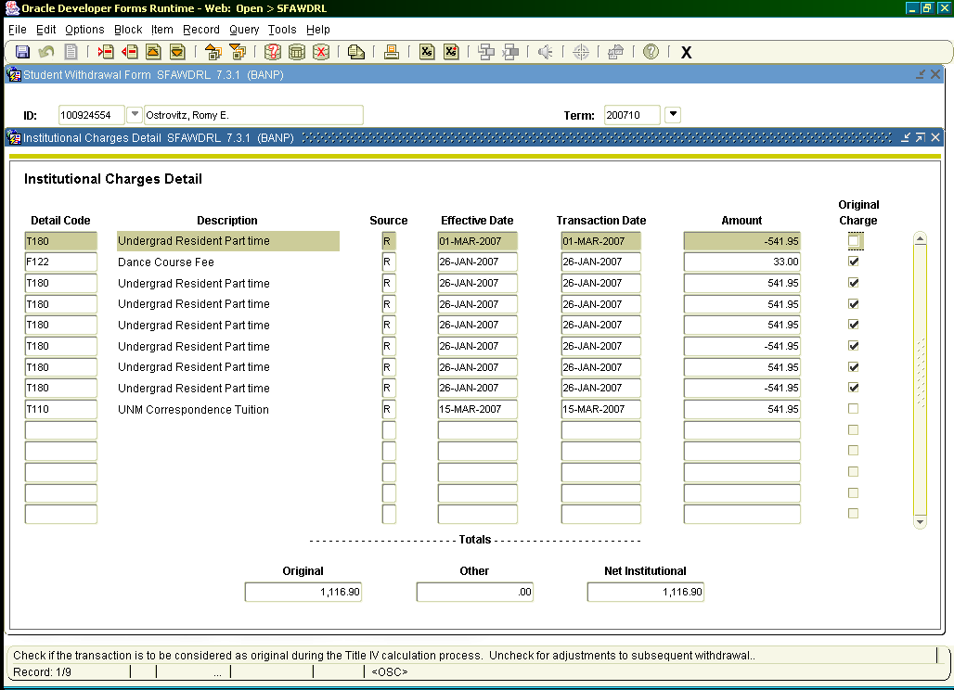

3. RPAAWRD W/S awards?, print screen, give to Marisa @ Stu. Employ./Workstudy.
Athletic awards?, “ ”, to Joseph @ Funds Mgmt.
Note student is flagged as “WD Exists for Aid Year”.

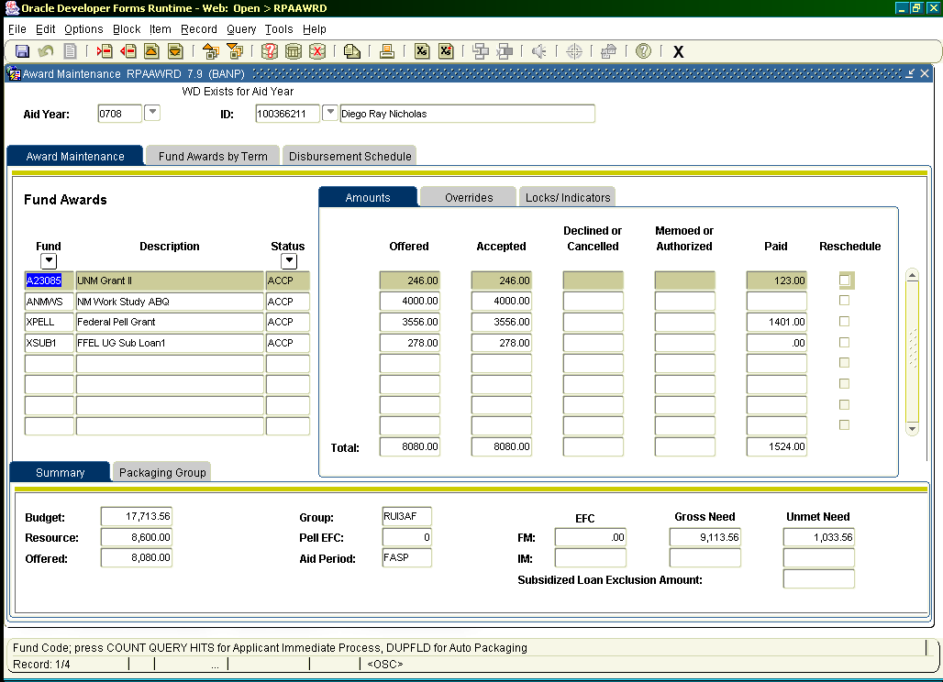

4. ROAENRL Check if FA Hours (Credit & Adj.) and Current Hours (Credit & Adj.) are 0, if
not go to 2nd block, schedule.
Confirm hrs > 0 b/c;
- Stu. re-enrolled (confirm on sfastca), note on
rhacomm, “stu dropped, then re-enrolled, removed w/d record, not a (semester code) w/d.”
- Stu. dropped with grade (DG), confirm on sfastca and roaenrl (schedule).

Check for c-sort. Confirm enrollment, save email, confirm enrollment again after 60% date.
Confirm enrollment period student was funded for (schedule).

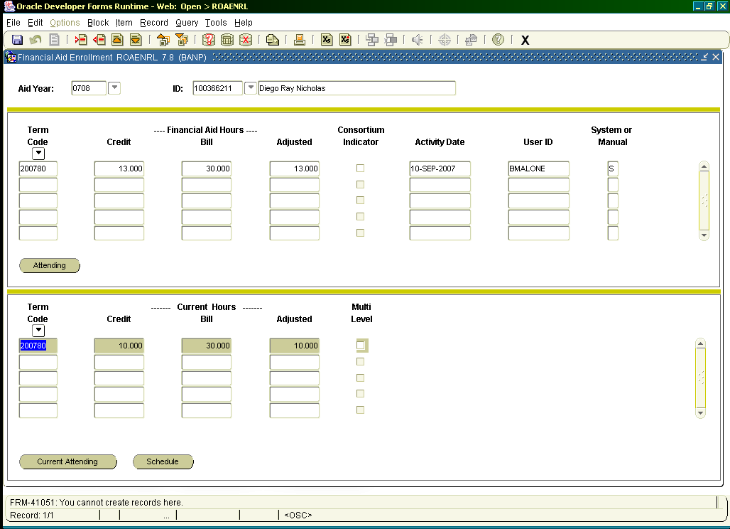

When you click the schedule button, you will see this:

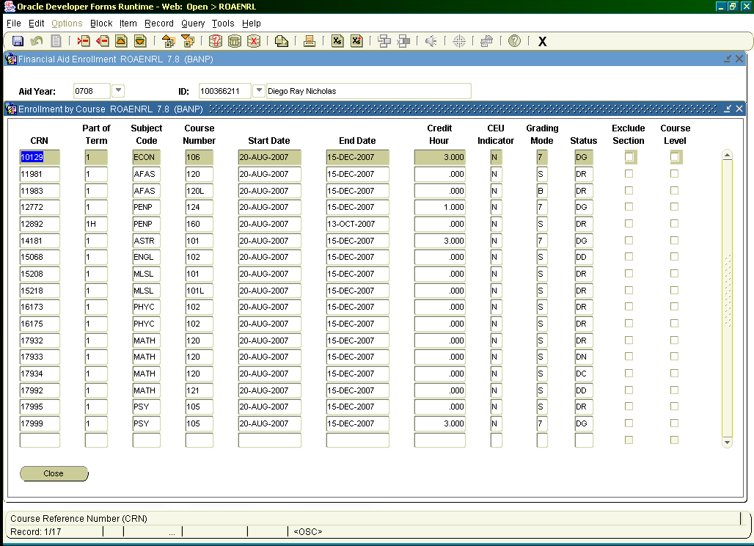

5. ROASTAT Check SAP, 3rd block

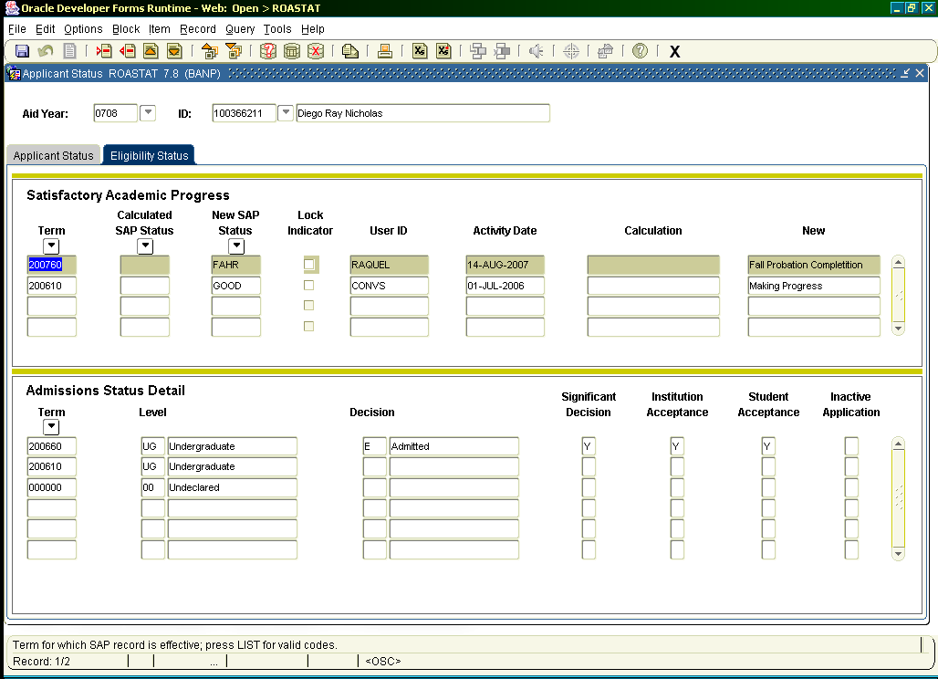

6. RHACOMM Make sure student was not already processed.
Note other relevant comments, csort, …
7. RPATIVC 2nd block, Options, simulation mode.
Note Student Sequence Number. If > 1, use sfiwdrl, confirm.

Make sure matches RPRTIVC report, confirm w. r2t4 on the web if needed.

Consult with officer on accurate award amounts and aid that could have credited (elig for ? @ time of w/d) . File must be complete.

Confirming PWDs; (Always check RRAAREQ & ROIDISB)
To be eligible for a $x loan pwd, RPAELAP (Application Status tab), Certified amount field must show $x. Date loan was certified is Created Date field. Loan certified date must be on or before w/d date. Loan Process Type must be “GO=Guar Only”.

To be eligible for $x grant (and perkins loan) pwd, stu must have been awarded on or before w/d date. Use RPAAPMT, Original Offer date.

Make sure “Eligible Disbursement” amount equals “Disbursed” amount. Change “Fund Lock” to “Y” & eligible disbursement amount(s) if needed.

Loans: Reduce by amount shown in “Institution’s Required Returns” field.
- New loan amount will be “Disbursed” amount minus “Institution’s
Required Returns” amount.

Grants: Reduce by amount shown in “Institution’s Required Returns” field.
- New grant amount will be “Disbursed” amount minus “Institution’s
Required Returns” amount.

Options, calc & save, confirm “Calculation Lock” box is checked.

Confirming Loan PWD’s
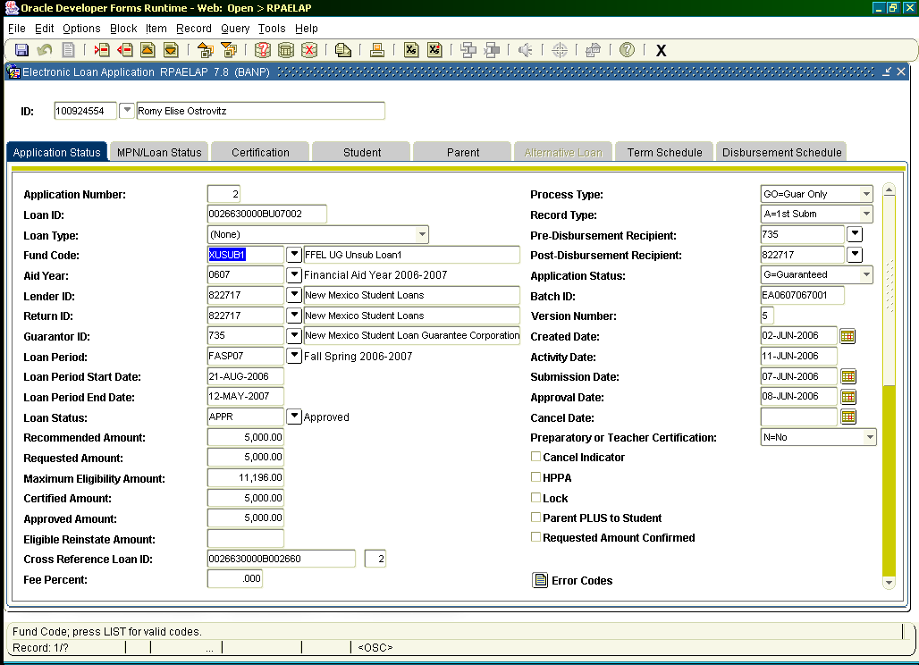
Confirming Grant PWD’s
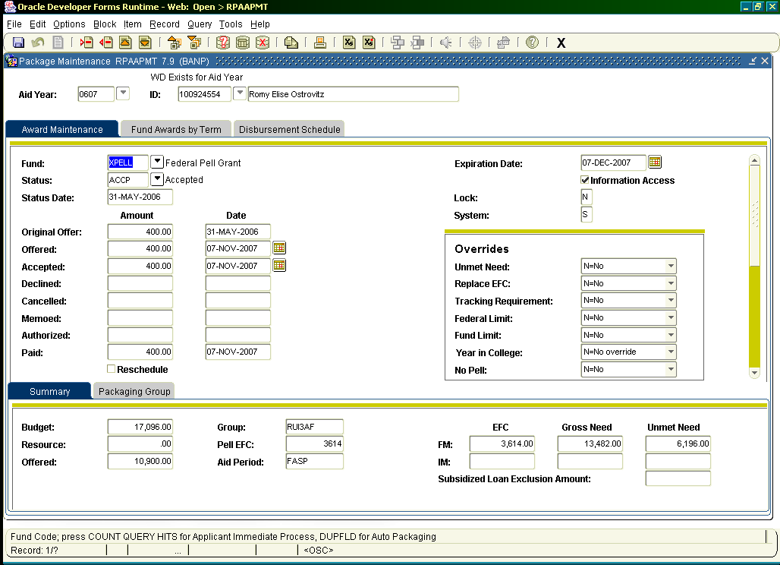

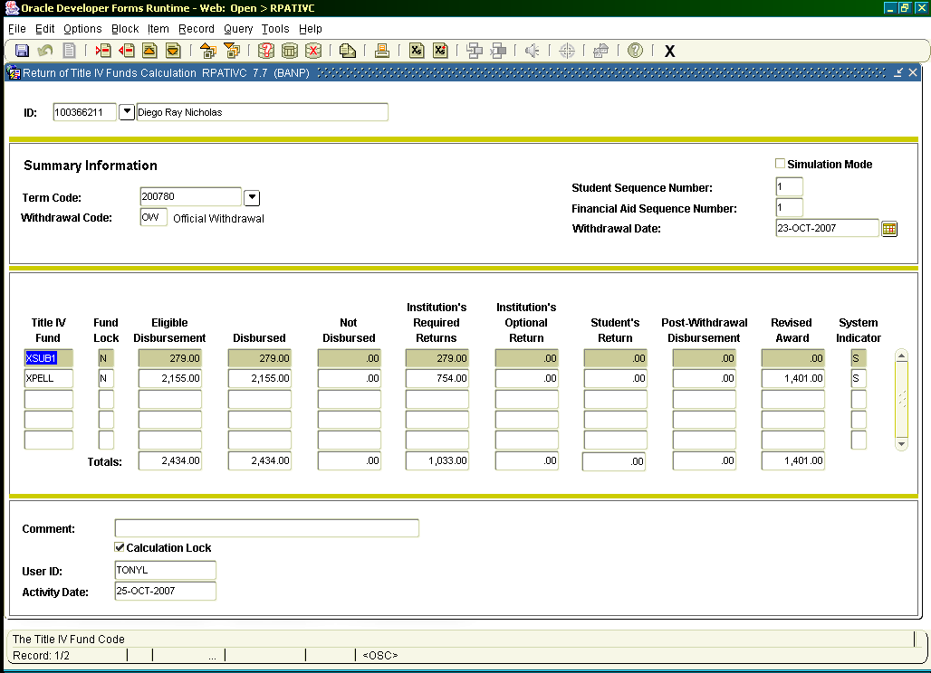

8. RHACOMM Summarize calc. & amt. for stu. to repay UNM, or if PWD, amt. offered, date
cert. ltr mailed and due date for response. If student responds, award, if no
response, cancel offer, leave note. (remember ROAMESG for unof’s)
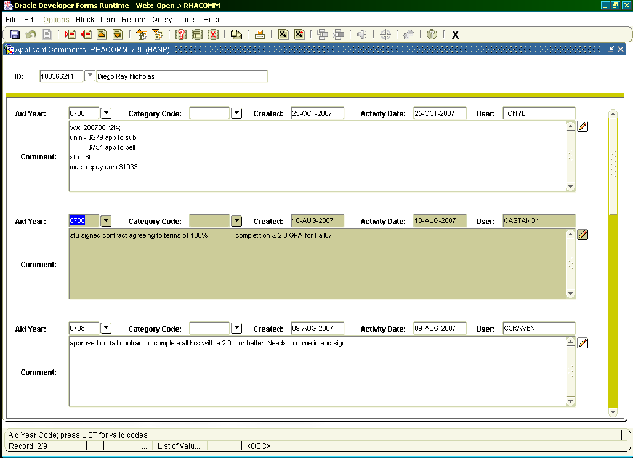
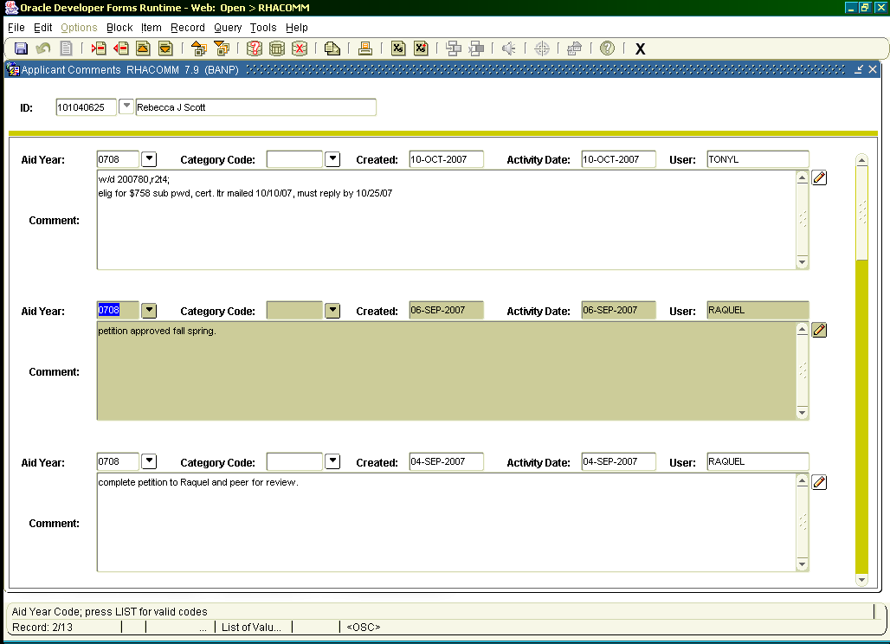

9. RPAAWRD Adjust awards, 3rd block, new offered & accepted amounts. .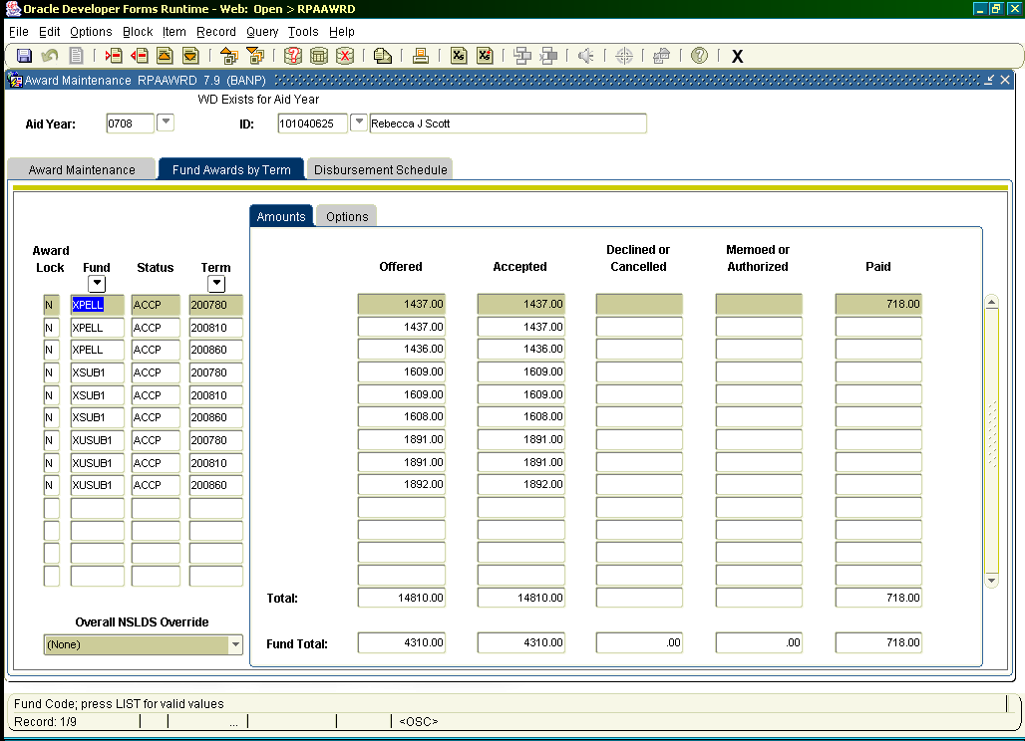
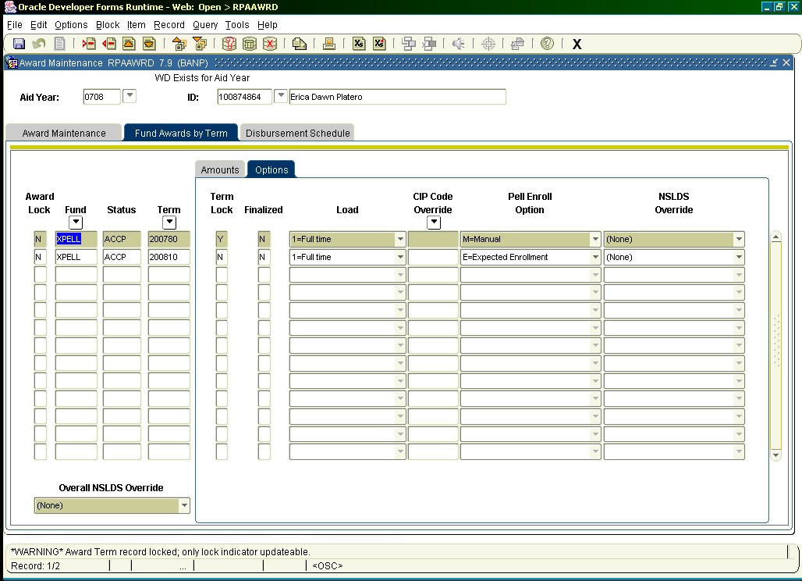
Lock term only when adjusting Pell.
10. RPALDSB Loans Only: 3rd block, return loan $, confirm semester, type, amount
Highlight “Reference ID”. Copy.
F6 to duplicate record. Paste refence Id to new record.
Tab to “Feed:: Y.
Tab to “Returned Amount”: enter amount to be returned.
Tab to “Comment”: enter “ret t4 aid – your initials”.
F10 to save.

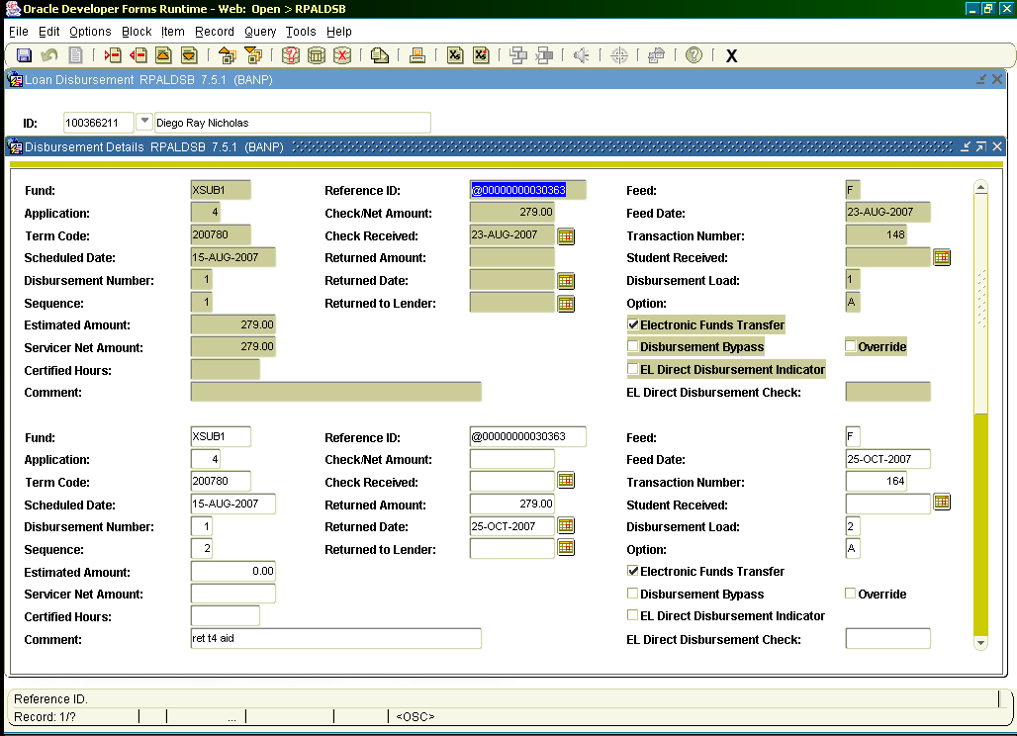

11. RPAELAP Loans only: Change the following fields to match RPAAWRD & RPALDSB
1st Block: Requested Amount, Approved Amount
Cert. Block: Certified Amount
Disb. Schedule Block: Change disb. % so amounts match
See
S:\SOPs\Financial Aid Policies and Procedures\500 Loan Awarding
For job aid with screen shots

12. ROAIMMP
Next block.
Check “Authorize or Disburse Available Aid” box.
Enter appropriate semester code.
F10 to save & disburse.

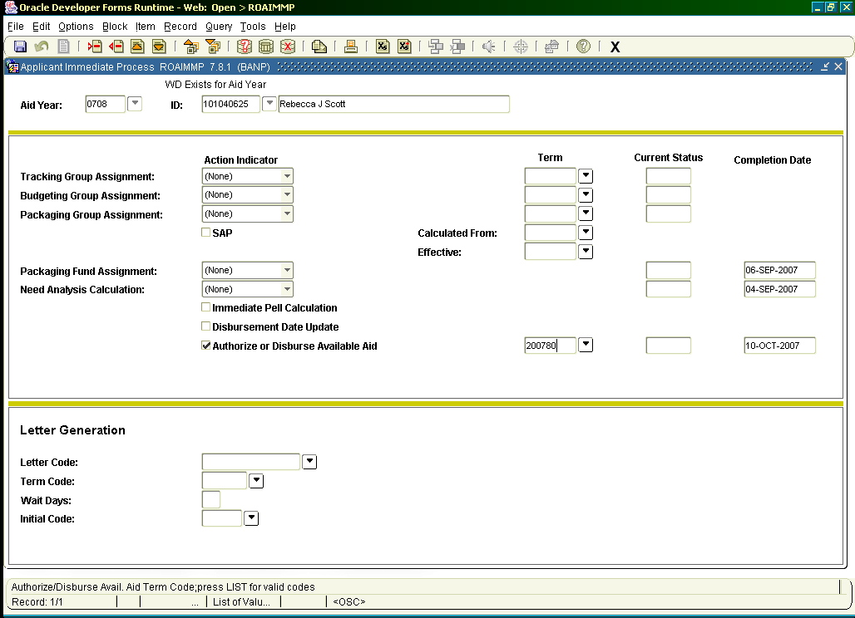

13. TSAAREV or RSIAREV Make sure aid backed off and other aid did not.
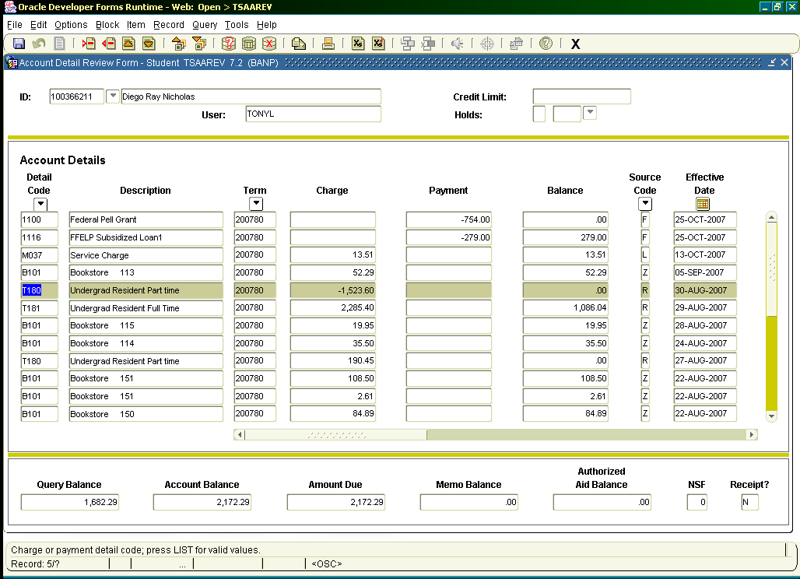

* * * E N D * * *

