Student Financial Aid

FAFM – 105 Maintaining W.D reports file

Date Issued/Rev: 10/26/07
General Description: This procedure explains how to maintain and update w/d reports files
Responsible Manager: Financial Aid Director
Related Procedures: FAFM - 103 Return of Title IV Funds, Official W/D (OW)
Related Forms: RPRTIVC

1. Go to RPRTIVC. This job creates w/d reports for a given semester code.
2. Enter “stu_banp” in Printer field.
3. Enter semester code.
4. Next block to SUBMISSION block.
5. F10 to save the report.

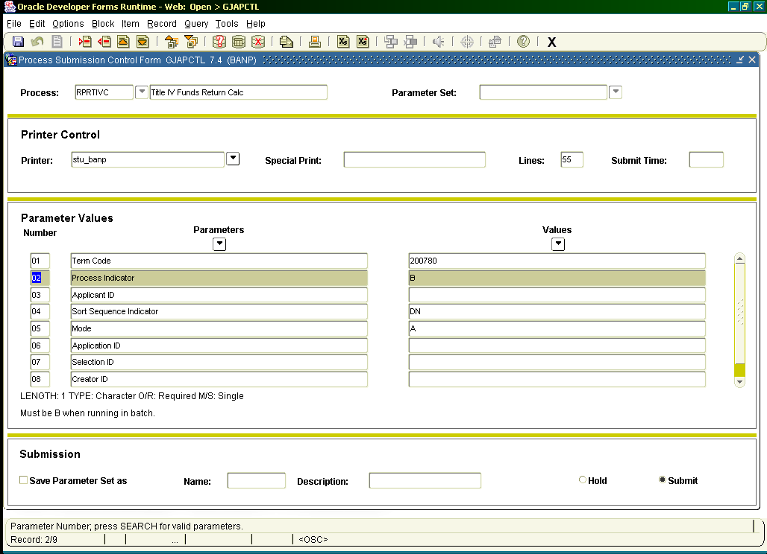

6. Go to https://eprint.unm.edu/cgi-bin/eprint.cgi
7. Enter User ID and Password.
For Repository, choose “stu_banp – Student/Fin Aid Banner – Production (banp)”.

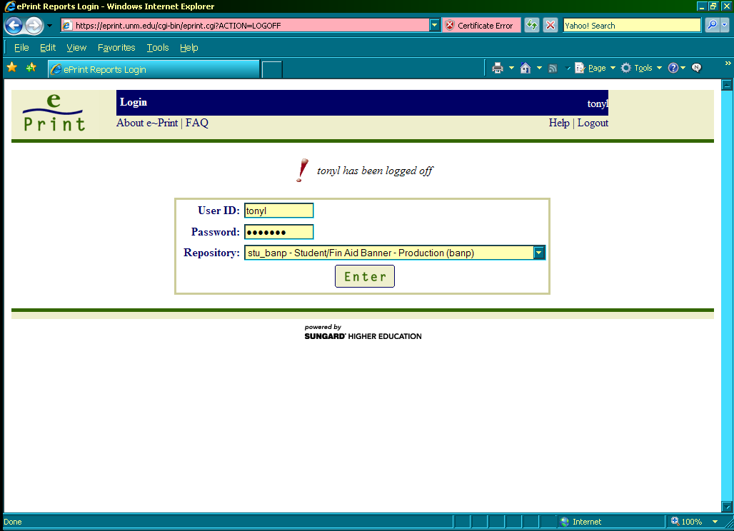

8. Choose RPRTIVC from drop down box in the lower center of screen. Use drill down icon to see all reports.

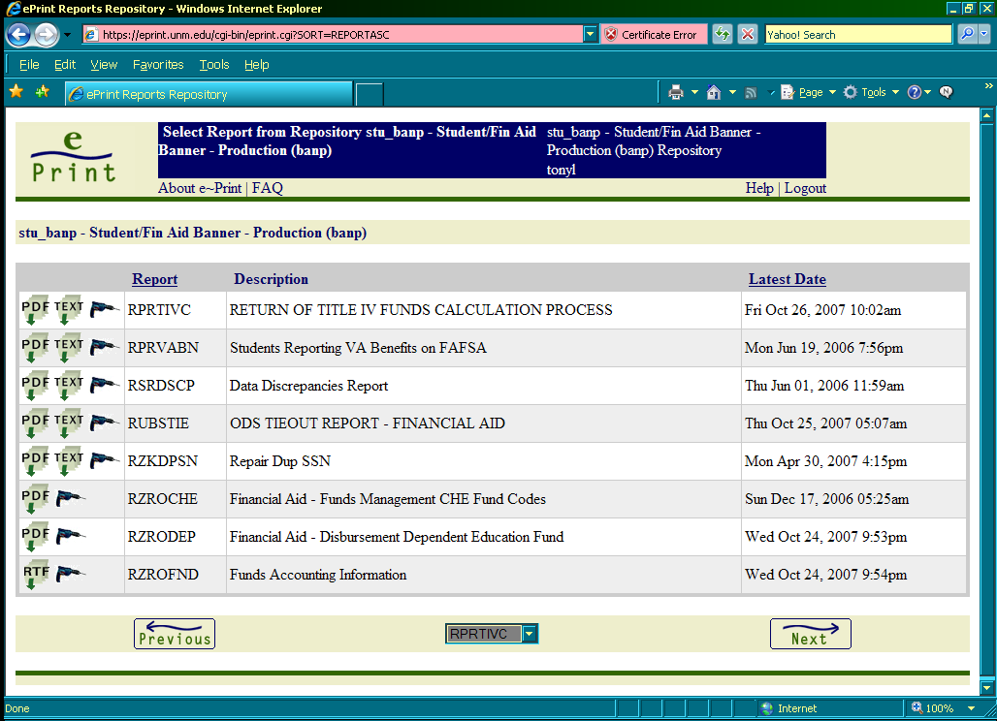

9. Click on PDF icon of report you want (may have to use drill down to see correct report date).

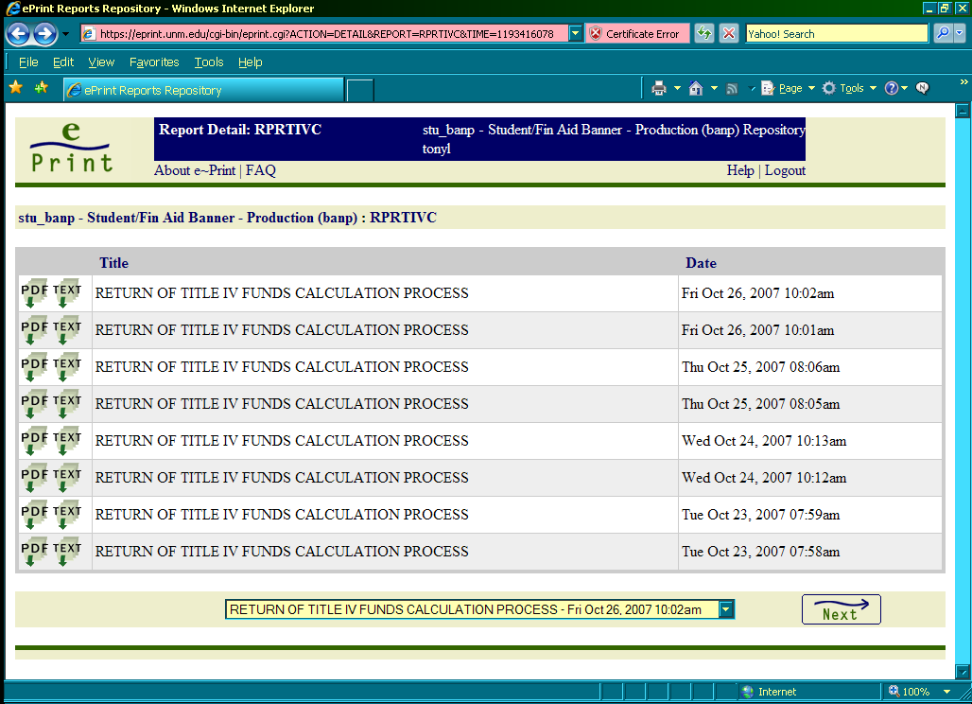

10. Example of W/D report

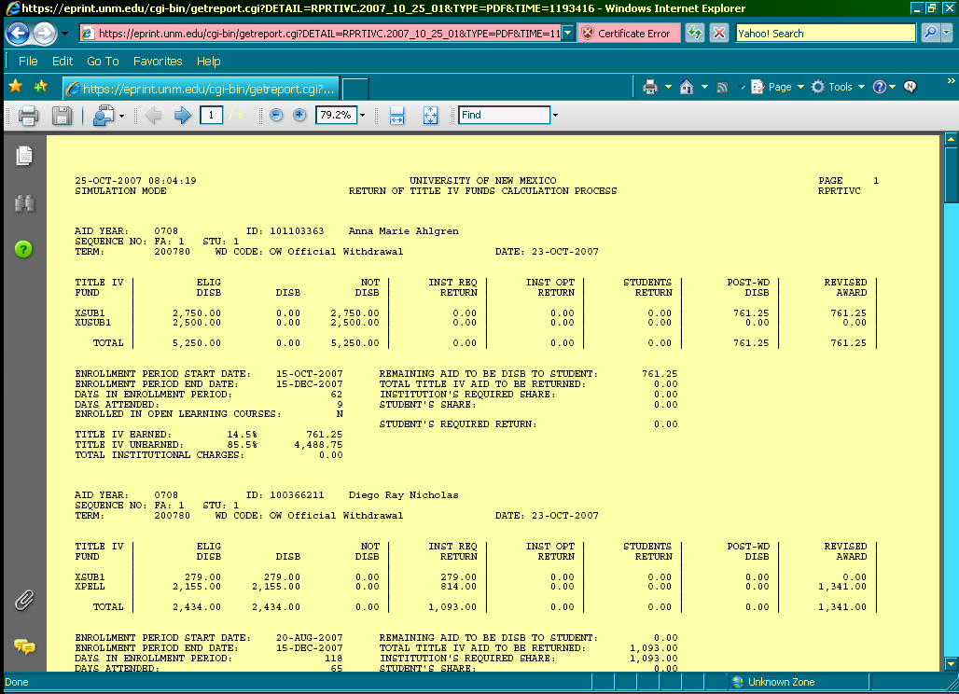

11. Save a copy of report to P/Shared/Accounting/Shortcut to W.D-Rpts (rprtivc) '06 '07 --/aid year/semester/semester code. Name it the date it was run. Print hardcopy if desired.

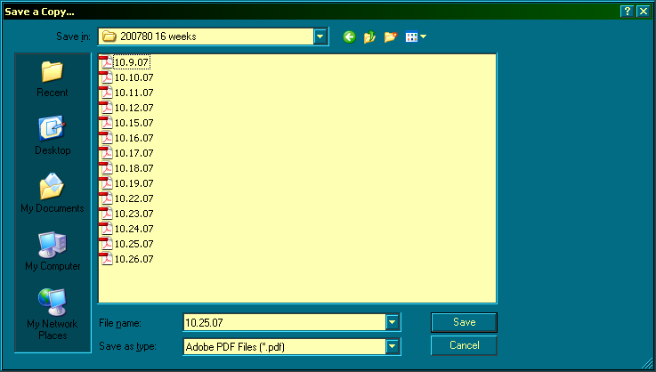

* * * E N D * * *

