 | LINK FINANCIAL AID  AWARD PACKAGING | 
 | FAPK-108 Package a Fund Manually | Date Issued: 7/28/2026
General Description:
This procedure explains how to package a fund manually.
Responsible Manager: Director of Financial Aid.
Related Forms:
RPAAWRD Award Maintenance
The procedure begins on the next page.
PROCEDURE
- From the direct access field of the main menu type RPAAWRD and press ENTER. Do NOT click on the magnifying glass.
- ID: Required. Type the student’s Banner identification number.
- Correct student found?
  - If yes, continue.
  - If not, go to UNM-100 or use on-line search tools and locate correct student.
- Select “Next Block”
- Choose next action:
  - If the student has not already been offered funds, the cursor displays in a blank row when the form is accessed.
  - If not, move the cursor to a row and select “Insert Record.”

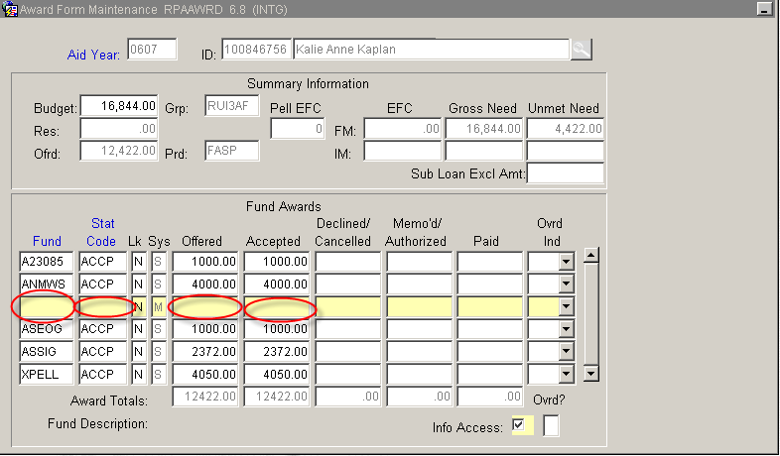

- Fund Code: Required. Type the fund code or click in the field to select from the pop-up window.
- Use “Tab” or use the ENTER key to move to Award Status.
- Award Status: Required. Type the code for the fund being offered or click on STAT CODE to display the status codes. Highlight the selection and click on “Select.”
- Offer Amount: Required. Enter the amount of the fund being offered. NOTE: Decimals and commas are not needed.
- Accept Amount: Conditional:
  - If the student has accepted the fund, or it has been auto-accepted by Banner, no entry required. Auto populates when saved.
  - If not, enter the amount accepted.
- Select “Save.”
- Check “Auto Help”
When saved, the award validation process starts and verifies that the student meets the eligibility requirements for the fund(s). If the student is not eligible to receive a fund, a message displays in the gray Auto Help bar stating why the student is ineligible. Delete this fund from the student’s awards (Use the Remove Record function or the tool bar button).
- More funds to package?
  - If yes, return to step 1.
  - If not, select “Exit.”
* * * E N D * * *

