Student Financial Aid

EMAIL-101 Sending MILS through Hobson’s

Date Issued/Rev: 04/04/2008
General Description: This procedure explains how to merge Banner MIL data with the Hobson’s Tool to send email notification
Responsible Manager: Financial Aid Director
Related References:
Related Procedures:
Websites Used:
Upload/Download Page -
Hobson’s EMT -
Will need:
WordPad
Microsoft Excel

Access the Upload/Download Site –
Save the MIL Files as a .csv file
Open the .csv files
For the ADMIT file delete the ZIP Code Column and the FAFSA Email Column - save
For the NOAD file delete the Zip Code Column and the UNM Email Column – save
Access Hobson’s EMT website
Upload .csv files
Merge NOAD with the Not Admitted MIL and queue EMAIL to be sent
Merge ADMIT with the Admitted MIL and queue EMAIL to be sent

PROCEDURE
Procedure:
- ACCESS UPLOAD/DOWNLOAD SITE
  - Access the Upload/Download site at https://www5.unm.edu/pls/unm/gzvupld.home
    - You will need your UNM NetID and Password to Login
  - Select ‘Download Files’ from menu on the left
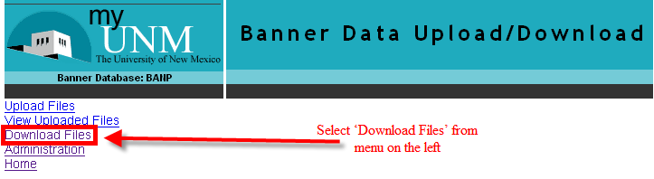
  - In the Banner File Download screen, scroll down to FINAID MISSING INFO LTRS 0809
  - Select FINAID MISSING INFO LTRS 0809 (it may take 20 to 30 seconds for the next page to open once FINAID MISSING INFO LTRS 0809 is seleceted)

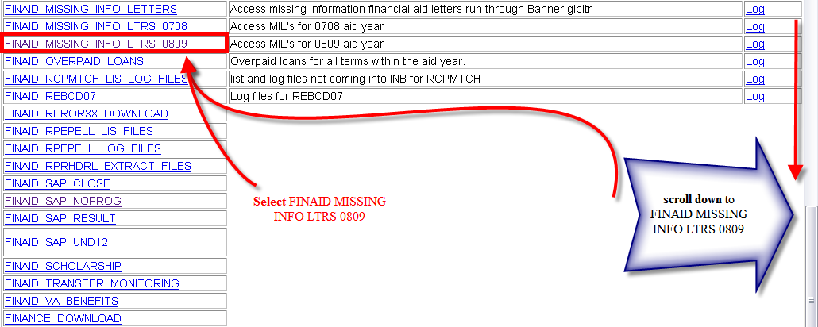
  - In the Banner File Download screen, scroll down to the desired SFAO-FA09MIL date
  - Right Click desired ‘SFAO-FA09MIL FINAID ADMIT #######.txt’
    - In the Right Click Menu Select ‘Save Target As…’ (In Internet Explorer) OR ‘Save Link As…’ (In FireFox).
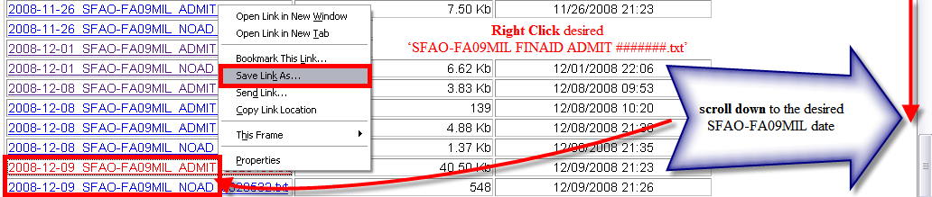
    - When Saving, name the file to match the file name from the download site (you may omit the numbers at the end of the file name).
    - It must be saved as a .csv file
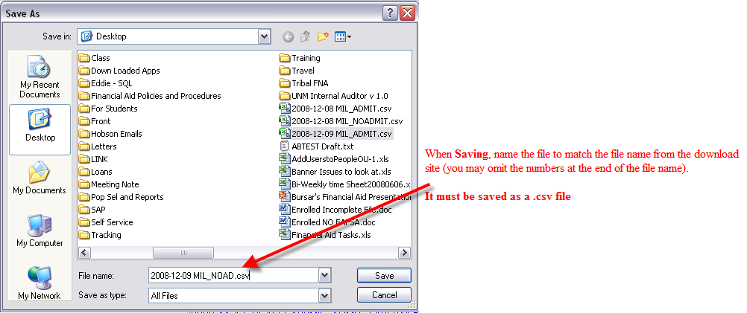

  - REPEAT the process for the ‘SFAO-FA09MIL FINAID NOAD #######.txt’ file
    - Right Click desired ‘SFAO-FA09MIL FINAID NOAD #######.txt’
    - In the Right Click Menu Select ‘Save Target As…’ (In Internet Explorer) OR ‘Save Link As…’ (In FireFox).
    - When Saving, name the file to match the file name from the download site (you may omit the numbers at the end of the file name).
    - It must be saved as a .csv file
  - Exit the Upload/Download Site

- OPEN THE .CSV FILES
  - Open the newly saved .csv files
  - For the ADMIT.csv file:
    - Select the ZIPC Column from the file and delete the ZIPC column
    - Select the **AA_FAFSA_EMAIL Column from the file and delete the **AA_FAFSA_EMAIL column
    - Save and close file
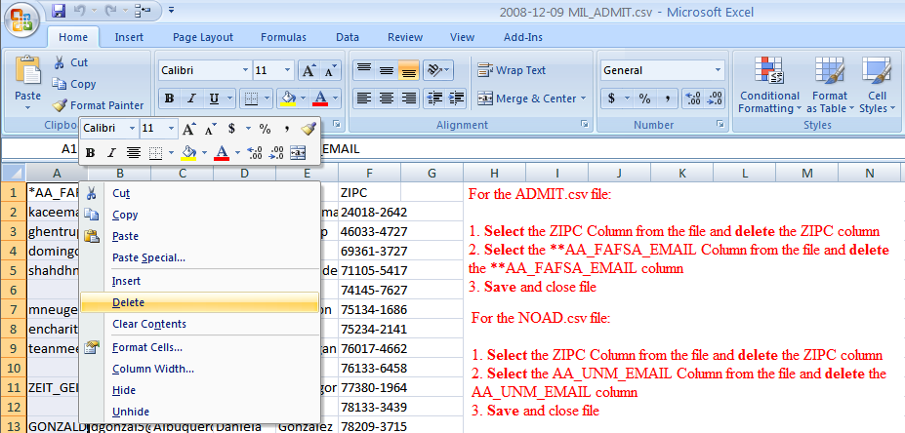
- For the NOAD.csv file:
    - Select the ZIPC Column from the file and delete the ZIPC column
    - Select the AA_UNM_EMAIL Column from the file and delete the **AA_UNM_EMAIL column
  - Save and close file

- ACCESS HOBSON’S EMT -
  - Access Hobson’s EMT at https://connect2.askadmissions.net/unm_ug/Admin/login.aspx
    - Enter your Hobson’s User Name and Password
  - Import the .csv files
    - Select the ‘Contacts’ Tab, Click ‘Import Now’

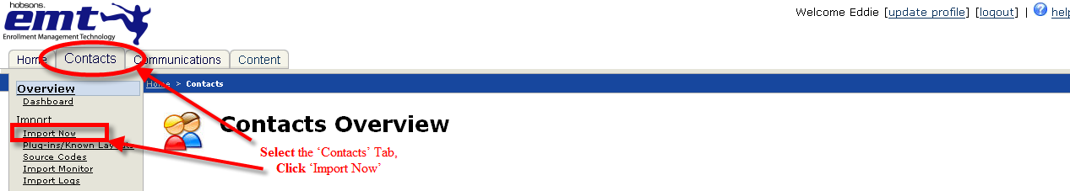
  - In Step 1, Select ‘Known Layout’
    - After Selecting ‘Known Layout’ Select ‘Fin Aid Missing Info Letters Admitted’
  - Step 2, Load ADMIT .cvs file from saved location
  - Confirm Step 3 – 5:
    - Step 3: Comma Delimiter radio button is selected
    - Step 4: Double Quote radio button is selected
    - Step 5: First row box is checked
  - Click ‘Next’
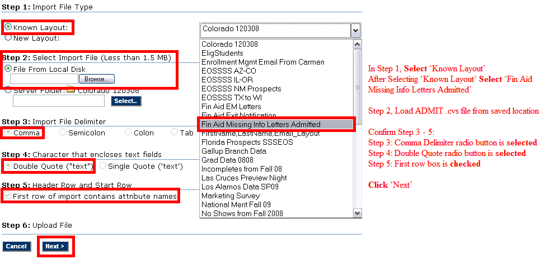
  - On the Import Contacts Wizard-Mappings page
    - Verify the File Uploaded is the correct .csv file
  - Verify Step 1 -2:
    - Step 1: ‘Column Attribute’ match the ‘EMT Attribute’
    - Step 2: ‘Edit| Delete – FName, LName, E-Mail’ boxed is checked
  - Click ‘Next’
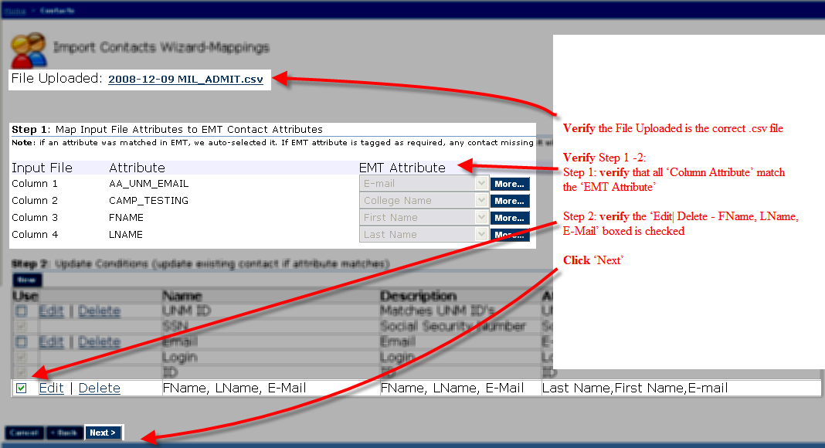
  - On the Import Contacts Wizard-Mappings page
    - Verify the File Uploaded is the correct .csv file
  - Step 1: Source Code is ‘Fin Aid’
  - Click ‘Next’
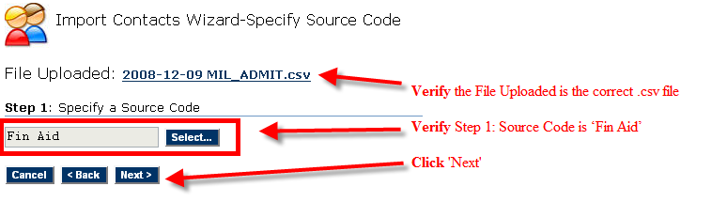
  - On the Contacts Import Options page
    - Verify the File Uploaded is the correct .csv file
  - Verify Step 1-2:
    - Step 1: ‘All (New and Updates)’ check box is checked
    - Step 2: ‘Email the Import Log to’ is checked and will be mailed to eddie94@unm.edu
  - Click ‘Queue and Monitor Import’

  - Repeat steps b. – o. for the second .csv file

- Validate the IMPORT LOG
  - Select the ‘Contacts’ Tab, Click ‘Import Logs’

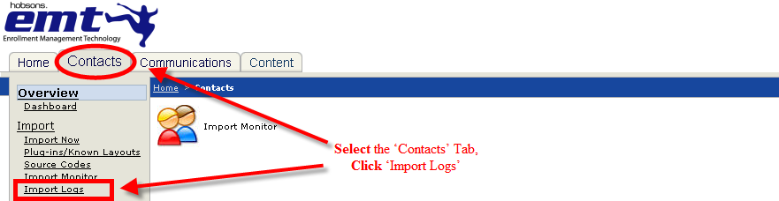
  - On the Import Logs Navigator page, select ‘Today’ from the View Logs dropdown menu
    - This will display the Fin Aid Missing Info Letters Admitted Folder
    - Click on the Fin Aid Missing Info Letters Admitted folder to open it
    - Click the ‘view’ link for the ADMIT.csv file
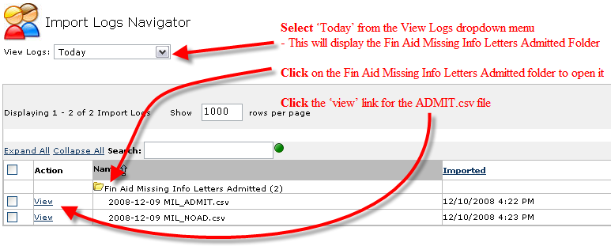
  - On the Import Logs Viewer page, click ‘Create Contact Filter’
    - This will give you a confirmation “Import filter has been created: Import filter 2008-12-09 MIL_NOAD.csv-All (With eastern Standard Time and Date Stamp)”
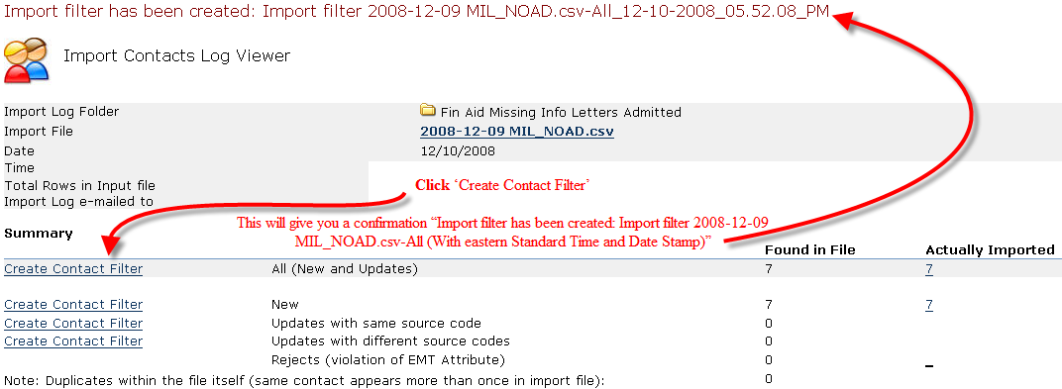
  - Repeat steps a- c for the NOAD .csv file

- QUEUE AND SENT EMAIL
  - Select the ‘Communications’ Tab, Click ‘Templates’
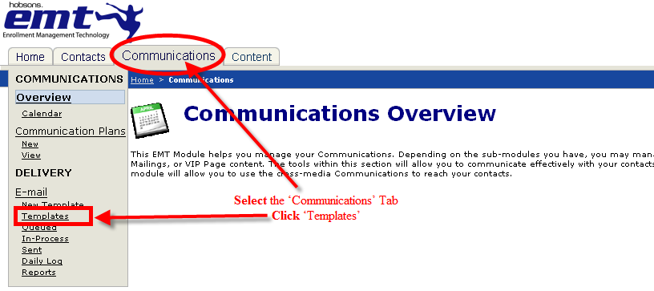
  - On the E-mail Templates Navigator page:
    - Click on the Financial Aid folder to open it
      - This will display all the Financial Aid E-mail templates
    - Click the ‘Queue’ link for the Financial Aid Missing Info Letter Admit
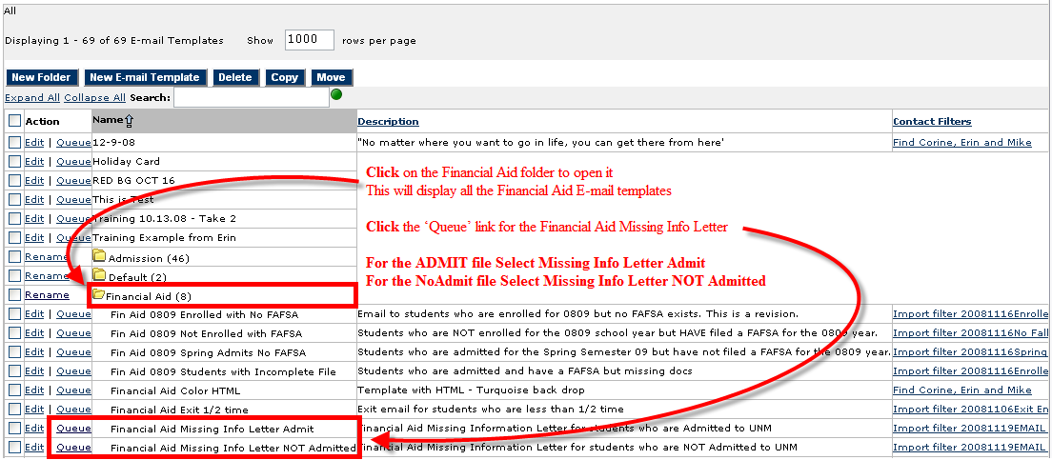
  - Step 1: Select Contact Filter
    - Click ‘Select’
      - In the Select Filters page, Click on the Imports folder to open it
        - This will display all the Imported files
      - Check the box next to ADMIT the file that was imported earlier
        - The name will match the name of the file given on the Import Contacts Log Viewer
NOTE: Only one box must be checked. Uncheck any boxes that were not checked are part of this process
      - Click ‘OK’
  - Verify the E-Mail Template name matches the Contact Filters Name
ex. Financial Aid Missing Info Letter Admit have a Filter of MIL ADMIT,
Financial Aid Missing Info Letter NOT Admitted have a Filter of MIL NOAD
  - Step 2: Start Time
    - Select ‘Now’ from the Send dropdown menu
  - Step 3: Send Frequency
    - Select ‘Send one time only’ radio button
  - Step 4: Send E-Mail Results Report (optional) – Skip
  - Click ‘OK’
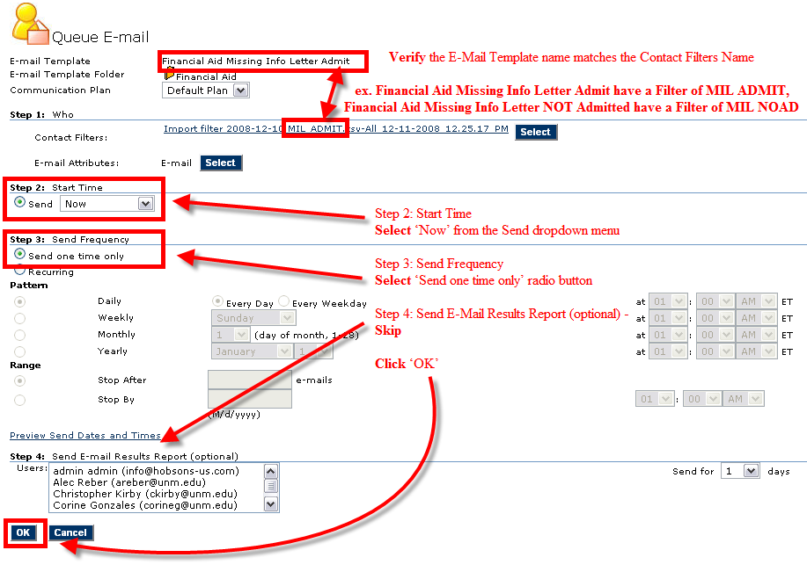
  - Once ‘OK’ is clicked, this will return you to the Email Templates Navigator page
  - On the E-mail Templates Navigator page:
    - Click on the Financial Aid folder to open it
      - This will display all the Financial Aid E-mail templates
  - Click the ‘Queue’ link for the Financial Aid Missing Info Letter NOT Admitted
  - Step 1: Select Contact Filter
    - Click ‘Select’
      - In the Select Filters page, Click on the Imports folder to open it
        - This will display all the Imported files
      - Check the box next to NOAD the file that was imported earlier
        - The name will match the name of the file given on the Import Contacts Log Viewer
NOTE: Only one box must be checked. Uncheck any boxes that were not checked are part of this process.
    - Click ‘OK’
  - Verify the E-Mail Template name matches the Contact Filters Name
ex. Financial Aid Missing Info Letter Admit have a Filter of MIL ADMIT,
Financial Aid Missing Info Letter NOT Admitted have a Filter of MIL NOAD
  - Step 2: Start Time
    - Select ‘Now’ from the Send dropdown menu
  - Step 3: Send Frequency
    - Select ‘Send one time only’ radio button
  - Step 4: Send E-Mail Results Report (optional) – Skip
  - Click ‘OK’
  - Exit Hobson’s

***END***

