Student Financial Aid

FA-103 Previous Year Over Awards

Date Issued/Rev: 09/04/08
General Description: This procedure explains how to log on Previous Year Over Awards on the resource form.
Responsible Manager: Director of Financial Aid
Related Procedures:

Related Forms: RPAARSC
RPAAWRD

Procedure
Step 1 - Go to RPAARSC
Step 2 - Type the student’s Banner ID number.
Step 3 - Select “Next Block”
Step 4 - Select “Insert Record”
Step 5 - Enter “PYOVER” code in resource field.
Step 6 - Enter the amount of the previous year’s over award in the Actual Amount Field.
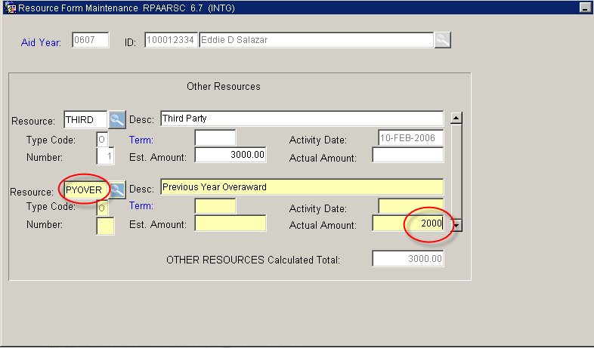
Step 7 - Select “Save” and “Exit”
Step 8 - Go to RPAAWRD to see if a current year over award has been created.

***END***

