Student Financial Aid

FA-202 Updating Tracking Files for Students Not Attending

Date Issued/Rev: 07/07/08
General Description: This procedure explains how to update tracking files for students who will not be attending UNM.
Responsible Manager: Financial Aid Director
Related Procedures:
Related Forms: RRAAREQ
RHACOMM

PROCEDURE

Step 1 - Receive documentation indicating student will not be attending UNM.
Step 2 - Go to RRAAREQ.
Step 3 - Perform “Next block”
NOTE: If all Documents are Complete skip to step 6.
Step 4 - Tab to the “Status Ind” field.
Step 5 - Change all “unsatisfied” documents to a “Status” of “Z” (Z = Student Not Attending). Please refer to Figure 1 and Figure 2.

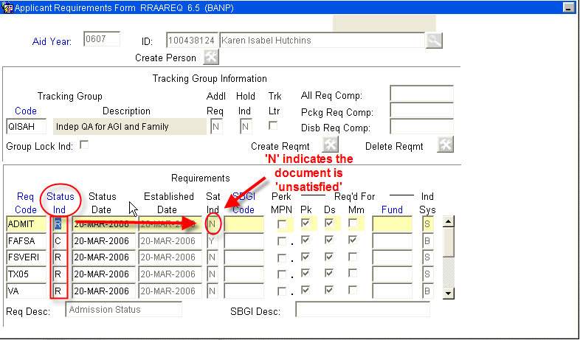
Figure 1 – Applicant Requirements Form
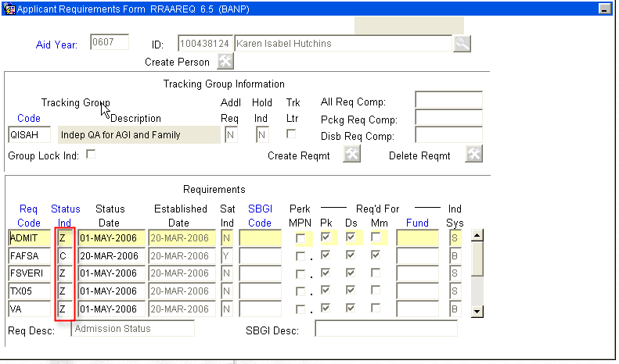
Figure 2 – Applicant Requirements Form
Step 6 - Save
Step 7 - Click on the Tracking Group Information Block.
Step 8 - Enter “NOATND” in the Tracking Group Code Field. Please refer to Figure 3.
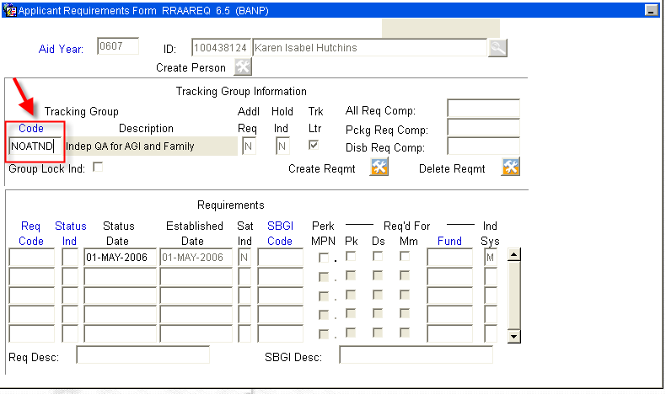
Figure 3 – Applicant Requirements Form
Step 9 - Press the “Create Reqmt” button . Please refer to Figure 4.
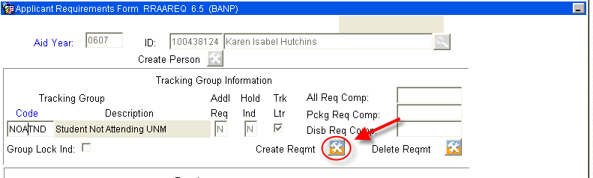
Figure 4 – Create Reqmt

Step 10 – Verify the Status Bar indicates.
Step 11 - Re-click the Tracking Group Information Block.
Step 12 - Deselect the “Trk Ltr” box (so the student does not receive an MIL). Please refer to Figure 5.
Step 13 - Select the “Group Lock Ind” box. Please refer to Figure 5.
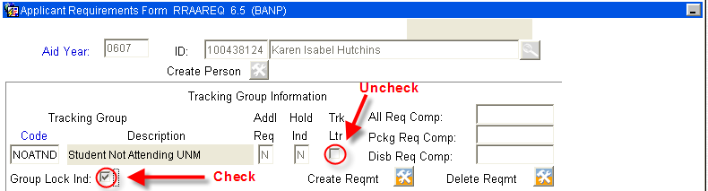
Figure 5 – Applicant Requirements Form

Step 14 - Save

Step 15 - Exit

Step 16 - Go to RHACOMM.

Step 17 – Leave a note that includes the following information:
Written confirmation was received from the student that they will not be attending UNM.

Step 18 - Save

Step 19 - Exit

NOTE: The student will see the tracking doc with “Student Not Attending” as the status on self-service. The student will receive no further MIL’s.

* * * E N D * * *

