Student Financial

FA-205 Processing a BACH2

Date Issued/Rev: 07/08/08
General Description: This process describes how to process a BACH2.
Responsible Manager: Financial Aid Director
Related Procedures:
Related Forms: RNANA07
A BACH2 Form will be requested if a student answers:
  - “1st Bachelor’s Degree by 01-JUL” field = ‘1’ (Yes) AND student is NOT admitted into a UNM Graduate program; OR
  - “Year in College” field is ‘6’ (1st YR Grad/Professional) or 7 (Cont Grad/Professional or Beyond) AND student is NOT admitted into a UNM Graduate Program; OR
  - “Degree/Cirt” field = ‘8’ (Grad/Professional) AND student is NOT admitted into a UNM Graduate Program; OR
  - “Graduate or Professional” field = ‘1’ (Yes) AND Student is NOT Admitted into a UNM Graduate Program; OR
  - “Degree/Cirt” field = ‘2’ (2nd Bachelors Degree)

On the MIL and LoboWeb, the BACH2 form requests:
- Admission to Grad Program/Level in 2nd Bachelor's Program

And a message of:
- According to our records, you have indicated you will be working on a degree beyond your first Bachelor's Degree for the 2006-2007 school year, however, you have not been admitted into a graduate or professional program. To receive financial aid you must be fully admitted to a UNM Graduate Program OR be admitted in to a 2nd Bachelor's Degree Program. Once you complete the graduate admissions process, our records will update automatically. If you are working on a Second Bachelor's Degree please complete and return the enclosed form.
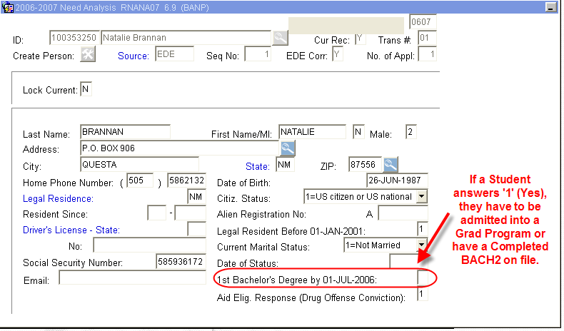
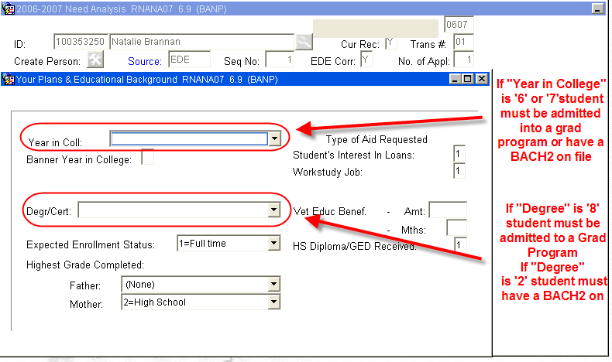

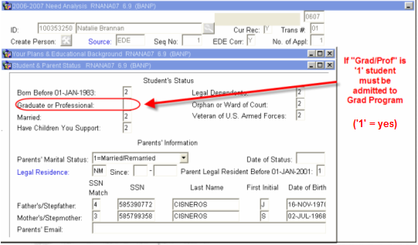
These 4 above fields are related to one another. They should always be consistent with each other and with the documentation on RRAAREQ.

If a student is receiving a BACH2
- “1st Bachelor’s Degree by 01-JUL” field = ‘1’ (Yes)
- “Year in College” field between ‘0’ and ‘5’. (0 = 1st time freshman; 5 = 5th Year/other undergrad)
- “Degree/Cert” field = ‘2’ (2nd Bachelors Degree)
- “Graduate or Professional” field = ‘2’ (No)
**Note: BACH2 students can be considered dependents

If student is a Graduate Student:
a. “1st Bachelor’s Degree by 01-JUL” field = ‘1’ (Yes)
- “Year in College” field = ‘7’ OR ‘8’. (7 = 1st time Grad/Prof; 8 = Con’t Grad/Prof)
- “Degree/Cert” field = ‘8’ (Grad/Prof)
- “Graduate or Professional” field = ‘1’ (Yes)
**Note: Grad students are considered Independent
If a student is an Undergraduate Student (neither BACH2 nor Grad Student):
- “1st Bachelor’s Degree by 01-JUL” field = ‘2’ (No)
- “Year in College” field between ‘0’ and ‘5’. (0 = 1st time freshman; 5 = 5th Year/other undergrad)
- “Degree/Cert” field = ‘1’, ‘3’, ‘4’, ‘5’, OR ‘6’ (1 = First Bach Degree, 3 = Assoc Degree, 4 = Assoc Degree, 5 = Cert/Diploma, 6 = Cert/Diploma)
- “Graduate or Professional” field = ‘2’ (No)
**Note: Undergraduate students may be considered Dependents

Changing and saving any of the fields below will result in an EDE being sent - you may want to consult your friendly processor before making any of these changes on RNANA07:
- First Bachelors Degree by July 1
- Degree/Cert (This is a change from the FAM system)
- Graduate Professional

PROCEDURE if the student is obtaining a Second Bachelor’s Degree:

Step 1 - Verify documentation is complete and has appropriate signatures.

Step 2 - Confirm first Bachelor’s Degree on either RSIPCOL or RSIDEGR
RSIPCOL. Please refer to Figure 1.

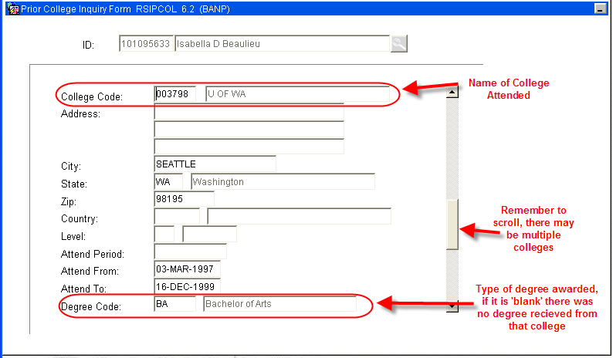
Figure 1 – Prior College Inquiry Form

Step 3 – Verify RSIDEGR displays that a Degree is “Pending” or has been received (“Confirmed”) from UNM. Please refer to Figures 2 and 3.

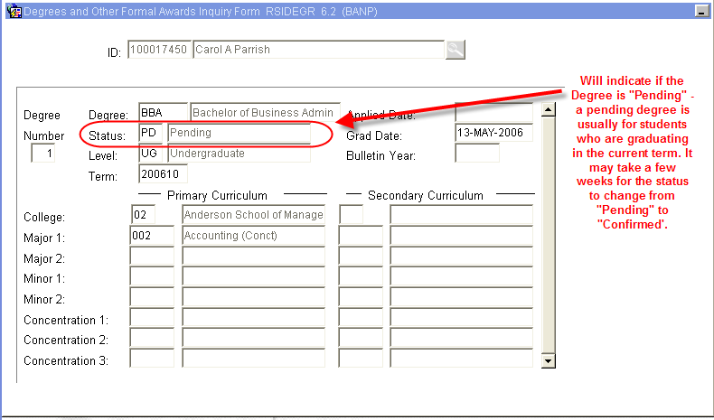
Figure 2 – Degrees and Other Formal Awards Inquiry Form

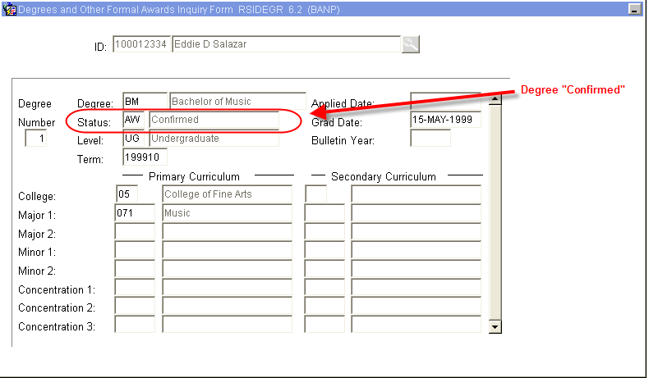
Figure 3 – Degrees and Other Formal Awards Inquiry Form

Step 4 - Verify Student Information on RNANA07. Please refer to figure 4, 5, and 6. For a BACH2 form RNANA07 should read:

  - “1st Bachelor’s Degree by 01-JUL” field = ‘1’ (Yes)
  - “Year in College” field between ‘0’ and ‘5’. (0 = 1st time freshman; 5 = 5th Year/other undergrad)
  - “Degree/Cert” field = ‘2’ (2nd Bachelors Degree)
  - “Graduate or Professional” field = ‘2’ (No)

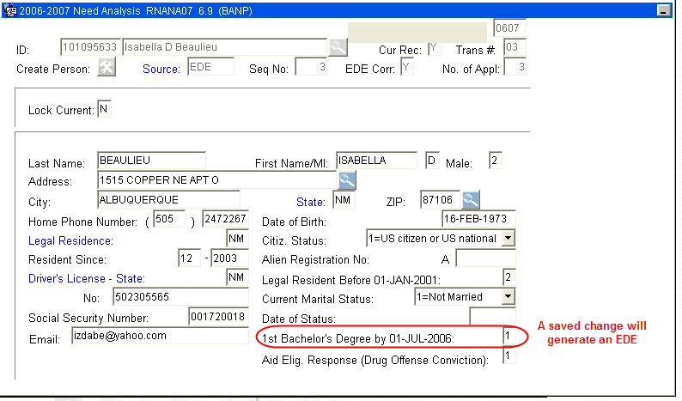
Figure 4 – Need Analysis
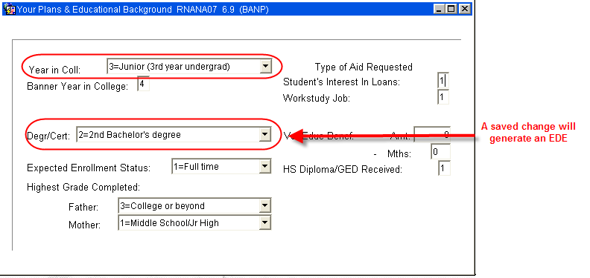
Figure 5 – Your Plans and Educational Background

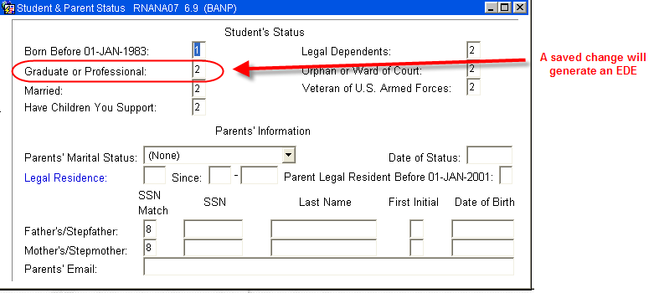
Figure 6 – Student and Parent Status
NOTE: Make note of any saved changes that will generate an EDE. Making changes and saving information in any of the following fields will result in an EDE being sent:
    - First Bachelors Degree by July 1
    - Degree/Cert (This is a change from the FAM system)
    - Graduate Professional
Step 5 - Access RRAAREQ.

Step 6 - Update BACH2 status to ‘C’ for complete. Please refer to Figure 7.

Step 7 - Update FAFSA to ‘E’ if an EDE will be sent. Please refer to Figure 7.

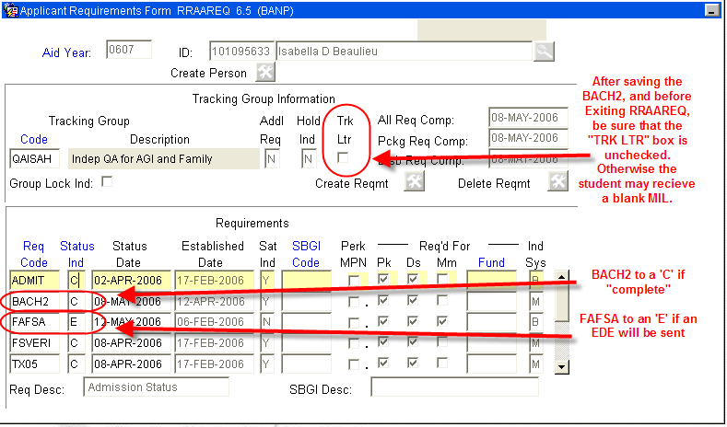
Figure 7 – Applicant Requirements Form

Step 8 - Access RHACOMM.

Step 9 - Leave a note regarding the BACH2. Please refer to Figure 8.

NOTE: If an EDE is being sent, be sure to include information about the EDE in the note.

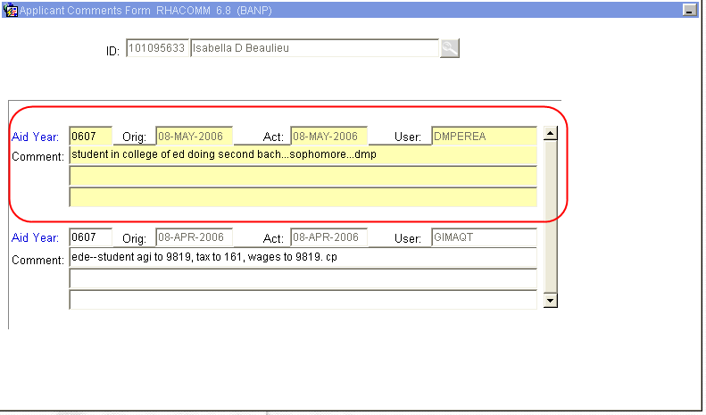
PROCEDURE if the student is a Graduate Student:

NOTE: There is no need to update any information on RRAAREQ. Once the student is admitted into a Graduate program, the BACH2 request will be waived by the system. Please refer to Figure 1.

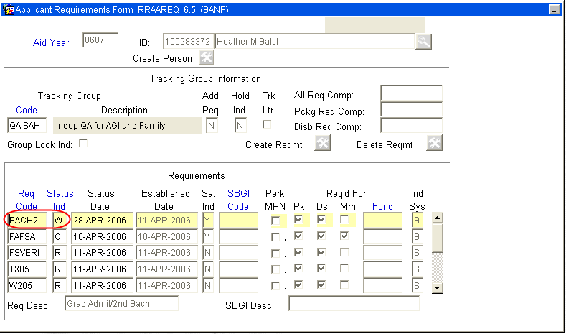
Figure 1 – Applicant Requirements Form

Step 1 - Verify in RSISTDN and RSIAPPL that BACH2 was waived. Please refer to Figure 2.

NOTE: This will be waived because the student has been fully admitted into a graduate program.

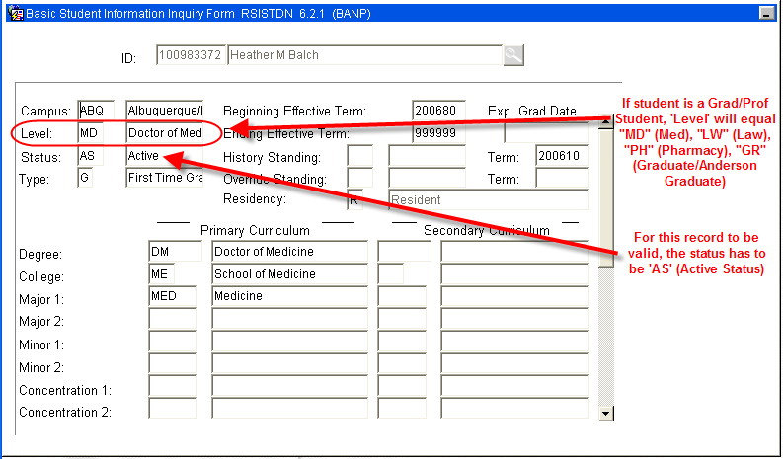
Figure 2 – Basic Student Inquiry Form

Step 2 – Verify the Application decision is equal to ‘E’. If NOT equal to ‘E’, the student may be provisionally admitted. If this is the case, the system will waive the BACH2 request and request a GADMIT (Confirmation of Full Admission into a Graduate Program). Please refer to Figure 3.

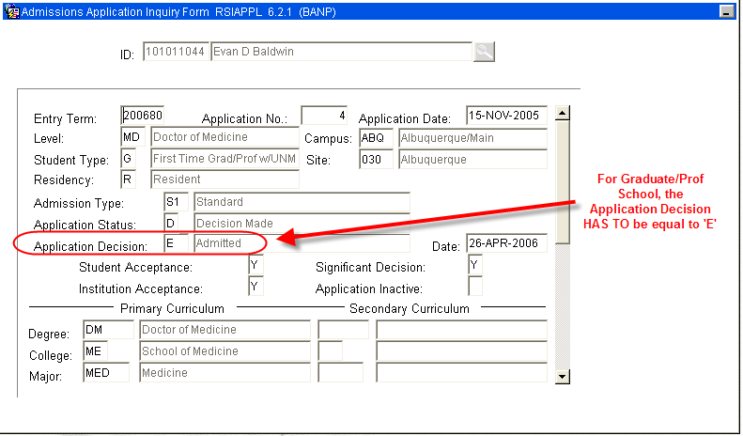
Figure 3 – Admissions Application Inquiry Form

Step 3 - Verify Student Information on RNANA07. Please refer to Figure 4, 5, and 6. For a Graduate Student RNANA07 should read:
  - “1st Bachelor’s Degree by 01-JUL” field = ‘1’ (Yes)
  - “Year in College” field = ‘7’ OR ‘8’. (7 = 1st time Grad/Prof; 8 = Con’t Grad/Prof)
  - “Degree/Cert” field = ‘8’ (Grad/Prof)
  - “Graduate or Professional” field = ‘1’ (Yes)

Figure 4 – Need Analysis
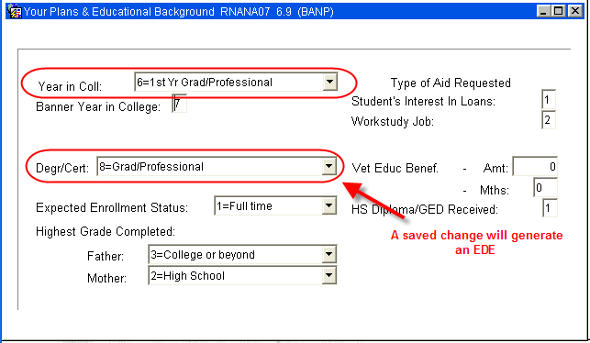
Figure 5 – Your Plans and Educational Background

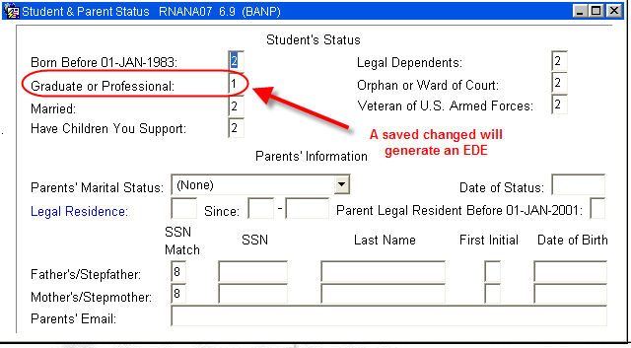
Figure 6 – Student and Parent Status
NOTE: Make note of any saved changes that will generate an EDE. Making changes and saving information in any of the following fields will result in an EDE being sent:
    - First Bachelors Degree by July 1
    - Degree/Cert (This is a change from the FAM system)
    - Graduate Professional
PROCEDURE if the student is an Undergraduate Student:

Step 1 - Verify Student Information on RNANA07. Please refer to Figure 1, 2, and 3. For an Undergraduate Student RNANA07 should read:
  - “1st Bachelor’s Degree by 01-JUL” field = ‘2’ (No)
  - “Year in College” field between ‘0’ and ‘5’. (0 = 1st time freshman; 5 = 5th Year/other undergrad)
  - “Degree/Cert” field = ‘1’, ‘3’, ‘4’, ‘5’, OR ‘6’ (1 = First Bach Degree, 3 = Assoc Degree, 4 = Assoc Degree, 5 = Cert/Diploma, 6 = Cert/Diploma)
  - “Graduate or Professional” field = ‘2’ (No)

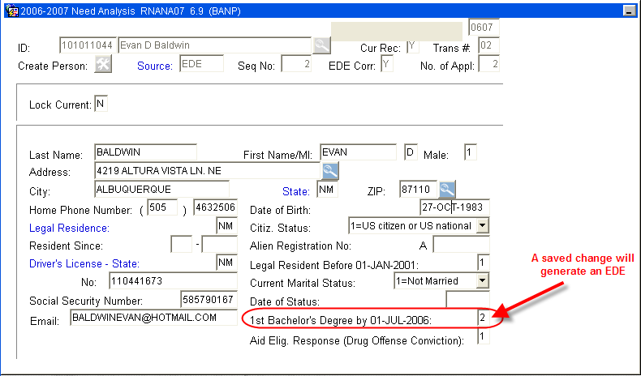
Figure 1 – Need Analysis
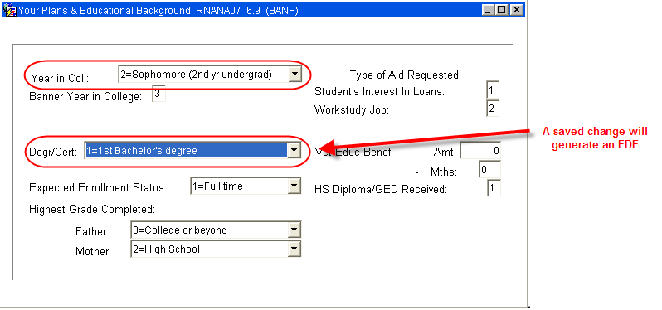
Figure 2 – Your Plans and Educational Background

Figure 3 – Student and Parent Status
NOTE: Make note of any saved changes that will generate an EDE. Making changes and saving information in any of the following fields will result in an EDE being sent:
    - First Bachelors Degree by July 1
    - Degree/Cert (This is a change from the FAM system)
    - Graduate Professional
Step 2 - Access RRAAREQ.

Step 3 - Update BACH2 status to ‘W’ for Waived. Please refer to Figure 1.

Step 4 - Update FAFSA to ‘E’ if an EDE is being sent. Please refer to Figure 1.

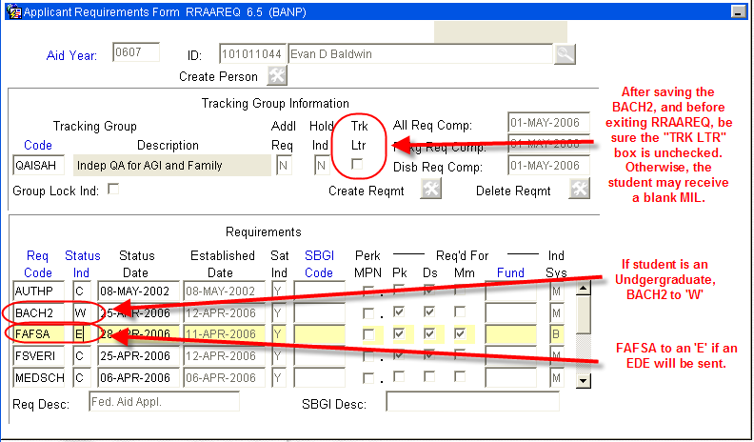
Figure 1 – Applicant Requirements Form

Step 5 - Access RHACOMM.

Step 6 - Leave a note regarding the BACH2 (If an EDE is being sent, be sure to include information about the EDE in the note.
NOTE: Make note of any saved changes that will generate an EDE. Making changes and saving information in any of the following fields will result in an EDE being sent:
    - First Bachelors Degree by July 1
    - Degree/Cert (This is a change from the FAM system)
    - Graduate Professional
***End***

