Student Financial Aid

FA-209 PROCEDURE to Process a Tribal Check
For Officers

Date Issued/Rev: 07/09/08
General Description: This procedure explains how to process a Tribal Check.
Responsible Manager: Financial Aid Director
Related Procedures:
Related Forms: RRAAREQ
ROAMESG
ROASTAT
ROAENRL
SGASTDN

PROCEDURE to Process a Tribal Check

Step 1 - Confirm Check Log and Student Eligibility
Step 2 - Access RRAAREQ Check Log. Please refer to Figure 1.

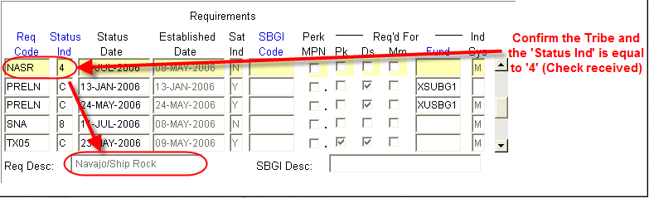
Figure 1 - RRAAREQ

Step 3 – Perform Next Block on RRAAREQ.
Step 4 - Confirm Certification . Please refer to Figure 2.
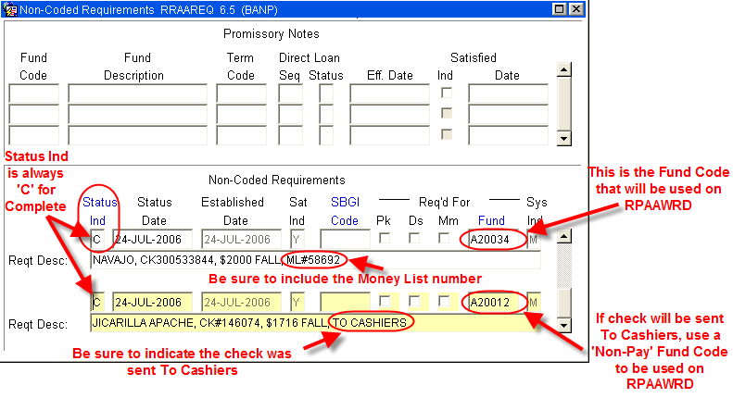
Figure 2 – Non-Coded Requirements
Step 5 - Access RPAAWRD
Step 6 - Confirm Estimate Award.
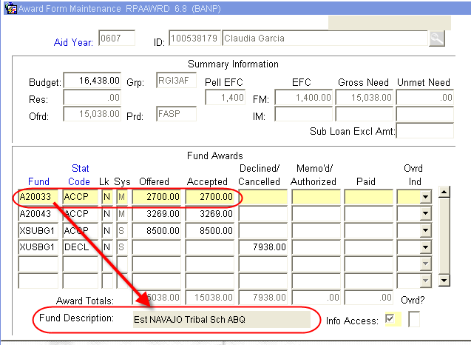
Figure 3 – Award Form Maintenance

Step 7 - Access ROAENRL
Step 8 - Confirm Enrollment. Please refer to Figure 4.
Step 9 - Contact Tribe to confirm fund eligibility on a less than full-time status if the student is enrolled less than full-time. Please refer to Figure4.
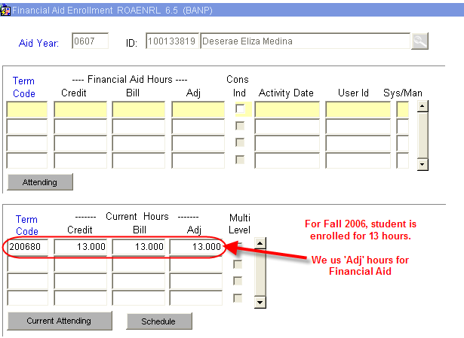
Figure 4 – Financial Aid Enrollment
Step 10 - Access ROASTAT
Step 11 - Verify SAP status on second block. Please refer to Figure 5.
Step 12 - Contact Tribe to confirm fund eligibility based on current SAP status if the student is NOT meeting satisfactory academic progress. Please refer to Figure 5.

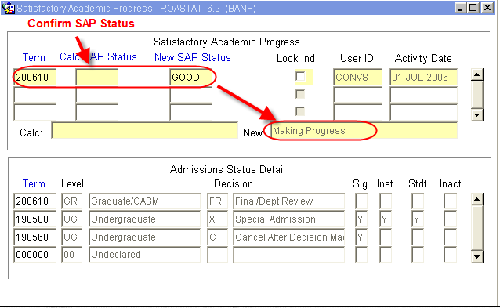
Figure 5 – Satisfactory Academic Progress

Step 13 - Access RPAAWRD
Step 14 - Adjust Estimate as needed. Please refer Figure 6.

Figure 6 – Award Form Maintenance

Step 15 - Award using Fund Code written on Check Stub (Also found on the second block of RRAAREQ)

Step 16 - Follow over award reduction procedure if over award is created.

Step 17 - Access RHACOMM

Step 18 - Leave note.

~ Fin ~

