Student Financial Aid

FA-210 Processing a Tribal Award Letter

Date Issued/Rev: 06/30/08
General Description: This procedure explains how to award an estimate from a Tribal award letter.
Responsible Manager: Financial Aid Director
Related Procedures:
Related Forms: RRAAREQ
RPAAWRD
RHACOMM

PROCEDURE

NOTE: If Check is attached to award letter, copy award letter and forward originals to the Funds area for check processing.

Step 1 - Verify external award letter for the following items:
  - Stamp
  - The student who is issued the award.
  - The amount of the award.
  - The year for which the award is made.
  - The term (i.e. Fall, Spring, Summer)

Step 2 - Access RRAAREQ

Step 3 - Verify the Needs Analysis Documentation on the First Block of RRAAREQ - the Needs Analysis name should correspond to the Tribe sending the Award Letter. Please refer to Figure 1.

    - If No Needs Analysis Information Exists on RRAAREQ: GO TO STEP 3
    - If There Is More Than One Needs Analysis: Be sure that you update the Needs Analysis that is tied to the Award Letter that you logging.
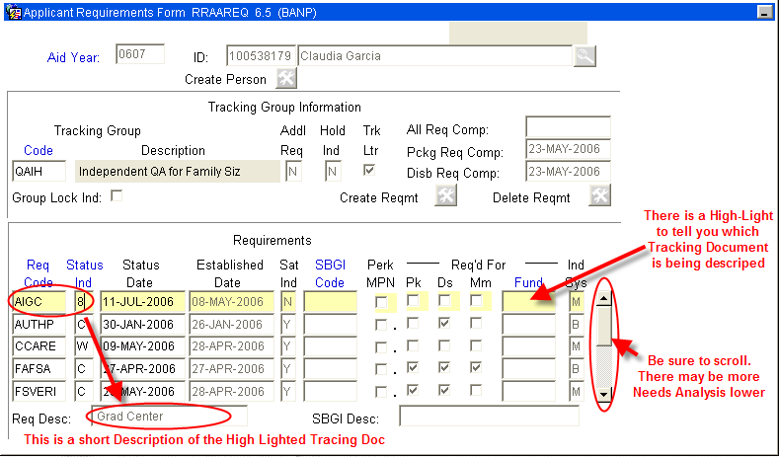
Figure 1 – RRAAREQ Form

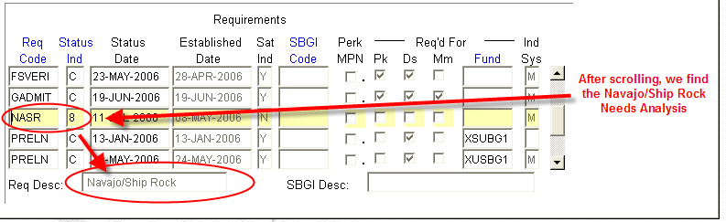
Figure

Step 4 - Update the Needs Analysis “Status Ind” with the code of ‘3’ (Award Letter Received). This will display on self-service that the Tribal Award Letter for this Needs Analysis has been received.

Step 5 - Suppress the MIL. Please refer to Figure 3.
NOTE: You may double click in the “Status Ind” field for a list all values. ***Numbers are used for the logging of Checks and Needs Analysis.

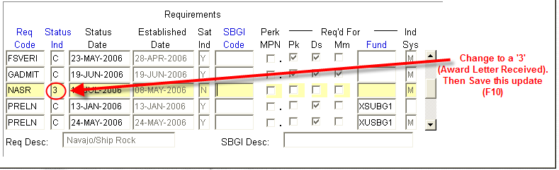
Figure 3 – ‘Status Ind’ field

Step 6 - Perform ‘Next Block’ - to the ‘Non-Coded Requirements’ Block. Please refer to Figure 4.

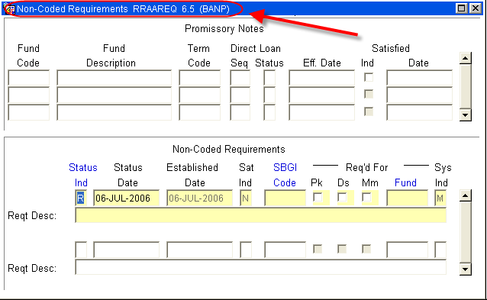
Figure 4 – Non-coded requirements block
Step – 7 Log the Award Letter in the ‘Non-Coded requirements” portion of the form:
1. Always enter “C” (for “complete” in the ‘Status Ind’ field
2. Tab to the ‘Fund’ Field’ enter the fund code that you are using for awarding the estimate.

NOTE: The Fund code should correspond to the Fund Code used on RPAAWRD for
awarding the estimate.

Step 8 - Double click in the Fund field to search for a “Fund Code” for a list of values (F9).

NOTE: When searching for an Estimate try %Est% or:
Step 9 - Use the estimate for the tribe making the award. Be aware each tribe has its own estimate. Please refer to Figure 5.

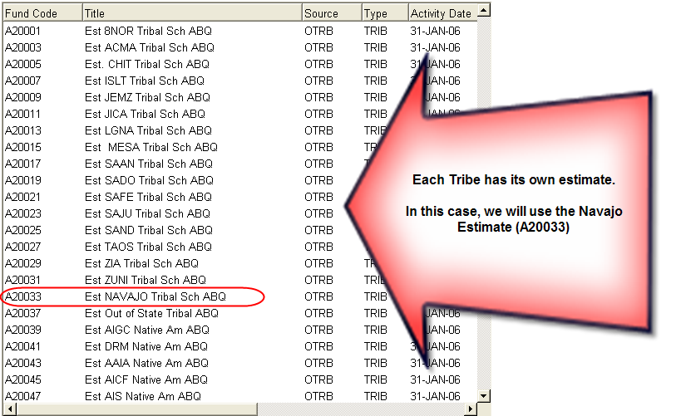
Figure 5 – Tribe estimate

Step 10 - Tab (once) to the ‘Reqt Desc’ field and enter information about the award once the Fund has been entered. Please refer to Figure 6.
Note: There are only 60 spaces to use, try to provide as much information in as little space as possible. Please include the following information:
1. The Source of the Award
2. The Term of the award (i.e. fall only $1000, fall/spg $1000 per semester)
3. Include also that an Estimate was placed on RRAAREQ - “EST RRAAREQ”
Step 11 – Save

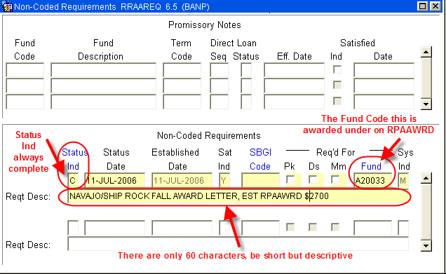
Figure 6 – RRAAREQ Form

Step 12 - Access RPAAWRD. Please refer to Figure 7.

Step 13 - Award the Estimate with the Fund Code placed on RRAAREQ. Please refer to Figure 7.

Step 14 – Save

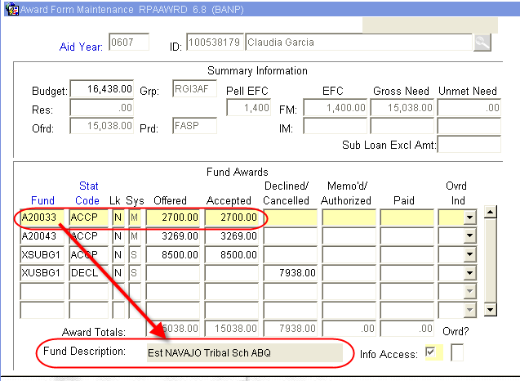
Figure 7 – RPAAWRD

Step 15 - Verify estimate does not create an Over Award. If Over Award is created, follow the procedure for correcting Over Award.

Step 16 - Suppress the award letter if there is no Over Award. Otherwise an award letter will be sent.

Step 17 – Access RHACOMM to indicate the receipt of the Award Letter, and awaiting the receipt of the Check.

~ Fin ~

