Student Financial Aid

FA-220 Processing an External Check Made

Payable to UNM ONLY (Money List)
For Scholarships

Date Issued/Rev: 07/10/08
General Description:
This procedure explains how to process an external check made payable to UNM only. Money List
Responsible Manager: Financial Aid Director
Related Procedures: Adding money to a fund
Related Forms: RRAAREQ
RPAAWRD
ROAENRL
(RFRMGMT)

PROCEDURE to process an external check made payable to
UNM ONLY.

Step 1 - Verify the external check.

Step 2 - Date Stamp the check stub.

Step 3 - Access RPAAWRD.

Step 4 - Confirm Estimate Award. Please refer to Figure 1.

NOTE: Estimate Outside Loans are FUND CODE: XENT4L

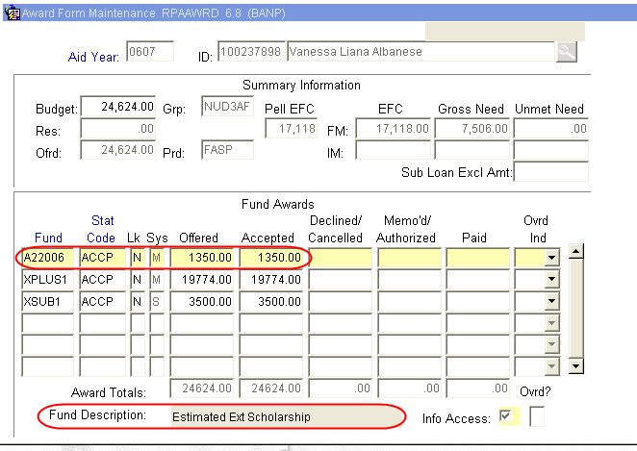
Figure 1 – Award Form Maintenance

Step 5 - Access ROAENRL

Step 6 – Confirm the student’s enrollment status. Please refer to Figure 2.

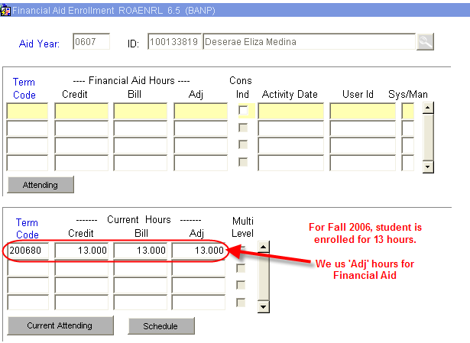
Figure 2 – Financial Aid Enrollment

Step 7 - Log the check.

Step 8 - Access RRAAREQ.

Step 9 - Perform ‘Next Block’ twice - to the ‘Non-Coded Requirements’ Block. Please refer to Figure 3.

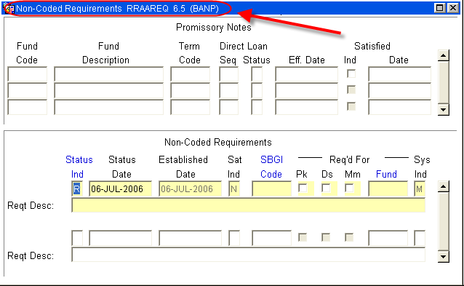
Figure 3 – Non – Coded Requirements

Step 10 - Log the Check in the ‘Non-Coded requirements” portion of the form.

Step 11 - Enter “C” for “complete” in the ‘Status Ind’ field.

Step 12 - Tab to the ‘Fund’ Field’.

Step 13 - Enter the fund code that you are using for awarding.

Additional resources: For a list of values (F9), double click in the Fund field to search for a “Fund Code”. Please refer to Figure 4.

NOTE: When searching for an External fund Code try %Ext% or:
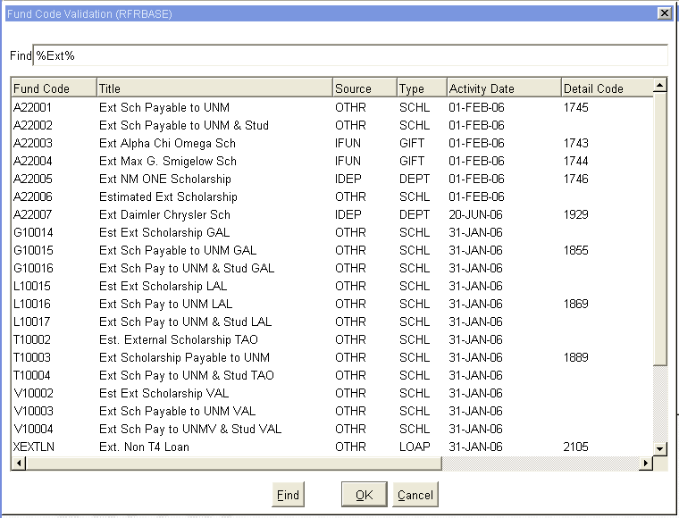
Figure 4 – Fund Code Validation (list as of July 2006)

Step 14 - Tab (once) to the ‘Reqt Desc’ field after the Fund has been entered

Step 15 - Enter information about the award:

NOTE: there are only 60 spaces to use, try to provide as much information in as little space as possible. Please refer to Figure 5.

- The Source of the Award
- Check Number
- The Term of the award (i.e. fall only $1000, fall/spg $1000 per semester)
- The Money List Number, if any

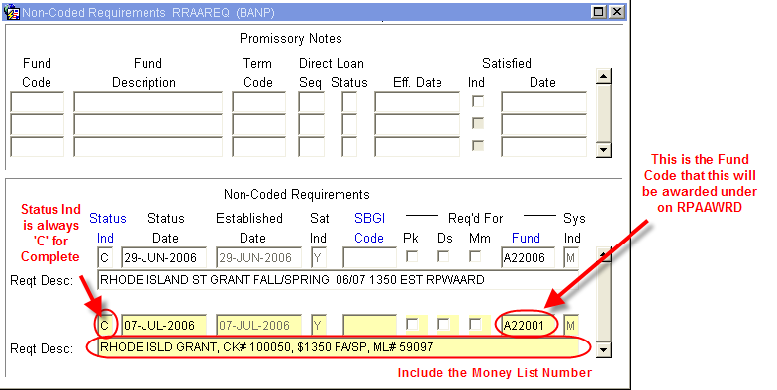
Figure 5 – Non-Coded Requirements

Step 16 - Save

Step 17 - Access RFRMGMT.

Step 18 - Add money to Fund if needed (follow fund increase procedures).

Step 19 - Perform the following actions on the physical check:
      - Endorse Check with UNM Stamp
      - Write Fund Code for RPAAWRD
      - Banner Index Code
      - Student’s Name
      - Students UNM ID
      - The Term of the Award
      - The Money List Number

Step 20 - Copy the check for Office records.

Step 21 - Complete the Money List.

Step 22 - Copy the Money List for Office records.

~ Fin ~

