Student Financial Aid

FAFM - 104 Athletic Disbursement Process and Report

Date Issued/Rev: 12/14/07
General Description: This procedure explains how to run the Athletic Disbursement Report.
Responsible Manager: Financial Aid Director
Related Procedures: N/A
Related Forms: GLBDATA
GLAEXTR
GLIEXTR
RORPOST
RORBPST
RPEDISB

1. Go to GLBDATA. This runs the population selection that identifies the group of athletes.
- Next block
- Enter DATABASE in the Printer field
- Next block
5. Enter parameters 01, 06 and 07 as listed below
6. Next block to SUBMISSION block
- Click the box next to Save Parameter Set as. This will save the parameters you entered. The next time you run the job; these parameters will default into the fields.
- Save (F10)
- Select OPTIONS
- Select REVIEW OUTPUT
- Double click in FILE NAME to verify that job is complete.
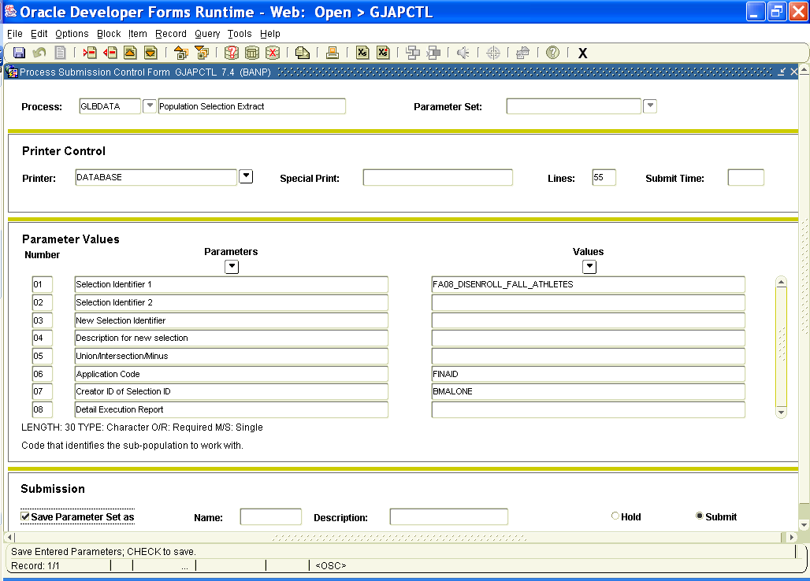
- Go to GLAEXTR or GLIEXTR to view the population
- Enter FINAID in the Application field
- Enter BMALONE in the Creator ID field
- Enter FAxx_DISENROLL_FALL_ATHLETES in the Selection ID field
- Next block
- Briefly verify the number of students and activity date
- Go to RORPOST. This form will define the process to remove holds. If the Use Indicator box is checked it shows which processes you want to run. The category shows what type of information is processed. The creator ID shows who created the process.
- Next block
- Enter a query (F7)
- Check the Use Indicator box
- Execute the query (F8)
- Click on the Use Indicator boxes next the processes which are checked. This will remove the checkmarks.
- Save (F10)
- Enter a query (F7)
- Type ATH_POST in the category column
- Execute the query (F8)
- Select the process with the Selection ID FAxx_DISENROLL_FALL_ATHLETES
- Type R in the Status or Term Code column to indicate that you wish to remove the holds
- Click on the Use Indicator box next to this process
- Save (F10)
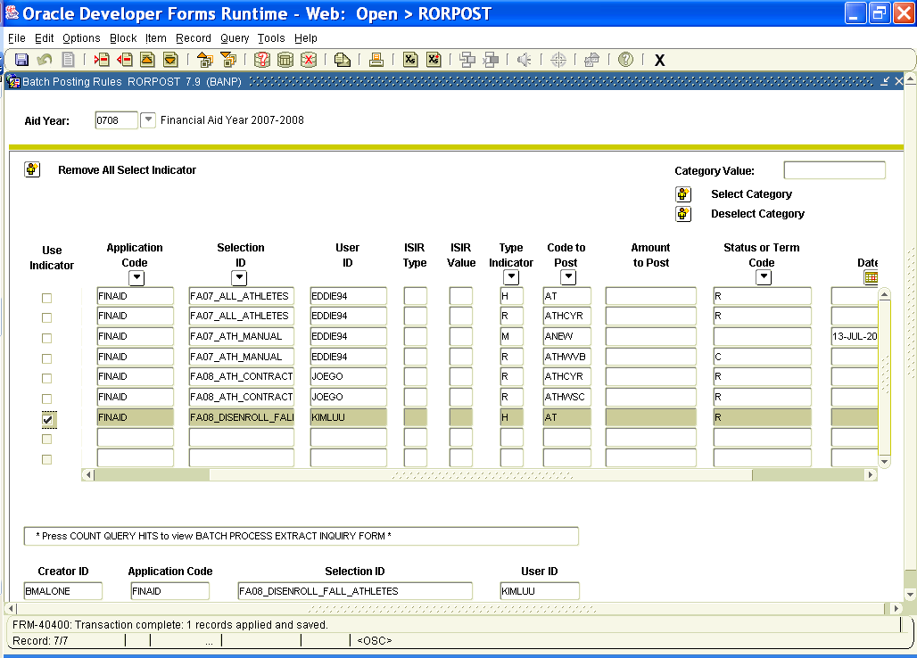

- Go to RORBPST to remove the holds
- Next block
- Enter DATABASE in Printer field
- Next block
- Enter parameters 01 and 02 as listed below
- Click the box next to Save Parameter Set as
- Save (F10)
- Select OPTIONS
- Select REVIEW OUTPUT
- Look at the list file to ensure that the hold has been removed
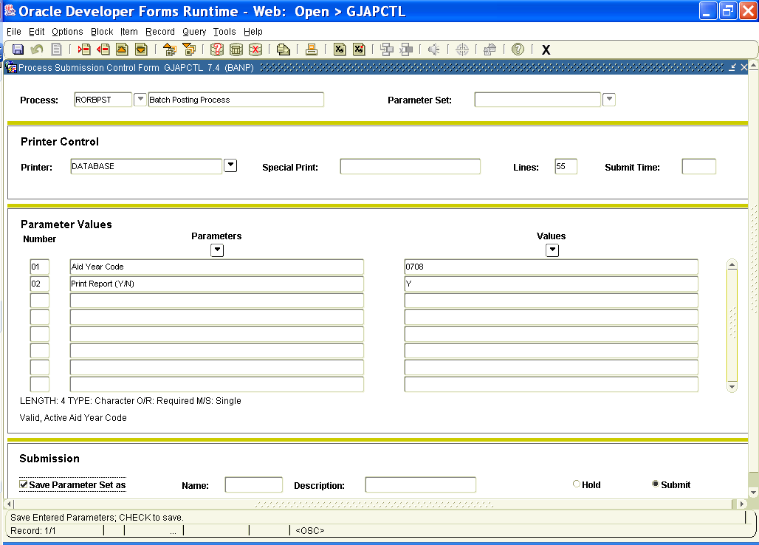

- Go to RPEDISB to run disbursement
- Next block
- Enter DATABASE in the Printer field
- Next block
- Enter parameters 01-03, 05 and 07-16 as listed below.
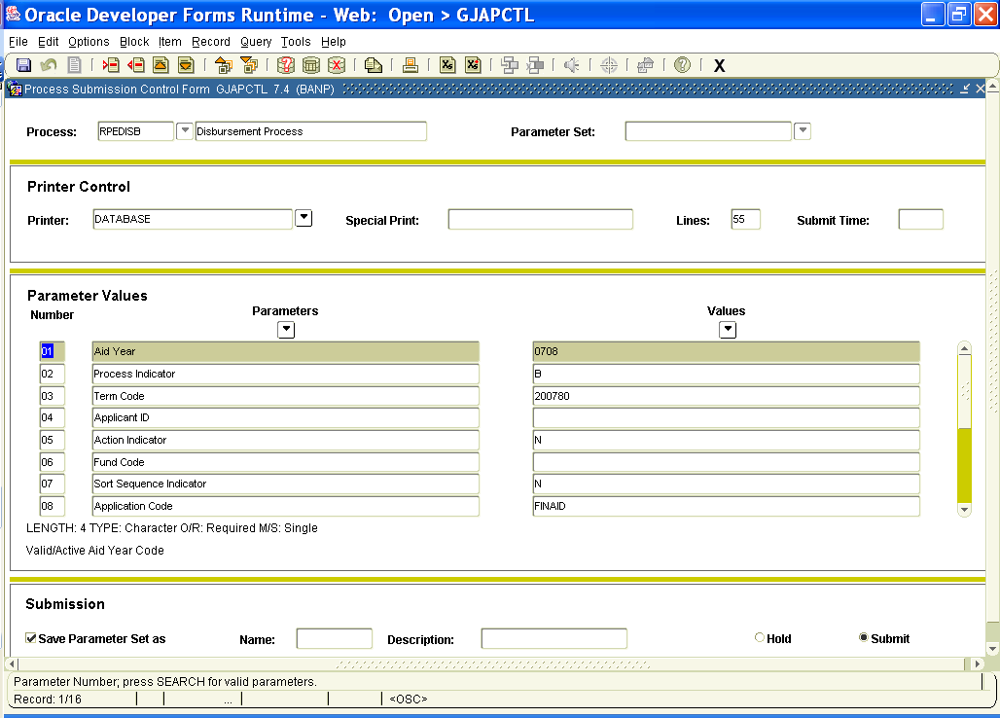
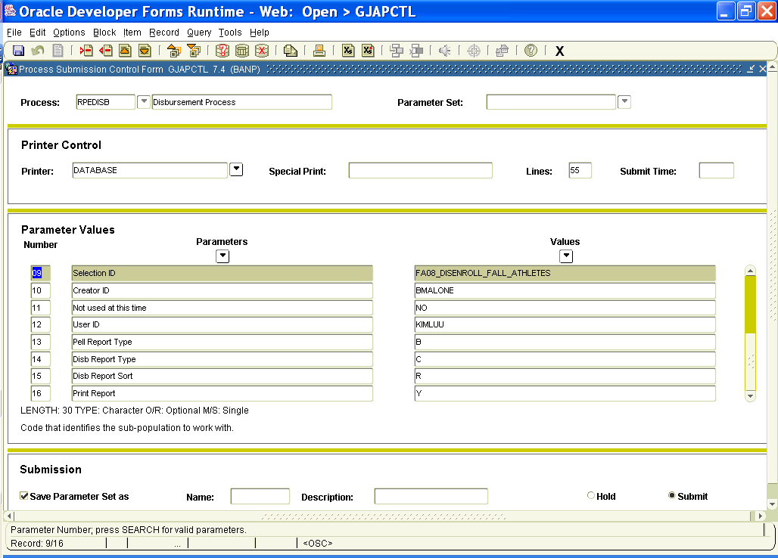
- Click the box next to Save Parameter Set as to save the parameters you entered
- Save (F10)
- Select OPTIONS
- Select REVIEW OUTPUT
- View the list file RPBDISB
- Save (F10)
- Save as a text file to the following path according to the appropriate aid year. P:\SHARED\Accounting\Athletics\Years 01-10\Year_08\Athletic Disbursement Reports 0708. The text file name should include year, month, day and type of report.
- Go to RORPOST to define hold replacement
- Enter a query to find the process you recently ran
- In the Status or Term Code column, delete the R and leave the space blank
- Save (F10)
- Go to RORBPST to replace the holds. Follow instructions 33-42. Look at the list file to ensure that the hold has been replaced.
- Review RPBDISB report. Look for outside scholarships. Check RHACOMM to see if scholarship has been approved by Athletics. Athletes cannot receive SEOG. Athletes are permitted to have their Athletic aid, Pell, ACG, SMART and institutional aid. Make sure aid for the right semester has credited. Take note of those who have an incomplete contract or are not enrolled. Notify Joseph of any problems.

**END**

