Student Financial Aid

FAFM - 108 Athletic Letter Creation

Date Issued/Rev: 04/04/08
General Description: This procedure explains how to create Athletic award and cancellation letters.
Responsible Manager: Financial Aid Director
Related Procedures: N/A
Related Forms: GLRSLCT
GLAEXTR
GLBLSEL
GLRLETR
RUAMAIL

1. Go to GLRSLCT to create and define the population selection. You are required to perform this step the first time only.
- Enter “FINAID” in the ‘Application field’
- Enter “FA_MANUAL” in the ‘Selection ID’ field
- Next block
- ‘Selection Description’ is optional
- Click the box next to ‘Manual’
- Save (F10)
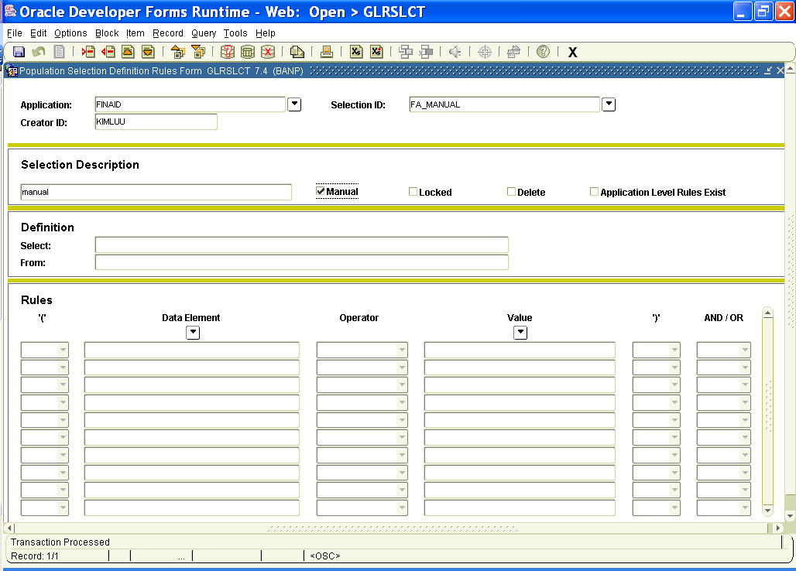

- Go to GLAEXTR to populate the list
- Enter “FINAID” in the ‘Application’ field
- Enter “FA_MANUAL” in the ‘Selection ID’ field
- Next block
- Enter student ID numbers in the ‘ID’ column that you want letters for
- Save (F10)
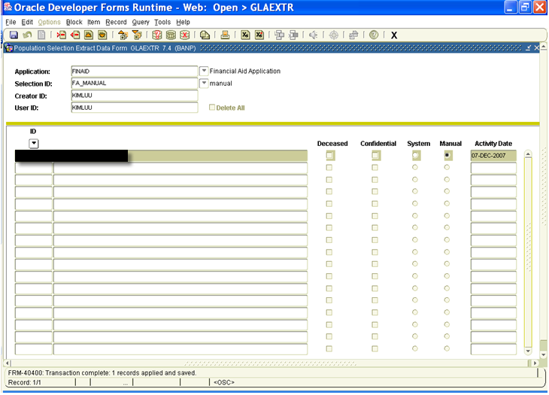

- Go to GLBLSEL to extract the letter
- Next block
- Enter “DATABASE” in the ‘Printer field’
- Next block
- Enter parameters 01-06 and 08-11 as listed on the following page
- For parameter 03 use “FA_ATH_REN” for new or renewal letters. Use “FA_ATH_CAN” for cancellation letters.
- For parameters 05 and 06 enter your Net ID
- For parameter 10 add a record (F6)
- Enter 1MA for the first parameter 10
- Enter 2PE for the second parameter 10
- Next block
- Check the box next to ‘Save Parameter Set as’.
  - Enter “ATH_AWARD” in the ‘Name field’.
  - Enter “Athletic Award” in the ‘Description’ field.
- “ATH_AWARD” is used for new or renewal letters.
- If creating cancellation letters, enter “ATH_CANCEL” in the ‘Name field’ and Athletic Cancel in the Description field.
***NOTE: You only need to set this up the first time only. Afterwards, you can enter the parameter name in the Parameter Set field at the top of the screen and it will pull up your saved parameters.
- Save (F10)
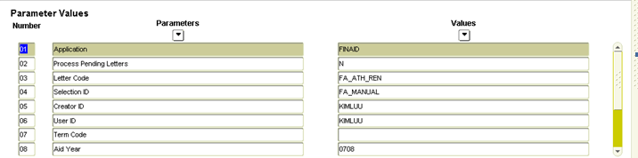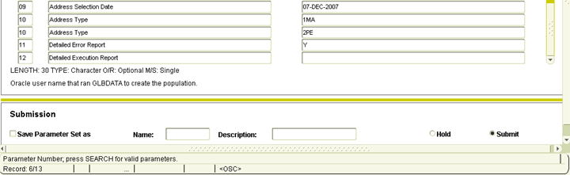
- Enter term information. These are dynamic parameters that will need to be entered each time; they will not be saved.
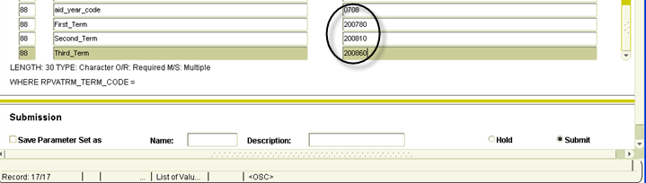
- Save (F10)
- Select OPTIONS at the top of the page
- Select REVIEW OUTPUT
- Check the number in your population. Make sure it equals the amount of letters you want to create.
- Go to GLRLETR. This works with GLBLSEL to pull and match the variables.
- Next block
- Enter “DATABASE” in the ‘Printer’ field
- Next block
- Enter parameters 01-04 and 06-07 as listed on the following page. Parameter 4 depends on the letter type you want to create. See step 19 for details.
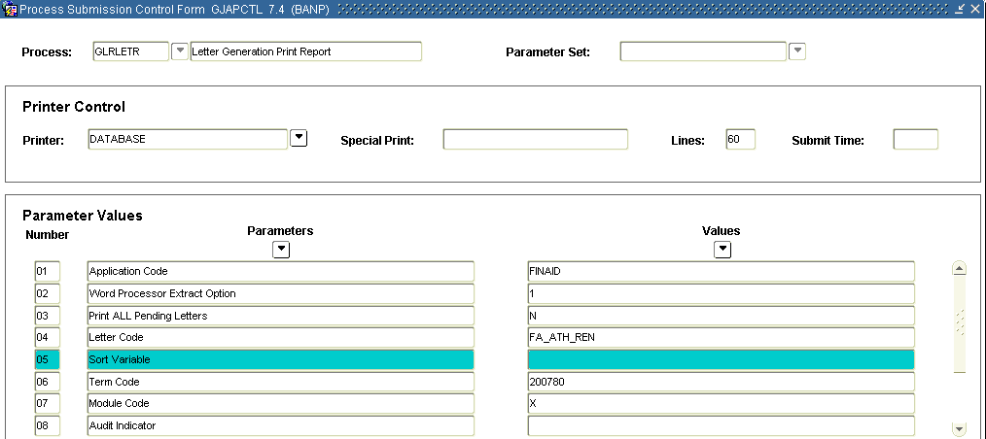
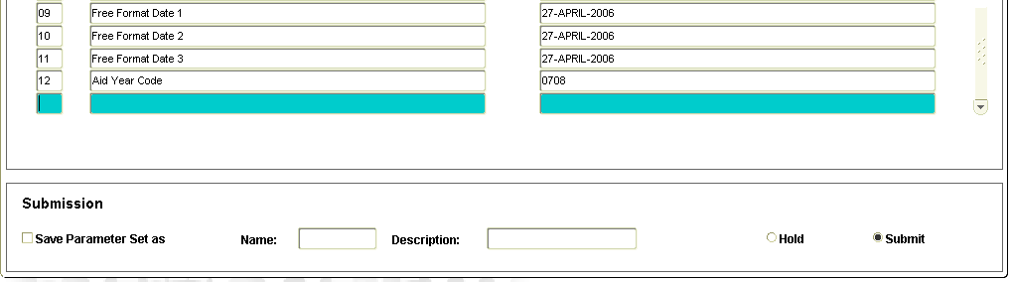
- Enter today’s date for parameters 09-11. They do not have to be updated each time you do this.
- Enter parameter 12 according to the current aid year
- Next block
- Click the box next to ‘Save Parameter Set as’
- See step 25 and enter the applicable name and description, if needed
- Save (F10)
- Select OPTIONS
- Select REVIEW OUTPUT
- Open the .doc file
- Save the file as a .doc file
- Open FA_AREN Final.doc (new or renewal) or FA_ACAN Final.doc (cancellation) in Word
- Select YES
- Select FIND DATA SOURCE
- Select your document
- Select TOOLS
- Select LETTERS AND MAILING
- Select SHOW MAIL MERGE TOOLBAR
- Choose MERGE TO NEW DOCUMENT on the toolbar
- Select ALL
- Select OK
- Verify the student’s name on the letter. Also, verify the contents of the letter.
- Select File
- Select Save As
- Name the document in the following format DAY-MONTH-YEAR Athletic (Award or Cancellation) Letter
- Save it in the following path P:\SHARED\Accounting\Athletics\Years 01-10\Year_08\07-08 GIA’s (From Athletic Dept). Make sure to put the document in the correct aid year.
- If you would like to check what letters have been sent to a certain student, go to RUAMAIL.

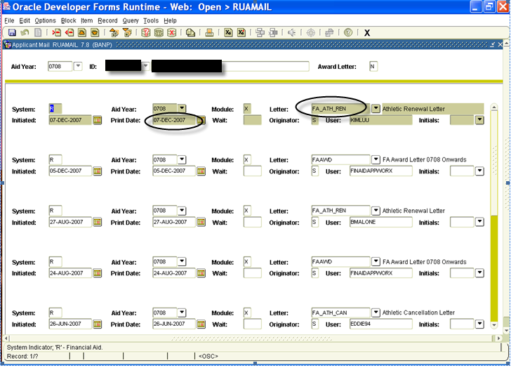

**END**

