Student Financial Aid

FA-104 Loan Aggregate Override

Date Issued/Rev: 06/30/08
General Description: This procedure explains how to override Loan Aggregate limits, when a student’s LAGG is resolved, but not yet cleared on RNASL07
Responsible Manager: Financial Aid Director
Related Forms: RNASL07
RNARSLT
RHACOMM
RRAAREQ

PROCEDURE

Step 1 - Go to RNASL07.

Step 2 - Confirm that either the Sub or Combined loan limits indicator is an “E”. Please refer to Figure 1.

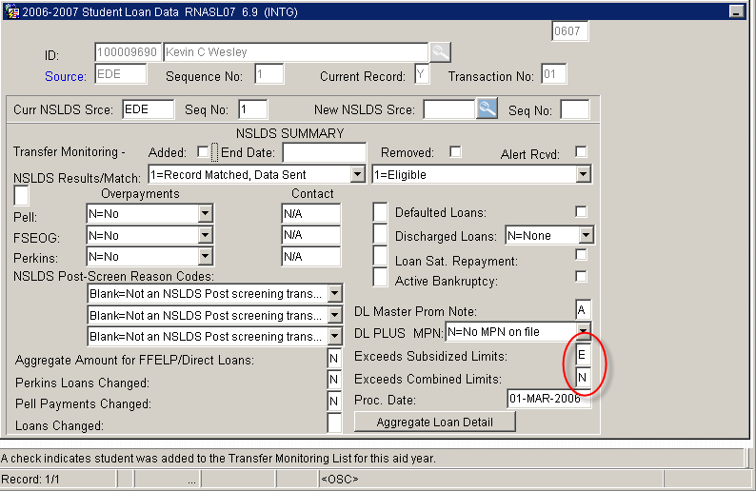
Figure 1 – RNASLO7 Form

Step 3 - Select “Exit”

Step 4 - Go to NSLDS and verify that student is no longer exceeding their loan aggregate limits.

Step 5 - Go to RHACOMM.
Step 6 - Type the student’s Banner ID number.

Step 7 - Select “Next Block”

Step 8 - Enter aid year.

Step 9 - Type a note indicating that the loan aggregate issue has been resolved and verified on NSLDS.

Step 10 - Place a copy of NSLDS screen print in student’s file.

Step 11 - Select “Save”

Step 12 - “Exit”

Step 13 - Go to RNARSxx. Please refer to Figure 1.

Step 14 - Select “Next Block” three times

Step 15 - Select “L=Limit Tests” from the NSLDS OVERRIDE field. Please refer to Figure 2.

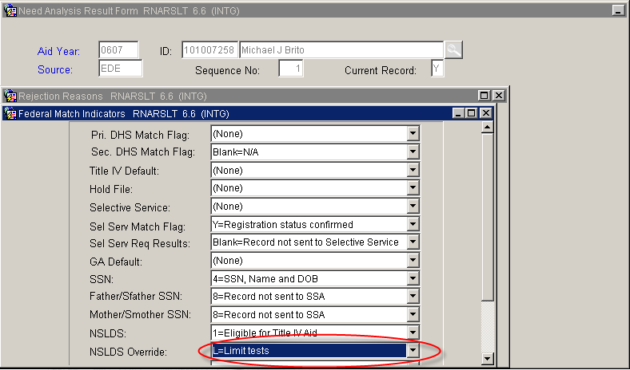
Figure 2 - RNARSxx Form

Step 16 - Select “Save”
Step 17 - “Exit”
Step 18 - Go to RRAAREQ
Step 19 - Complete the LAGG mnemonic.
Step 20 - Select “Save”
Step 21 - “Exit”
* * * E N D * * *

