 | LINK Financial Aid | 

FALN - 108 Increase an Existing Loan

Date Issued/Rev: 7/25/06
General Description: This procedure explains how to increase an existing FFELP loan.
Responsible Manager: Financial Aid Director
Related Procedures: FAPK-109 Changing the Offered Amount of a Fund
Related Forms:
RPAAWRD
RPAELAP
1. Go to RPAAWRD
2. Increase the loan amount under the existing fundcode
3. SAVE (the rest of the steps are optional)
4. Go to OPTIONS select CREATE LOAN APPLICATIONS
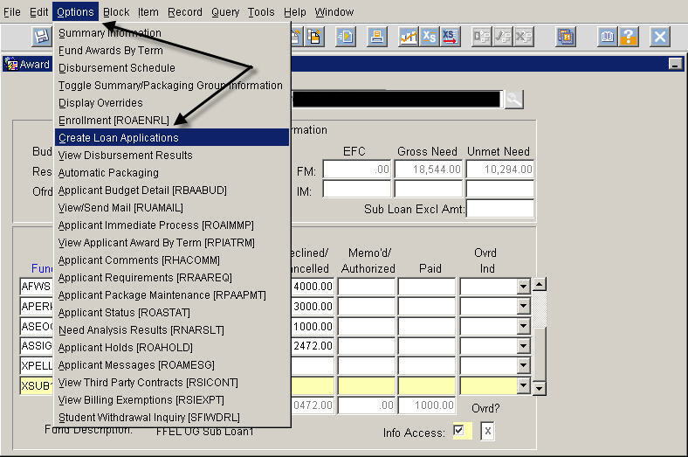
5. This will open RPAELAP
6. An new application will be created for the difference between the original loan amount and the new amount. This will then be transmitted to the lender that evening for guarantee.

* * * E N D * * *

