 | LINK Financial Aid | 

FALN - 109 Awarding a One Semester Loan within a Different Aid Period

Date Issued/Rev: 7/25/06
General Description: This procedure explains how to award a one semester loan when a student has an aid period that is more than one semester. You DO NOT need to follow these instructions for a one semester loan, when a student has a one semester aid period.
Responsible Manager: Financial Aid Director
Related Procedures: FAPK – 108 Package a Fund – Manually
FAPK – 112 Change the Term Distribution of a Fund
Related Forms:
RPAAWRD
RPAELAP
NOTE: First five steps are covered in FAPK-108 and FAPK-112 – for additional detail please refer to these two SOPs.
1. Go to RPAAWRD
2. Award loan on first block
3. SAVE
4. Adjust term distribution on second block
5. SAVE
6. Perform PREVIOUS BLOCK function to get back to first block
7. Go to OPTIONS and select CREATE LOAN APPLICATION
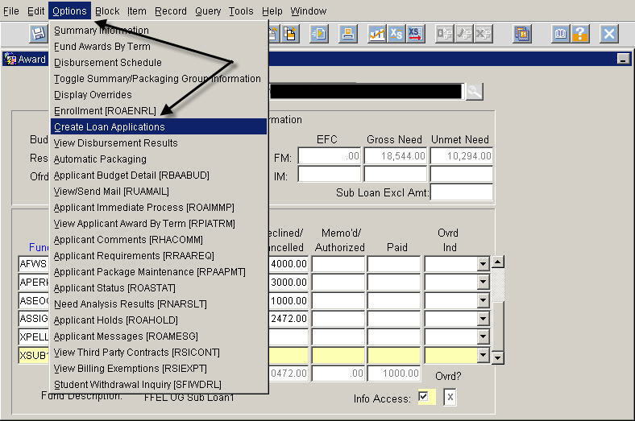
8. Adjust LOAN PERIOD field to term you awarded loan in.
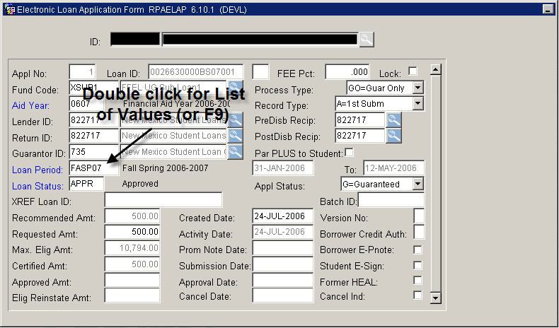
9. SAVE
10. Next block to Certification Data (second block)
11. Adjust COST OF ATTENDANCE, ESTIMATED FINANCIAL AID, and EFC to reflect the one semester numbers.
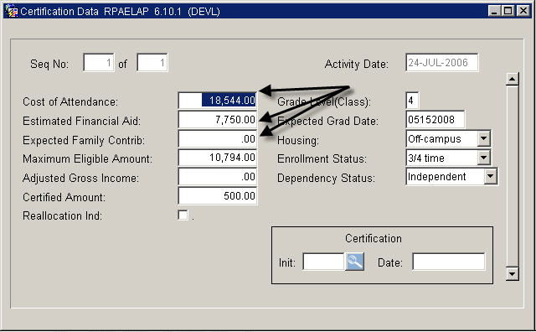
10. Next block three times to Term Schedule (fifth block)
11. SAVE
12. Adjust loan percent to reflect term distribution you want
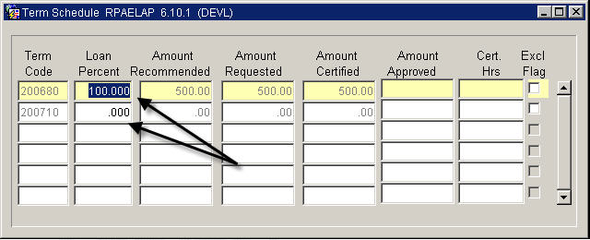
13. SAVE
14. Next block to Disbursement Schedule (sixth block)
15. Adjust DISB % for each term – DO NOT SAVE IN BETWEEN – only SAVE after you have made disbursement schedule for all applicable terms.
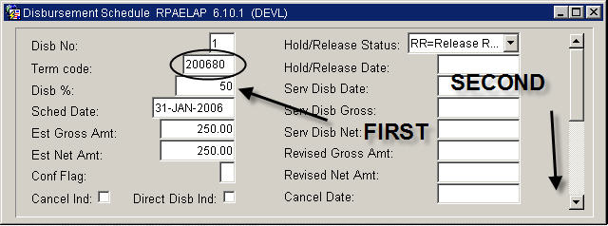
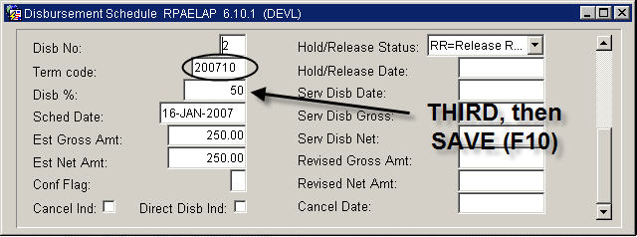
16. SAVE
* * * E N D * * *

