Student Financial Aid

FALN – 110 Cancel a Loan Prior to Guarantee

Date Issued/Rev: 7/01/08
General Description: This procedure explains how to cancel a loan prior to guarantee (see LOAN STATUS TYPES section below for more information). This does not send any information to the lender but it will prevent a loan from disbursing.
Responsible Manager: Financial Aid Director
Related Procedures:
Related Forms:
RPAELAP

Loan Status Types

Ready – record has not yet been sent to guarantee agency. Should change to SENT that evening when extract runs. You could delete this record, if it was created in error. NOTE - THIS IS THE ONLY TIME YOU SHOULD EVER DELETE A RPAELAP RECORD.

Sent – record has been sent to the guarantee agency. We are awaiting a response. Do not make any adjustments to the loan record on RPAELAP when the loan is in this status.

Application Approved – no prom note, but loan is otherwise approved. NO PROM NOTE. You cannot update disbursement data on the fifth block when a loan is in this status. You will get a message indicating that the fields are protected against update. If you need to reduce the loan amount you can do so on RPAAWRD, but the RPAELAP cannot be adjusted until the loan is guaranteed.

Guaranteed – prom note is on file with guarantee agency and loan is approved. This is the only status that will allow disbursement. You can make adjustments to this loan. However, you will not be able to make disbursement adjustments four days prior to a scheduled disbursement date or afterwards. Post disbursement adjustments are not handled on RPAELAP.

Pending - no prom note, but loan is otherwise approved. NO PROM NOTE. Same as Application Approved status.

Denied/Rejected – loan is denied or rejected.

PROCEDURE

Step 1 - Go to RPAELAP. Please refer to Figure 1.

Step 2 – Select the loan you want to cancel. Please refer to Figure 1.

Step 3 – Enter CANC in the LOAN STATUS field. Please refer to Figure 1.

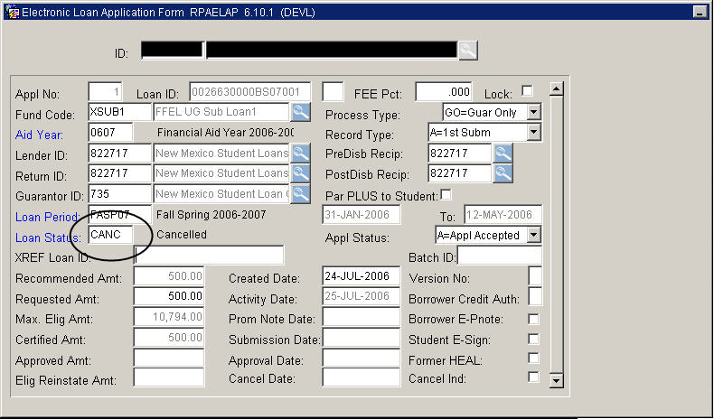
Figure 1 – RPAELAP Form

Step 4 - SAVE
* * * E N D * * *

